OVIDIUS UNIVERSITY OF CONSTANTA
DOCTORAL SCHOOL OF MEDICINE
FIELD OF MEDICINE
ACADEMIC YEAR 2023-2024

DOCTORAL THESIS

CARDIOVASCULAR RISK ASSESSMENT IN HIV PATIENTS FROM THE REGIONAL CENTER OF CONSTANTA, INFECTED PARENTERALLY BETWEEN 1985-1990

PhD Supervisor: Prof. Dr. Sorin Rugină

PhD Candidate: Lucia Zamfirescu

Table of Contents (Summary)
- Introduction 5
- Justification for Choosing the Topic 6
- Study Objectives 8
- Materials and Methods 8
- Main Results and Discussions 10
Sub-study 1: Presentation of the Patient Group and
Evaluation of Traditional and Emerging Cardiovascular Risk Factors 10
Sub-study 2: Assessment of Cardiovascular Risk Using the
Framingham, D:A:D(R), and D:A:D(F) Scores 14
Sub-study 3: Prevalence and Spectrum of Cardiovascular
Conditions in Patients Infected with HIV During Childhood 16
- Study Limitations 22
- Thesis Conclusions 22
- Originality of the Thesis 24
- References 25
- List of Publications and Articles 26

Table of Contents (Thesis)
- Introduction
- Current State of Knowledge
  - General Information on HIV Infection
    - 1.1. Epidemiological Data on HIV Infection Globally and Locally
    - 1.2. Etiology
    - 1.3. Pathogenesis
    - 1.4. Diagnosis
    - 1.5. Complications and Treatment
    - 1.6. Prevention
  - Cardiovascular Involvement in Patients with HIV Infection
    - 2.1. Pathophysiology of Cardiovascular Conditions in HIV-Infected Patients
    - 2.2. Spectrum of Cardiovascular Conditions in HIV-Infected Patients
      - 2.2.1. Coronary Diseases
      - 2.2.2. Valvular Diseases
      - 2.2.3. Rhythm and Conduction Disorders
      - 2.2.4. Heart Failure
      - 2.2.5. Cardiomyopathies
      - 2.2.6. Arterial Hypertension
      - 2.2.7. Acute Myocardial Infarction
      - 2.2.8. Sudden Death
    - 2.3. Cardiovascular Pathology Associated with Antiretroviral Therapy (ART)
  - Cardiovascular Risk Factors in HIV-Infected Patients
    - 3.1. Traditional Cardiovascular Risk Factors
    - 3.2. Emerging Cardiovascular Risk Factors
    - 3.3. Cardiovascular Risk Assessment Scores Used in HIV-Infected Patients
- Personal Contribution
  - Justification for Choosing the Topic
  - Objectives
  - Materials and Methods
  - Sub-study 1: Presentation of the Patient Group and Evaluation of Traditional and Emerging Cardiovascular Risk Factors
    - 4.1. Results
      - 4.1.1. Presentation of the Patient Group
      - 4.1.2. Cardiovascular Risk Factors
        - 4.1.2.1. Traditional Cardiovascular Risk Factors
        - 4.1.2.2. Metabolic Syndrome
        - 4.1.2.3. Emerging Cardiovascular Risk Factors
        - 4.1.2.4. Comorbidities
    - 4.2. Discussions
  - Sub-study 2: Assessment of Cardiovascular Risk Using the Framingham, D:A:D(R), and D:A:(F) Scores
    - 5.1. Results
    - 5.2. Discussions
  - Sub-study 3: Prevalence and Spectrum of Cardiovascular Conditions in Patients Infected with HIV During Childhood
    - 6.1. Results
      - 6.1.1. Echocardiography Parameters
      - 6.1.2. Present Cardiovascular Conditions
      - 6.1.3. Comparison Between the Main Group and the Seronegative Young Control Group
      - 6.1.4. Comparison Between the Main Group and the Seronegative Adult Control Group
    - 6.2. Discussions
  - Conclusions
  - Originality and Innovative Contributions of the Thesis
- References
- Appendices
- List of Publications

Introduction
HIV infection remains one of the most significant global health challenges. Forty years after the first case was identified, 88.4 million people have been infected with the HIV virus, resulting in approximately 42.3 million deaths. As of the end of 2023, 39.9 million people worldwide were living with HIV, and the burden of the epidemic continues to vary significantly between countries and regions. Therefore, stopping the spread of a virus on a global scale requires complex medical approaches, both in terms of treatment and prevention. Despite the success of numerous vaccines in controlling or eradicating infectious diseases, the human immunodeficiency virus (HIV) is still under study for the development of a preventive vaccine. As such, health education and antiretroviral treatment currently play an important role in limiting the spread of HIV infection (1). Since the introduction of the first HIV treatment in 1987 (2) and the continuous development of antiretroviral therapy (ART) to meet current needs, more than 30 drugs are now available for treating HIV, and many patients can control their infection with just one pill per day (1). By the end of 2023, 28.7 million patients had access to ART, which has significantly reduced the death rate by 69% compared to the peak HIV mortality in 2004, and by 51% compared to 2010 (3). The advent and use of combined ART has led to a reduction in AIDS-related mortality, with the life expectancy of HIV patients increasing by 9–10 years between 1996 and 2010 in socio-economically developed countries. While the existence of treatment is an extraordinary medical breakthrough that has extended the life expectancy of people with HIV infection, the long-term consequences of treatment represent a new medical challenge. The "aging" HIV population, having been on ART for over 20 years, faces an increased risk of metabolic, renal, and cardiovascular complications, as well as central nervous system impairment (4).
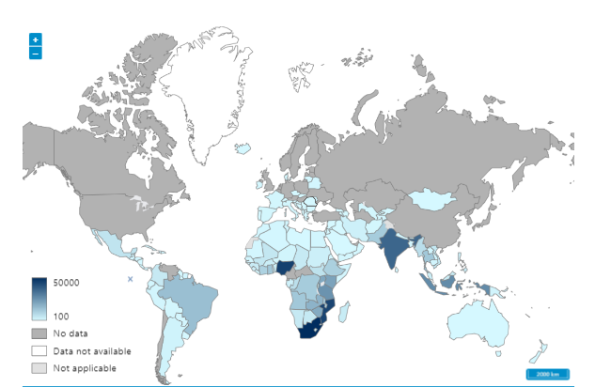
Fig.1. HIV global deaths 2023https://www.who.int/data/gho/data/indicators/indicator-details/GHO/number-of-deaths-due-to-hiv-aids
Thus, morbidity and mortality attributed to aging-related causes among people with HIV are on the rise (5), (6). Cardiovascular disease (CVD) ranks as the leading cause of death both in the U.S. and globally. Among patients with HIV, mortality attributed to CVD is also increasing, with the proportion of CVD-related deaths in HIV-positive patients in the U.S. doubling between 1999 and 2013, rising from 2% to 4.6%. It has been shown that HIV infection is an independent risk factor for coronary artery disease and heart failure (7), (8). Understanding the impact of HIV infection on a wide range of cardiovascular diseases will contribute to a more detailed characterization of cardiovascular pathology among HIV-infected patients, informing the specific needs for managing traditional cardiovascular risk factors (9).

Justification for Choosing the Topic
Although four decades have passed since the first reports of HIV/AIDS cases, it continues to be a medical challenge and a significant public health issue. Currently, there are 39.9 million people living with HIV infection. A major turning point in the management of HIV infection was the introduction of highly active antiretroviral therapy (HAART), which significantly increased life expectancy by reducing mortality from opportunistic infections. While antiretroviral therapy (ART) has drastically improved the clinical and biological outcomes of HIV infection, long-term administration of antiretrovirals has led to various adverse effects, including new clinical and evolutionary issues such as cardiovascular and neurovascular complications. These complications have a greater impact on HIV-infected patients than on the general population of similar ages. This specific group is often referred to as the "aging HIV population."
Romania, particularly in the years between 1985 and 1989 when HIV cases were not officially reported, holds a unique position in Europe. After 1990, once HIV diagnosis became accessible, Romania recorded the highest number of pediatric HIV cases, with Constanța becoming the epicenter of pediatric HIV by April 1999. During this period, 94% of HIV/AIDS cases in Romania were children under 13 years of age, most of them diagnosed in Constanța. These survivors now form the largest cohort of patients under systematic surveillance, representing more than 5,000 cases out of the 28,273 reported as of June 30, 2024, according to CNLAS.
These patients initially received Zidovudine treatment starting in 1995, followed by dual therapy (Didanosine, Zalcitabine), and then HAART in the early 2000s with the introduction of protease inhibitors (Indinavir, Nelfinavir, Kaletra, Darunavir, etc.). In 2000, the Constanța Regional Center benefited from a significant donation of Kaletra for cohort patients, for lifelong treatment. This has led to the Constanța Regional Center having the largest patient cohort on Kaletra-based HAART, providing an opportunity to study the adverse effects and potential cardiovascular implications of this therapy.
Global studies have shown the presence of cardiovascular issues in long-term HIV patients on ART. This is why I considered it important to conduct an in-depth evaluation of cardiovascular manifestations and the risk of cardiovascular complications in this special population, who have been on antiretroviral treatment for an extended period. The aim is to compare these results with those found in the literature.
Most studies and data related to cardiovascular pathology in the literature focus on the adult population, while data on young HIV-positive individuals are limited and controversial. Evaluating the cardiovascular risk in patients from the Constanța Regional Center cohort is crucial, given that these patients have had the infection for 30 years and have been on ART for 20 years. This will help define fundamental parameters for the early monitoring of cardiovascular impairment in this patient group. Continuous monitoring would allow for optimized therapeutic interventions, reduce the cost of emergency medical services and prolonged hospitalizations, and contribute to improving the quality of life for these patients.

Study Objectives
The proposed objectives of the study involving HIV patients infected during 1987-1990 from the Dobrogea Regional Center are as follows:
- Evaluate traditional and emerging cardiovascular risk factors.
- Assess patients using cardiovascular risk scores and compare the results.
- Evaluate the spectrum and prevalence of cardiovascular conditions.
- Perform echocardiographic evaluation of HIV-positive patients in the main study group, compared to a group of non-HIV cardiovascular patients aged 45-55, as well as to a control group of healthy adults of the same biological age as the main study group patients.

Materials and Methods
The study followed the established research phases: planning, selection of the patient group, creation of a database, statistical data analysis, and presentation of results and conclusions.
The study group consisted of HIV-infected patients under the care of the Constanța Regional Center, infected via parenteral routes, diagnosed from 1990 onward. Approximately 200 patients were randomly selected from the database. Given the clinical setup of the day clinic at the Clinical Hospital for Infectious Diseases Constanța, where patients are under the care of different attending physicians, permission was requested from colleagues to include their patients in the study. After obtaining their consent, patients were informed and provided written consent to participate.
Patients included in the study were confirmed using the diagnostic protocol valid at the time (presence of anti-HIV antibodies via two ELISA tests, confirmed by WB-HIV test, and viral load determination by PCR-HIV RNA). Patients filled out a medical questionnaire, as outlined in Appendix 1, to provide necessary information for the study. Patients who refused to participate, preferred to remain under the care of their primary physician for confidentiality reasons, or feared stigmatization and discrimination were excluded. Patients suffering from uncontrolled opportunistic infections or comorbidities at the time of the study's initiation were also excluded.
After applying these criteria, the final study group consisted of 62 patients.
Based on the objectives, three sub-studies were conducted:
- Sub-study I & II: Retrospective analysis up to 2019 and prospective analysis during 2019-2020, focusing on the presence of cardiovascular risk factors and the use of cardiovascular risk scores.
- Sub-study III: A prospective study evaluating the spectrum and prevalence of cardiovascular conditions in patients from the Constanța Regional Center, conducted between 2020-2023.
The final part of the study involved echocardiographic evaluation of the HIV-infected patient group, compared to two control groups of seronegative adults of different ages (20-40 years and 45-55 years).
Statistical data processing was done using IBM SPSS Statistics for Windows, Version 29.0 (30-day trial version), Armonk, NY: IBM Corp. Nominal data were presented as absolute frequency and percentage, while continuous variables were expressed as mean and standard deviation. The association between categorical variables was analyzed using cross-tabulation and the χ2 (chi-square) test. When the chi-square test results were significantly altered, Fisher’s exact test was used. The independent t-test was applied to compare means based on dichotomous variables. For comparing three or more group means with the same participants in each group, the ANOVA test was used. A statistical significance value of p<0.05 was considered significant.

Main Results and Discussions
Sub-study 1 – Presentation of the patient cohort and evaluation of traditional and emerging cardiovascular risk factors
The study was conducted on 62 patients, 27 men and 35 women, infected with HIV through parenteral transmission between 1987-1990, who are part of the Constanța Regional Center cohort. The average age of the patients in the study is 32 years. According to the CDC Atlanta classification, there are 9 patients in stage A of the disease, 11 in stage B, and 42 in stage C, with most patients being in stage C due to the late diagnosis of HIV infection at the beginning of the pandemic, as clinical and biological criteria for accurate diagnosis were lacking.
Since the introduction of HAART triple therapy in Romania, the most common ARV regimen used by the patients was 2NRTIs + PI/booster for 46 patients, followed by NRTI + II + PI/booster for 9 patients, with the least used being 2NRTIs + NNRTI regimens. The average duration of ART was 19 years, with a maximum of 25 years and a minimum of 10 years. Due to this, the cohort is considered "aged" due to long-term treatment. The most frequently used protease inhibitors were Lopinavir and Darunavir in similar proportions (41.9% and 33.9%), with an average duration of use of 17.47 years. Almost half of the patients used PIs for 20-25 years.
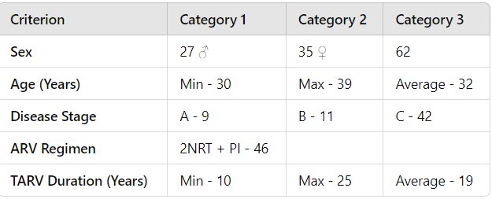
Table 1 – presentation of the group of patients

I have analyzed traditional risk factors due to their importance in evaluating cardiovascular risk and found that sedentary behavior was present in most patients, and a third of them were smokers.
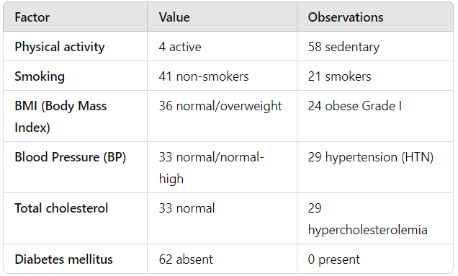
Table no. 2 – Traditional cardiovascular risk factors
Recent studies show a strong correlation between the presence of HIV, ART, and obesity, which is also reflected in the evaluation of patients from the Constanța Regional Center cohort. Of the 62 patients, 38.9% were obese or overweight, the highest percentage being from stage C of the disease (22%). Additionally, 93.5% of the patients were sedentary. A total of 58.1% were of normal weight, including 5 from stage A, 5 from stage B, and 26 from stage C.
Specialized studies indicate a significant association between protease inhibitors and abdominal circumference. However, in this study, 37 of the patients had an abdominal circumference above normal values, though it was not significantly associated with any specific PI, nor did abdominal circumference above normal limits statistically differ by HIV stage (p=0.873).
Low HDL cholesterol levels were observed in 56 patients, and the proportion of cases with values below 35 mg/dl was similar across the three stages of the disease, with one patient each from stage A and B, and four from stage C.
The triglyceride levels of the patients in the study averaged 192.92 mg/dl, with a minimum value of 34 mg/dl and a maximum of 1,343 mg/dl.
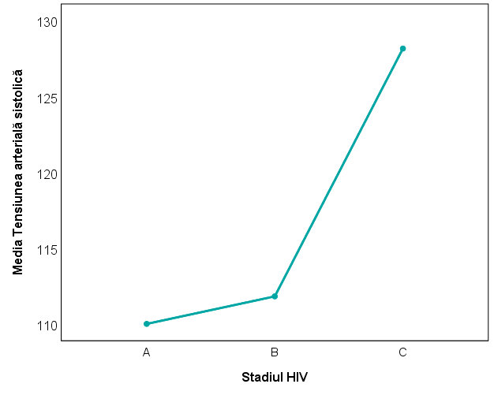
High normal blood pressure and hypertension were present in 28 patients, 27 of whom were in stage C of the disease, a significantly higher number (p<0.001 for systolic BP, p=0.020 for diastolic BP) compared to HIV-negative individuals of the same age. Hypercholesterolemia was also present in 29 patients, all in stage C of the disease. Hypertension was not significantly associated with the type of PI used or CD4 count, which had an average value of 546 cells/mm3.
Chart 1. Systolic BP
Tabel nr.3.Blood pressure * HIV Stage
 |  |  | HIV stage |  |  | Total
 |  |  | A | B | C | Total
BP | Normal | Frequency | 9 | 9 | 15 | 33
BP | Normal | % | 100,0% | 81,8% | 35,7% | 53,2%
BP | Normal-High BP | Frequency | 0 | 0 | 11 | 11
BP | Normal-High BP | % | 0,0% | 0,0% | 26,2% | 17,7%
BP | Hypertension | Frequency | 0 | 2 | 16 | 18
BP | Hypertension | % | 0,0% | 18,2% | 38,1% | 29,0%
Total |  | Frequency | 9 | 11 | 42 | 62
 |  | % | 100,0% | 100,0% | 100,0% | 100,0%

International studies support the correlation between metabolic syndrome and PI use, but in this study, the prevalence of metabolic syndrome was low at 27.4%, compared to most studies where it affects a majority of patients. Of the patients with metabolic syndrome, 41.2% had LPV in their therapy, 29.4% had DRV, 11.8% had both LPV/DRV, and 5.9% had ATV. Another 11.8% had no PIs in their regimen.
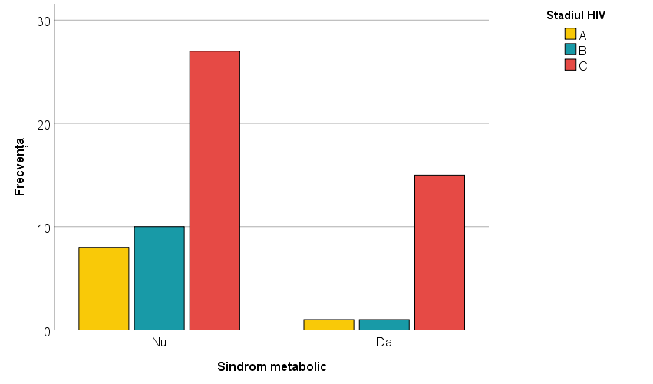
Chart 2. Metabolic Syndrome in HIV stages
I have analyzed HDL and LDL cholesterol precursors. In the analysis of Apolipoprotein A1 (the precursor to HDL), we found that most patients had HDL within normal limits (91.5%), as well as ApoA1 (100%). ApoA1 was not considered a superior factor for the presence of metabolic syndrome in this study. Different results were found for the LDL precursor, Apolipoprotein B, with elevated ApoB levels observed in a similar number of patients as with LDL cholesterol. Thus, we considered incorporating ApoB into the screening and cardiovascular monitoring of HIV patients. We can conclude that there is a significant association (p<0.001) between LDL and ApoB levels, with elevated LDL levels significantly associated with elevated ApoB levels.
Tabel nr.4 Apolipoprotein B * LDL
 |  |  | LDL |  | Total
 |  |  | 40-140 | >140
Apolipoprotein B | Normal | Frequency | 42 | 11 | 53
Apolipoprotein B | Normal | % | 79.2% | 20.8% | 100.0%
Apolipoprotein B | High | Frequency | 1 | 8 | 9
Apolipoprotein B | High | % | 11.1% | 88.9% | 100.0%
Total |  | Frequency | 43 | 19 | 62
 |  | % | 69.4% | 30.6% | 100.0%

Another emerging risk factor studied was hs-CRP compared to standard CRP, both markers of inflammation associated with cardiovascular risk. In the study cohort, hs-CRP was found to be a more reliable marker for assessing cardiovascular risk compared to CRP. A total of 51.6% of patients had hs-CRP values indicating moderate to high cardiovascular risk, compared to only 9.7% of patients with CRP values above the normal limit. Patients with elevated hs-CRP were predominantly in stage C of the disease (28.6%) compared to 18.2% in stage B and 11.1% in stage A. The proportion of patients with moderate or high risk did not significantly differ by HIV stage (p=0.380).
Tabel nr.5. CRP-hs * HIV stage
 |  |  | HIV stage |  |  | Total
 |  |  | A | B | C | Total
CRP-hs | Low risk <1 | Frequence | 5 | 6 | 19 | 30
CRP-hs | Low risk <1 | % | 55,6% | 54,5% | 45,2% | 48,4%
CRP-hs | Moderate risk >1-3 | Frequence | 3 | 3 | 11 | 17
CRP-hs | Moderate risk >1-3 | % | 33,3% | 27,3% | 26,2% | 27,4%
CRP-hs | High risk >3 | Frequence | 1 | 2 | 12 | 15
CRP-hs | High risk >3 | % | 11,1% | 18,2% | 28,6% | 24,2%
Total |  | Frequence | 9 | 11 | 42 | 62
 |  | % | 100,0% | 100,0% | 100,0% | 100,0%
Fibrinogen, the third inflammation marker studied, was elevated in 21 patients. High hs-CRP levels were significantly associated with elevated fibrinogen levels (p=0.005), suggesting that these two markers could be dynamically studied to assess cardiovascular risk.
Sub-study 2 – Evaluation of cardiovascular risk using the Framingham, D:A:D(R), and D:A:D(F) scores
To date, no precise score exists for determining cardiovascular risk in HIV-infected patients. For the general population, numerous options are available for calculating cardiovascular risk, such as the Framingham risk score, SCORE (Systematic Coronary Risk Evaluation), and ASCVD risk estimator. However, these scores are not applicable to the patients in the study, as they do not meet the age criteria. The most commonly used score for the general population is the Framingham risk score, while for HIV patients, the D:A:D(R) and D:A:D(F) scores are the most used.
Comparing the three cardiovascular risk scores (Framingham, D:A:D(R), and D:A:D(F)), we found that the Framingham score was not appropriate for HIV-infected patients, as 96.8% of patients were classified as low-risk for 10-year cardiovascular risk. In contrast, the two D:A:Dscores, developed for HIV populations, provided more accurate assessments.
Tabel nr.6. Framingham risk score
 |  | Frequence | Percent
Valid data | <10, low risk | 60 | 96,8
Valid data | >19, high risk | 2 | 3,2
Valid data | Total | 62 | 100,0

Using the D:A:D(R) score, we found that 58.1% of patients had low risk, 27.4% had moderate risk, and 14.5% had high cardiovascular risk. Statistical analysis indicated no significant association (p=0.935) between the D:A:D(R) score and HIV stage.
Tabel nr.7. DAD-R * HIV stage
 |  |  | HIV stage |  |  | Total
 |  |  | A | B | C | Total
DAD-R | <10, low risk | Frequence | 5 | 6 | 25 | 36
DAD-R | <10, low risk | % | 55,6% | 54,5% | 59,5% | 58,1%
DAD-R | 10-19, moderate risk | Frequence | 2 | 3 | 12 | 17
DAD-R | 10-19, moderate risk | % | 22,2% | 27,3% | 28,6% | 27,4%
DAD-R | >19, high risk | Frequence | 2 | 2 | 5 | 9
DAD-R | >19, high risk | % | 22,2% | 18,2% | 11,9% | 14,5%
Total |  | Frequence | 9 | 11 | 42 | 62
 |  | % | 100,0% | 100,0% | 100,0% | 100,0%
The D:A:D(F) score classified 12.9% of patients as low risk, 25.8% as moderate risk, and 61.3% as high risk. A total of 61.3% (38 patients) were classified as high-risk according to the D:A:D(F) score, with 26 of them in stage C.
Tabel nr.8. DAD-F * HIV stage
 |  |  | HIV Stage |  |  | Total
 |  |  | A | B | C | Total
DAD-F | <10, low risk | Frequence | 1 | 3 | 4 | 8
DAD-F | <10, low risk | % | 11,1% | 27,3% | 9,5% | 12,9%
DAD-F | 10-19, moderate risk | Frequence | 1 | 3 | 12 | 16
DAD-F | 10-19, moderate risk | % | 11,1% | 27,3% | 28,6% | 25,8%
DAD-F | >19, high risk | Frequence | 7 | 5 | 26 | 38
DAD-F | >19, high risk | % | 77,8% | 45,5% | 61,9% | 61,3%
Total |  | Frequence | 9 | 11 | 42 | 62
 |  | % | 100,0% | 100,0% | 100,0% | 100,0%
The D:A:D(F) score is considered the most useful of the three, as it includes the most relevant parameters for assessing cardiovascular risk. However, the predictability of the scores is uncertain because the "aging HIV population" is still being studied regarding the mechanisms involved in cardiovascular disease development. It has been found that conventional strategies for cardiovascular disease prevention and evaluation are insufficient for HIV patients. Therefore, cardiovascular management remains under development.
Sub-study 3 – Prevalence and spectrum of cardiovascular diseases in patients infected with HIV during childhood
The 62 patients were investigated using echocardiography, and the following parameters were monitored: left ventricular systolic and diastolic diameters, right atrial diameter, left atrial diameter, right ventricular diameter, posterior wall thickness, interventricular septum thickness, LV ejection fraction, aortic diameter, A wave velocity, E wave, fractional shortening, and trans-aortic gradient.
The diameters of the heart chambers were within physiological limits, with the LV having an average diastolic diameter of 47.2 mm and a systolic diameter of 29.9 mm, the left atrium measuring an average of 31.06 mm, the right ventricle 30.47 mm, and the right atrium 32.2 mm.
LVEF was normal in 51 patients, with values below 60% in 11 patients. The proportion of patients with left ventricular ejection fractions below 60% did not differ significantly by HIV stage (p=0.351). Elevated hs-CRP levels were not significantly associated with reduced ejection fractions (p=0.108).
Tabel nr.9. LVEV
 |  | Frequence | Percent
Valid data | <60% | 11 | 17,7
Valid data | 60%-80% | 51 | 82,3
Valid data | Total | 62 | 100,0

In terms of valve abnormalities, 43.5% of the patients presented with heart valve disease: 27.4% had mild or minimal mitral/tricuspid regurgitation, 8.1% had regurgitation in two valves, 6.5% had mitral/tricuspid insufficiency, and 1.6% had grade 2 aortic/mitral/tricuspid regurgitation. Although there were differences in the prevalence of heart valve disease by HIV stage, the differences were not statistically significant (p=0.346). As an inflammation marker, hs-CRP is not statistically significantly associated (p=0.901) with certain heart valve disease. Similarly, there is no significant association between heart valve disease and protease inhibitors (PIs). 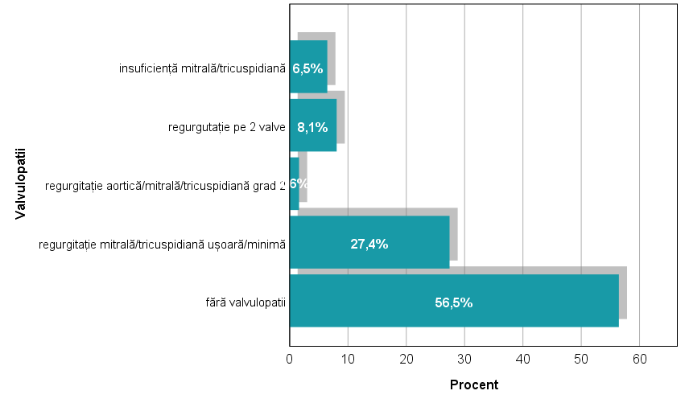
Chart 3. heart valve disease in HIV patients. Fără valvulopatii = without heart valve disease, regurgitație mitrală/tricuspidiană usoară/minima = mild/minimal mitral/tricuspid valve regurgitation, regurgitație aortică/mitrală/tricuspidiană grad 2 = grade 2 aortic/mitral/tricuspid valve regurgitation, regurgitație pe 2 valve = regurgitation on 2 valves, insuficiență mitrală/tricuspidiană = mitral/tricuspid valve insufficiency, procent=percent.
Diastolic dysfunction (type I left ventricular diastolic dysfunction) was present in 7 patients, most of them in stage C of the disease; however, there were no statistically significant differences between the three HIV stages (p=0.455). Furthermore, there was no statistically significant association (p=0.972) between diastolic dysfunction, rhythm disorders, heart valve disease, and PIs.

Tabel nr.10. Diastolic dysfunction * HIV stage
 |  |  | HIV stage |  |  | Total
 |  |  | A | B | C | Total
Diastolic dysfunction | no | Frequence | 9 | 10 | 36 | 55
Diastolic dysfunction | no | % | 100,0% | 90,9% | 85,7% | 88,7%
Diastolic dysfunction | yes | Frequence | 0 | 1 | 6 | 7
Diastolic dysfunction | yes | % | 0,0% | 9,1% | 14,3% | 11,3%
Total |  | Frequence | 9 | 11 | 42 | 62
 |  | % | 100,0% | 100,0% | 100,0% | 100,0%
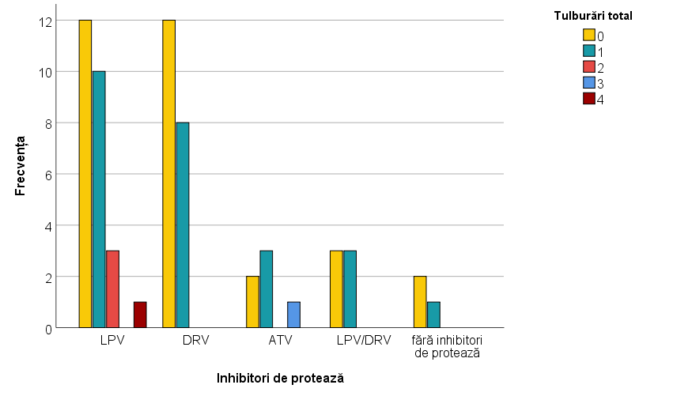
Chart 4. the link between IP and cardiovascular disorders (Inhibitori de protează=Protease inhibitors, LPV=lopinavir, DRV=darunavir, ATV=atazanavir, fără inhibitori de protează=without protease inhinitors)
Although traditional risk factors do not reveal the cardiovascular risk in HIV patients, emerging risk factors may provide a more precise evaluation. Additionally, important information can be obtained through cardiac echocardiography, which should become part of the mandatory screening for HIV-infected patients.
I have compared the main group with a cohort of HIV-negative young adults aged 20-40 years and observed that, while both groups had normal heart chamber diameters, the average right ventricular size was 30.47 mm compared to 24.21 mm, a statistically significant difference (p<0.001). This indicates that this group of patients is at risk of developing cardiomyopathy. The other heart chamber diameters were similar between the two groups, as was the ejection fraction.
Tabel nr.11. Comparing study group with group 1 – ultrasound parameters
 | Lot | N | Media | Standard deviation | p
Left ventricular diastolic diameter | Study lot | 62 | 47,02 | 4,503 | <0,001
Left ventricular diastolic diameter | Lot 1 | 24 | 42,42 | 5,012 | <0,001
Left ventricular systolic diameter | Study lot | 62 | 29,90 | 3,579 | <0,001
Left ventricular systolic diameter | Lot 1 | 24 | 22,42 | 2,205 | <0,001
LVEF | Study lot | 62 | 64,08 | 4,930 | 0,389
LVEF | Lot 1 | 24 | 63,13 | 3,555 | 0,389
Interventricular sept | Study lot | 62 | 9,21 | 1,256 | 0,007
Interventricular sept | Lot 1 | 24 | 9,79 | ,658 | 0,007
Posterior wall | Study lot | 62 | 8,61 | 1,347 | 0,001
Posterior wall | Lot 1 | 24 | 9,71 | 1,083 | 0,001
Left Atrium | Study lot | 62 | 31,06 | 4,160 | 0,376
Left Atrium | Lot 1 | 24 | 30,38 | 2,763 | 0,376
Right Ventricle | Study lot | 62 | 30,47 | 4,056 | <0,001
Right Ventricle | Lot 1 | 24 | 24,21 | 1,615 | <0,001
Right Atrium | Study lot | 62 | 32,26 | 3,662 | <0,001
Right Atrium | Lot 1 | 24 | 27,71 | 1,197 | <0,001

Comparing the main group with HIV-negative patients aged 45-55 years, we observed that the left ventricular systolic diameter and ejection fraction were significantly larger in the main group (p<0.001)

Tabel 12. Comparing study lot with lot 2 – ultrasound parameters
 | Lot | N | Media | Standard deviation | p
Left ventricular diastolic diameter | Study lot | 62 | 47,02 | 4,503 | 0,859
Left ventricular diastolic diameter | Lot 2 | 20 | 46,80 | 5,367 | 0,859
Left ventricular systolic diameter | Study lot | 62 | 29,90 | 3,579 | <0,001
Left ventricular systolic diameter | Lot 2 | 20 | 25,65 | 4,404 | <0,001
LVEF | Study lot | 62 | 64,08 | 4,930 | <0,001
LVEF | Lot 2 | 20 | 57,25 | 6,973 | <0,001
Interventricular sept | Study lot | 62 | 9,21 | 1,256 | <0,001
Interventricular sept | Lot 2 | 20 | 10,45 | ,759 | <0,001
Posterior wall | Study lot | 62 | 8,61 | 1,347 | 0,001
Posterior wall | Lot 2 | 20 | 9,70 | ,733 | 0,001
Left Atrium | Study lot | 62 | 31,06 | 4,160 | <0,001
Left Atrium | Lot 2 | 20 | 35,50 | 5,605 | <0,001
Right Ventricle | Study lot | 62 | 30,47 | 4,056 | 0,092
Right Ventricle | Lot 2 | 20 | 29,30 | 2,003 | 0,092
Right Atrium | Study lot | 62 | 32,26 | 3,662 | 0,861
Right Atrium | Lot 2 | 20 | 32,10 | 2,900 | 0,861

A significantly higher prevalence of heart valve disease was noted among HIV patients compared to the younger control group, with a statistically significant difference (p=0.050), while the prevalence of heart valve disease was similar between the main group and the 45-55-year-old group (p=0.283). Thus, echocardiography reveals the biological similarity of the hearts of "aged" HIV patients due to therapy, with those of individuals aged 45-55 years.

Tabel 12. Lot * heart valve disease
 |  |  |  |  |  |  |  | Total
 |  |  | without heart valve disease | mild/minimal mitral/tricuspid valve regurgitation | grade 2 aortic/mitral/tricuspid valve regurgitation | regurgitation on 2 valves | mitral/tricuspid valve insufficiency
Lot | Study lot | Frequence | 35 | 17 | 1 | 5 | 4 | 62
Lot | Study lot | % | 56,5% | 27,4% | 1,6% | 8,1% | 6,5% | 100,0%
Lot | Lot 1 | Frequence | 19 | 4 | 0 | 1 | 0 | 24
Lot | Lot 1 | % | 79,2% | 16,7% | 0,0% | 4,2% | 0,0% | 100,0%
Total |  | Frequence | 54 | 21 | 1 | 6 | 4 | 86
 |  | % | 62,8% | 24,4% | 1,2% | 7,0% | 4,7% | 100,0%

In a more in-depth comparison, we noted a higher frequency of mild/minimal mitral/tricuspid regurgitation in the main group compared to the 45-55-year-old control group, in which grade 2 heart valve disease and regurgitation in two valves were more frequent.
Tabel 13.Lotul * heart valve disease
 |  |  |  |  |  |  |  | Total
 |  |  | without heart valve disease | mild/minimal mitral/tricuspid valve regurgitation | grade 2 aortic/mitral/tricuspid valve regurgitation | regurgitation on 2 valves | mitral/tricuspid valve insufficiency
Lot | Study lot | Frequency | 35 | 17 | 1 | 5 | 4 | 62
Lot | Study lot | % | 56,5% | 27,4% | 1,6% | 8,1% | 6,5% | 100,0%
Lot | Lot 2 | Frequency | 14 | 0 | 3 | 2 | 1 | 20
Lot | Lot 2 | % | 70,0% | 0,0% | 15,0% | 10,0% | 5,0% | 100,0%
Total |  | Frequency | 49 | 17 | 4 | 7 | 5 | 82
 |  | % | 59,8% | 20,7% | 4,9% | 8,5% | 6,1% | 100,0%

Kinetic disorders were more common in the 45-55-year-old control group (45%) compared to the main group (11.3%), with a statistically significant difference (p=0.001).

Study Limitations
The small number of HIV patients enrolled in the study cohort was due to rigorous selection criteria, the methodology of the long-term study, and patients' concerns about confidentiality, all of which decisively impacted the willingness to participate and the acquisition of informed consent from all initially identified patients in the Constanța Regional Center Database.
Thesis Conclusions
- Cardiovascular disease (CVD) associated with HIV infection results from a complex interaction of virus-related, host-related, and ARV treatment-related factors. Chronic inflammation and immune dysregulation play a key role in increasing CVD risk.
- Among the traditional cardiovascular risk factors identified in the cohort, physical activity assessment revealed that 93.5% of the patients were sedentary. In terms of BMI, 38.9% were obese or overweight, with the highest percentage in stage C of the disease (22%). A total of 33.9% of patients were smokers, 51.6% had dyslipidemia, and 8.1% were diagnosed with hypertension (HTN).
- Among patients diagnosed with metabolic syndrome, 41.2% were on LPV-based therapy, 29.4% on DRV, 11.8% on LPV/DRV, and 5.9% on ATV. 11.8% of patients were not on a PI-based regimen.
- Cardiovascular risk management in the study patients involved controlling dyslipidemia and hypertension and offering behavioral counseling to promote a healthy lifestyle, focused on physical activity, a healthy diet, maintaining ideal body weight, and reducing risky behaviors such as tobacco use and illicit substance consumption.
- Emerging cardiovascular risk factors, such as elevated ApoB (in 14.5% of patients) and hs-CRP (which classified 51.6% of patients as moderate-to-high risk), can offer a more accurate risk assessment and may serve as reliable biological markers of inflammation in HIV patients.
- Among the emerging risk factors, hs-CRP is considered a more reliable marker for cardiovascular risk assessment than traditional CRP. 51.6% of patients had hs-CRP levels indicating intermediate to high cardiovascular risk, compared to 9.7% of patients with elevated CRP levels. A total of 28.6% of patients with elevated hs-CRP were classified in stage C of HIV.
- The D:A:D(F) score is regarded as the most useful in assessing cardiovascular risk in HIV patients, classifying 87.1% of the cohort as moderate-to-high risk. Its predictability requires periodic updates, as the "aging HIV population" is still under study regarding cardiovascular disease development mechanisms. Conventional CVD assessment and prevention strategies are insufficient for HIV patients.
- A total of 61.3% (38 patients) of the study cohort were classified as high-risk according to the D:A:D(F) score, with 26 in stage C.
- Echocardiography in Substudy 3 revealed that 43.5% of patients had heart valve disease: 27.4% had mild/minimal mitral/tricuspid regurgitation, 8.1% had regurgitation in two valves, 6.5% had mitral/tricuspid insufficiency, and 1.6% had grade 2 aortic/mitral/tricuspid regurgitation.
- Diastolic dysfunction (type I left ventricular diastolic dysfunction) and cardiac rhythm disorders were present in 11.3% of patients, correlating with the stage of HIV infection, specifically 9.1% in stage B and 14.3% in stage C.
- A significantly higher prevalence of had heart valve disease was recorded in HIV patients (43.5%) compared to the young control group (20.8%).
- Kinetic disorders were more frequent in the 45-55-year-old HIV-negative control group (45%) compared to the main group (11.3%), with a statistically significant difference (p=0.001).
- Echocardiography detected had heart valve disease in 43.5% of patients, a statistically significant difference compared to the same biological age group (p=0.050), with a prevalence similar to that in non-HIV adults aged 40-55 years.
- The risk and prevalence of HIV-associated cardiovascular diseases are increasing due to the extended lifespan and "aging" of this specific population. Thus, preventive measures must be strengthened to mitigate cardiovascular risk.
- Effective screening and control of cardiovascular risk factors, along with early diagnosis and optimal ARV treatment to reduce immune activation and systemic inflammation, are essential in managing HIV-infected patients. Cardiac echocardiography should be included in both initial and periodic evaluations, as it has proven useful in detecting early cardiac pathology in this patient category.
- Cardiovascular disease management in HIV-infected patients requires optimization of prevention, diagnosis, and treatment strategies. Interdisciplinary collaboration between infectious disease specialists and cardiologists is essential.
Original Contributions
The study introduces the assessment of emerging cardiovascular risk factors and echocardiographic investigation in the screening of cardiovascular disease in HIV patients. Additionally, it suggests updating the local HIV patient care protocol to include annual cardiological evaluations.

References
- HIV.gov [Internet]. [cited 2024 Apr 11]. HIV Treatment Overview. Available from: https://www.hiv.gov/hiv-basics/staying-in-hiv-care/hiv-treatment/hiv-treatment-overview
- The First AIDS Drugs | Center for Cancer Research [Internet]. [cited 2024 Apr 11]. Available from: https://ccr.cancer.gov/news/landmarks/article/first-aids-drugs
- HIV – Number of people dying from HIV-related causes [Internet]. [cited 2024 Aug 7]. Available from: https://www.who.int/data/gho/data/indicators/indicator-details/GHO/number-of-deaths-due-to-hiv-aids
- Chawla A, Wang C, Patton C, Murray M, Punekar Y, de Ruiter A, et al. A Review of Long-Term Toxicity of Antiretroviral Treatment Regimens and Implications for an Aging Population. Infect Dis Ther. 2018 Jun;7(2):183–95.
- Alonso A, Barnes AE, Guest JL, Shah A, Shao IY, Marconi V. HIV Infection and Incidence of Cardiovascular Diseases: An Analysis of a Large Healthcare Database. J Am Heart Assoc. 2019 Jul 16;8(14):e012241.
- Prevalence and distribution of non-AIDS causes of death among HIV-infected individuals receiving antiretroviral therapy: a systematic review and meta-analysis - PubMed [Internet]. [cited 2024 Jun 24]. Available from: https://pubmed.ncbi.nlm.nih.gov/26868158/
- So-Armah K, Freiberg MS. HIV and Cardiovascular Disease: Update on Clinical Events, Special Populations, and Novel Biomarkers. Curr HIV/AIDS Rep. 2018 Jun;15(3):233–44.
- Global, regional, and national age-sex specific mortality for 264 causes of death, 1980-2016: a systematic analysis for the Global Burden of Disease Study 2016 - PubMed [Internet]. [cited 2024 Jun 24]. Available from: https://pubmed.ncbi.nlm.nih.gov/28919116/
- Contributions of traditional and HIV-related risk factors on non-AIDS-defining cancer, myocardial infarction, and end-stage liver and renal diseases in adults with HIV in the USA and Canada: a collaboration of cohort studies - PubMed [Internet]. [cited 2024 Jun 24]. Available from: https://pubmed.ncbi.nlm.nih.gov/30683625/
- HIV [Internet]. [cited 2024 Apr 11]. Available from: https://www.who.int/data/gho/data/themes/hiv-aids
- Paraschiv S, Otelea D, Batan I, Baicus C, Magiorkinis G, Paraskevis D. Molecular typing of the recently expanding subtype B HIV-1 epidemic in Romania: evidence for local spread among MSMs in Bucharest area. Infect Genet Evol J Mol Epidemiol Evol Genet Infect Dis. 2012 Jul;12(5):1052–7.
- Paraschiv S, Otelea D, Batan I, Baicus C, Magiorkinis G, Paraskevis D. Molecular typing of the recently expanding subtype B HIV-1 epidemic in Romania: Evidence for local spread among MSMs in Bucharest area. Infect Genet Evol. 2012;12(5):1052–7.
- Manolescu LSC, Temereanca A, Ruţă S. HIV-1 circulating subtypes in Romania. Roum Arch Microbiol Immunol. 2013;72(2):121–34.

List of publications and articles
- Cardiovascular risk assessment in young HIV patients from Constanța County, Romania, using cardiovascular risk scores Zekra L., Dumitru I. M., Cernat R.C. Hangan A, Bajdechi M, Militaru N.M., Vodarici M.E., Rugina S. – Ars medica tomitana 2024 (articol în curs de publicare)
- Coronary Artery Disease in People Living With Human Immunodeficiency Virus. Bajdechi M, Gurghean A, Mateescu I, Zekra L, Rugina S. Internal Medicine, 2022 Vol XIX No.2.
- SARS-CoV-2 Infection and Emery-Dreifuss Syndrome in a Young Patient with a Family History of Dilated Cardiomyopathy. Dumitru IM, Vlad ND, Rugina S, Onofrei N, Gherca S, Raduna M, Trana A, Dumitrascu M, Popovici E, Bajdechi M, Zekra L, Cernat RC. Genes (Basel). 2021 Jul 14;12(7):1070. doi: 10.3390/genes12071070. PMID: 34356086; PMCID: PMC8306179
- Cardiovascular risk assessment in HIV-infected patients – Zekra Lucia, Dumitru Irina Magdalena, Bajdechi Mircea, Rugina Sorin – Volume 26 (2020): Issue 1 (February 2020)
- COVID-19 Pandemic and Global Economic Impact – Zekra Lucia – Ovidius University Annals. Economic Sciences Series – Vol XX Nr.1/2020
- Factori de prognostic nefavorabil in infectia cu SARS-CoV-2- Irina Magdalena Dumitru, Roxana Cernat Carmen, Carmen Ilie Serban, Andra Elena Petcu, Aurelia Hangan, Lucia Zekra, Sorin Rugina – SARS-CoV-2 – Provocarea Inceputului de Mileniu 3- Editia a VI-a, Editura “Gr.T.Popa”, U.M.F. Iasi, Iasi 2020 -p:36-42. ISBN 978-606-544-707-3
- The Utility of Electronic Bracelets for Monitoring Hositalized Patients – Zekra Lucia – 35 IBIMA Conference (ISBN:978-0-9998551-4-0, Published in the USA)
- Riscul infectios la pacienții oncologici – Irina Magdalena Dumitru, Roxana Cernat, Cristina Sava, Andra Petcu, Elena Dumea, Lucia Zekra, Sorin Rugina – Provocarea Teorieie în Practica Medicala Curentă, Ediția a IV-a, Ed. Gr.T.Popa, Iași 2019, p126-132.
- Clasificari si scoruri de severitate in bolile infectioase Irina Magdalena Dumitru, colaboratori Aurelia Hangan, Lucia Zekra: Constanta: Editura Muntenia, 2017, ISBN 978-973-692-422-4

Presentations
- Management of Gram positive related infections in hospital environment – Conf. Univ. Dr. Dumitru Irina Magdalena, As.Univ.Dr. Zekra Lucia, NATIONAL CONFERENCE ON INFECTION CONTROL AND ANTIMICROBIAL STEWARDSHIP PROGRAMS DESIGNED FOR ROMANIAN HOSPITALS February 14-15, 2020, "Dr. Carol Davila" University Central Emergency Military Hospital Bucharest, Romania
- Abordarea multidisciplinara a pacientul cu infectie COVID -19 si multiple comorbiditati in spital de monospecialitate – o provocare! Zekra Lucia - CONFERINTA “Cazuri Clinice COVID 19” 16 iulie 2020
- Limfom non-hodgkin la un pacient cu infecție HIV, neaderent la TARV – Zekra Lucia, Sorin Rugina, Sava Cristina, Dumitru Irina Magdalena – Zilele Facultatii de Medicină Constanța 2019
- Meningita Acută cu Enterococus Fecalis – Sava Cristina, Zekra Lucia, Dumitru Irina Magdalena, Sorin Rugina - Conferința Națională de Boli Infecțioase Timișoara 2017
- Considerații asupra unui caz de botulism – Zekra Lucia, Dumitru Irina Magdalena, Rugina Sorin - Zilele medicale dobrogene, 7-10 aprilie 2016
- Ancheta epidemiologica – botulism - Conferinta de sterilizare, Zalau, 19-20 mai 2016
- Infectia HIV la navigatori – Zekra Lucia, Dumitru Irina Magdalena - Congres Medicina Marii, 8-10 septembrie 2016
- Lucrare de licenta – Ocluzia intestinala, 2014
Competitions
- Comorbidități și riscuri ale aparatului reno-urinar la pacient infectat HIV - HIV Voices for Tomorrow – Timisoara 2019

