"OVIDIUS" UNIVERSITY OF CONSTANTA
DOCTORAL SCHOOL OF MEDICINE

FRACTURES OF THE UPPER EXTREMITY OF THE FEMUR

DOCTORAL THESIS

PhD supervisor:
Prof. univ. dr. PETRU BORDEI

PhD student:
ALGIOUNIDIS MANSOUR IOANNIS

CONSTANTA 2024

INTRODUCTION

The femur forms the thigh skeleton, carries body weight, supports the movements of the lower limb and ensures the insertion of the thigh muscles. Geometric indices are significant indicators of the range of motion and strength of the thigh muscles after total hip arthroplasty is performed. Commercially available hip prostheses are made based on anatomical data, undersized or oversized hip prostheses from total hip arthroplasty can affect motor function. The morphometric study of the proximal femur has been carried out in different populations and communities, the data obtained from these studies demonstrating that femoral morphometry has regional characteristics and social differences. The frequency of total hip arthroplasty (THA), as an effective treatment for various traumas or the final stage of hip osteoarthritis, has increased worldwide. Many factors influence the longevity of THA, such as implant design, type of material, body weight, surgical technique, and hip anatomy reconstruction. In their studies, several authors have described the effects of incorrect reconstruction of the hip anatomy in the case of THA, which leads to patient dissatisfaction, uneven leg length, lameness, pain, increased wear of the material and weakening of the hip prosthesis, and in many of these cases it is necessary to revise the total hip prosthesis. The goal of surgery is mainly to achieve anatomical reduction with stable fracture fixation that helps bone reunion and allows early mobilization. Also, the goal of arthroplasty is to achieve a painless and functional hip for an extended period. The exact reconstruction of hip anatomy depends largely on the design of the implant. To select an implant in correspondence with the native hip, proximal femoral morphology has been the focus of many studies in recent years. Studies have shown significant differences in the anatomy of the proximal femur between races, ethnic groups and sexes, but also between geographical regions of the same population. Lifestyle factors also influence geometric indices of bone strength in the proximal femur. Therefore, these studies established the need for ethnicity and gender-specific implant development.
Fractures of the proximal extremity of the femur are one of the most common injuries treated by orthopedic surgeons. These fractures are often associated with multiple injuries and can be life-threatening [Denisiuk]. Fractures in the upper extremity of the femur are common and have a huge impact on social and professional life. They most often affect the elderly after minor trauma and can compromise the vital prognosis in the short and medium term.
Fractures of the femoral neck have an increased incidence, which is becoming more common due to the aging of the population. There are obvious variations in the incidence of hip fractures depending on racial and ethnic groups. In recent decades, studies have shown that there is also a difference in hip fractures by geographical area, with the largest being in the U.S. and Sweden [Dhanwal]. The healing potential of femoral neck fractures is limited due to their anatomical features [Huang]. Femoral neck fractures are often the result of severe trauma in young patients [Ly]. In elderly patients, fractures can also occur as a result of low-intensity trauma [Adams].
Recent trochanteric fracture in adults affects elderly subjects. The frequency increases with the aging of the population despite the development of treatments for osteoporosis [Rau].
Femoral neck fractures are a particular type of intracapsular hip fracture. The management of these fractures is interdisciplinary, starting with the evaluation of the associated defects [Sekeito]. In most cases, it requires surgical treatment that allows rapid growth and restoration of autonomy, the only guarantee of simple consequences without complications [Schroeder].
In Greece, the incidence of hip fractures doubled between 1997 and 2007 among people aged 50 and over, but the most affected group is those aged over 80 [Lyritis].
For the diagnosis and treatment of fractures of the upper extremity of the femur, it is mandatory to have the most thorough knowledge of the anatomy of this region, which is why we have reserved a chapter dedicated to this. The component elements of the region are described from the morphometric point of view, of the shape, of the angles that are formed between different component landmarks, aspects that give information on the normal constitution of the femoral proximal epiphysis.
In the clinical part, the work aims to investigate and analyse the frequency of different types of fractures of the proximal extremity of the femur in the area of Northern Greece and to identify the etiological factors that contribute to these injuries, thus providing a comprehensive understanding of these traumatic events. By consulting the literature, we highlight aspects such as the predominant types of femoral fractures, the most susceptible age groups and sexes, the traumatic mechanisms involved, as well as the associated risk factors, as well as information on the treatment and its results. In this way, the study will provide relevant information for doctors, helping to improve prevention, diagnosis and treatment.
I want to thank all those who helped me in the realization of the thesis. First of all, to the team from the anatomy of the Faculty of Medicine in Constanta, especially to the director of the department, Dr. Ionescu Constantin, who helped me in the realization of the anatomical part and in the editing of the work.
I also thank Mr. Hangan Tony, a computer science teacher, who helped me in making statistics.
The warmest thanks to Professor Petru Bordei, the scientific supervisor of the thesis, whose support and guidance I have always benefited from in the realization of this thesis.

PURPOSE OF THE WORK

Analysing the literature, we did not find much data on hip anatomy in the population of Southeastern Europe. The object of this study is to analyse the proximal femoral geometry by morphometric evaluation in the population from the Dobrogea area, following the study of dry femurs. The restoration of extramedullary proximal femoral parameters are key objectives for optimal hip biomechanics, functional outcome, and survival of THA. This anatomical study aimed to evaluate the relationship between the parameters on the right side with the parameters on the left side of the proximal femur and to analyse the relationship between the variables of the proximal femur. Therefore, knowing the geometry of the proximal extremity of the femur is very important either for the surgical operation or for the design of the implant.

Material and working methods.
My study on the morphological properties of the anatomical landmarks of the upper epiphysis of the femur was carried out on a number of 128 dry femurs existing in the anatomy laboratory of the Faculty of Medicine in Constanta. Of these, 70 were left femurs and 58 were right femurs, the results obtained being compared right/left. They could not be compared according to gender or age. The femurs were photographed from four positions: anterior, posterior, medial and lateral.
The measurements were carried out manually, using anthropometric instruments such as the metric ribbon, the goniometer and the digital roller. The differences were determined by the Unpaired Student test, and the values less than 0.05 cm were considered insignificant.
Not all anatomical landmarks were followed on the same number of cases, each landmark being followed on a specific number of cases, specified at the beginning of its description in the results chapter.
Morphometrically, for each element of the proximal epiphysis of the femur we determined an interval in which its size was included and not a single dimension, which we mentioned within the average values.
I compared the results of my study with the results of similar studies by different authors in the literature that I had the opportunity to consult.
The paper is a retrospective study of 140 cases of fracture of the upper extremity of the femur in the trauma department of Naousa Hospital over a period of 6 years, from December 2018 to December 2024 (668 patients), processed and reviewed, with a follow-up of at least 6 months.
The inclusion criteria for this paper were:
• fracture of the femoral neck;
• trochanteric fractures;
• usable medical file;
• patient who has undergone surgical treatment;
• follow-up for at least 6 months.
For the study of the files, we have drawn up an operational sheet that groups together data: epidemiological, clinical, radiological, therapeutic, scalable.
To evaluate the functional results, we used the Merle d'Aaubigne rating.

Score | Pain | Mobility | Ability to walk
0 | The pain is intense and permanent | Ankylosis in abnormal position | Impossible
1 | The pain is severe, disturbs sleep | Ankylosis in normal position or slightly abnormal position | Only with crutches
2 | Pain is severe when walking, prevents any activity | Flexion <40° (abduction = 0°) or slight deformity of the joint | Only with two canes
3 | The pain is severe but can be tolerated with limited activity | Bending <40°-60° | Limited with a cane (less than an hour). Very difficult without a cane
4 | The pain only occurs when walking and disappears at rest | Flexion >60°-80° (can tie his shoelaces). | Prolonged with a cane; limited without cane (lame)
5 | The pain is small and intermittent, does not hinder normal activity | Flexion >80°-90°. Limited abduction (>25°) | Without a cane but with a slight limp
6 | He does not complain of pain | Normal. Bending >90°. Abduction >25° | Normal

PERSONAL RESULTS

LENGTH OF THE PROXIMAL EPIPHYSIS OF THE FEMUR
We studied a total of 115 cases, of which 51 cases of right femurs (44.35% of cases) and 64 cases of left femurs (55.65% of cases), being measured from the upper part of the femoral head to the level of the surgical neck (below the small trochanter). I found it between 6.60-11.60 cm.

Chart no. 1. The length of the proximal epiphysis of the femur.

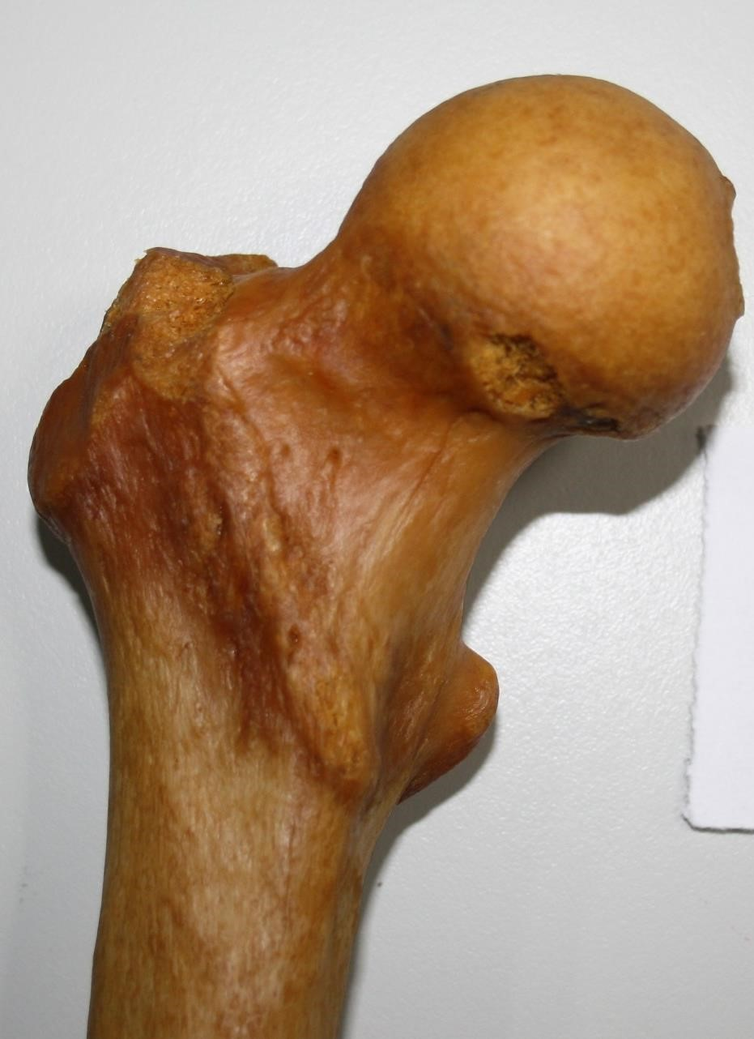

Fig. 21. Proximal epiphysis, right femur, anterior face; length of the proximal epiphysis: 7.9 cm.

The length of the proximal epiphysis of the right femur was between 6.60-10.50 cm, and the length of the left femur was between 7.0-11.60 cm.
Length of the femur: I found it between 34.20-48.30 cm.

Chart no. 2. The length of the femur.
At the level of the right femur, the length was found to be between 38.40-47.20 cm, and at the level of the left femur, the length was between 34.20-48.30 cm.
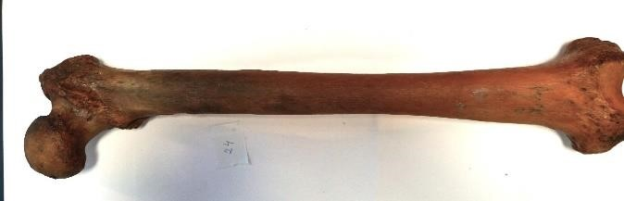

Fig. 24. The length of the left femur is 44.28 cm; length of the proximal epiphysis of the femur: 9.30 cm; The ratio of proximal epiphysis length to femur length is 21.0%.
Femoral head circumference
She was followed on 113 cases, 51 right femurs (45.13% of cases) and 62 left femurs (54.87% of cases), finding her between 12.20-16.40 cm
The length of the circumference of the right femoral head was found to be between 13.50-16.10 cm, and the length of the circumference of the left femoral head was between 12.20-16.40 cm.
The vertical diameter of the femoral head was measured from the level of the upper part of the head to the level of the lower part of it. I found it between 3.30-8.20 cm. The vertical diameter of the right femoral head was found between 4.10-8.10 cm, and the vertical diameter of the left femoral head was between 3.30-8.20 cm.
The horizontal diameter of the femoral head was found to be between 3.90-8.20 cm. The horizontal diameter of the right femoral head was between 4.21-8.20 cm, and the horizontal diameter of the left femoral head was between 3.90-8.20 cm.
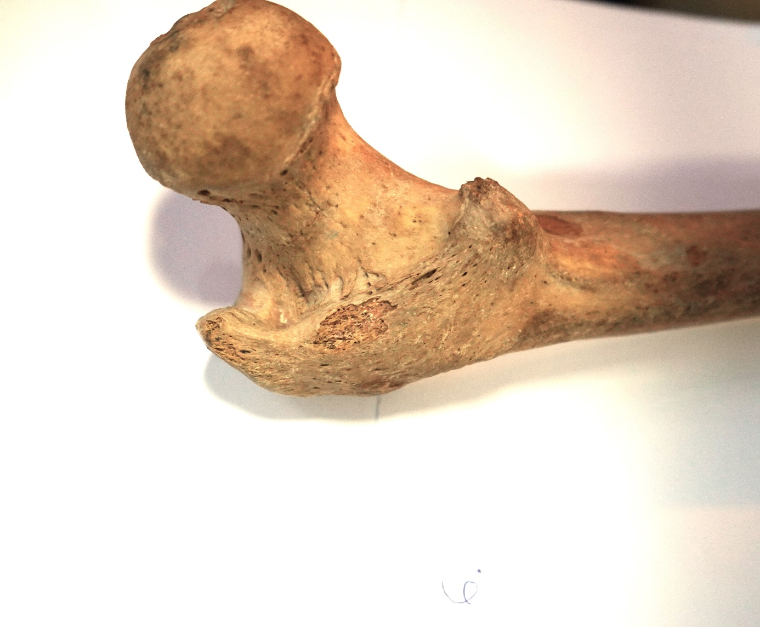
Fig. 29. Proximal epiphysis of the left femur. The femoral head has a circumference of 15.40 cm; the vertical diameter is 6.0 cm, and the horizontal diameter is 7.0 cm.
Femoral head fossa
We followed it in terms of diameters (vertical and horizontal), distance from the edges of the femoral head and the shape it presented.
The vertical diameter of the fissure was between 0.70-1.80 cm, at the level of the right femur I found it between 0.90-1.80 cm, and at the level of the left femur between 0.70-1.61 cm. The horizontal diameter of the fissure was between 0.60-2.11 cm, at the level of the right femur I found it between 0.71-1.80 cm, and at the level of the left femur between 0.60-2.11 cm.
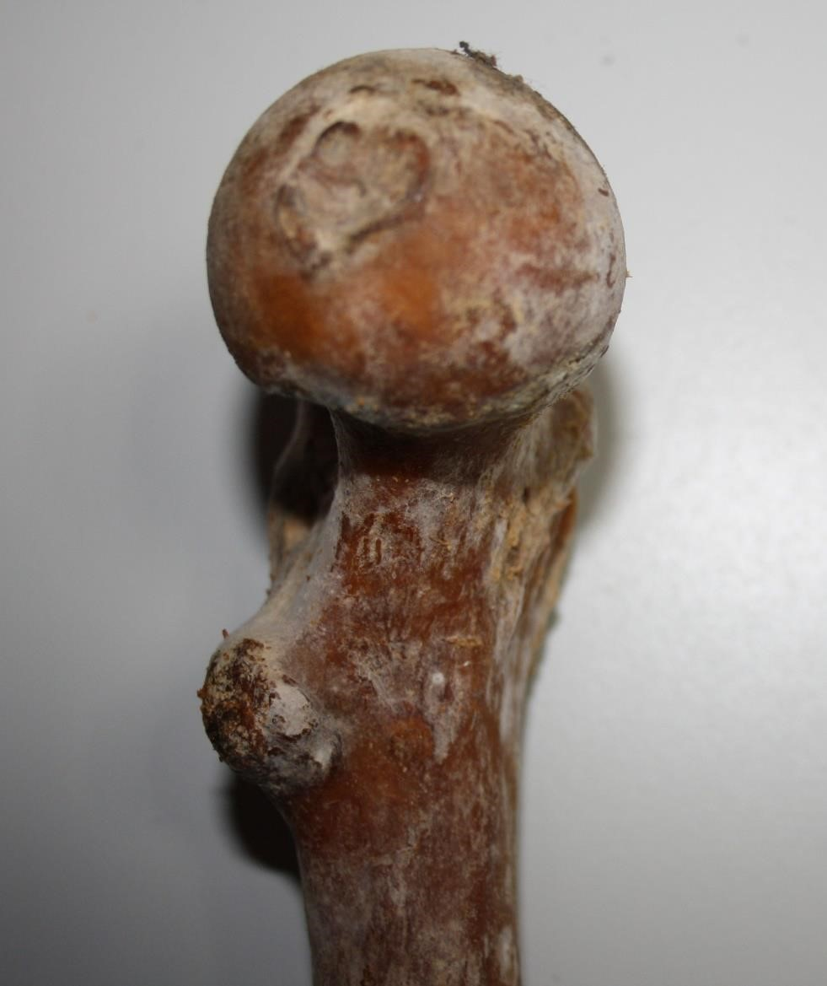

Fig. 31. Left femur. The femoral head fossa is heart-shaped; vertical diameter: 1.4 cm; horizontal diameter: 1.2 cm; distance from the upper circumference: 4.2 cm; Distance from the lower circumference:
1.9 cm; distance from the anterior circumference: 3.1 cm; distance from the posterior circumference: 3.6 cm.

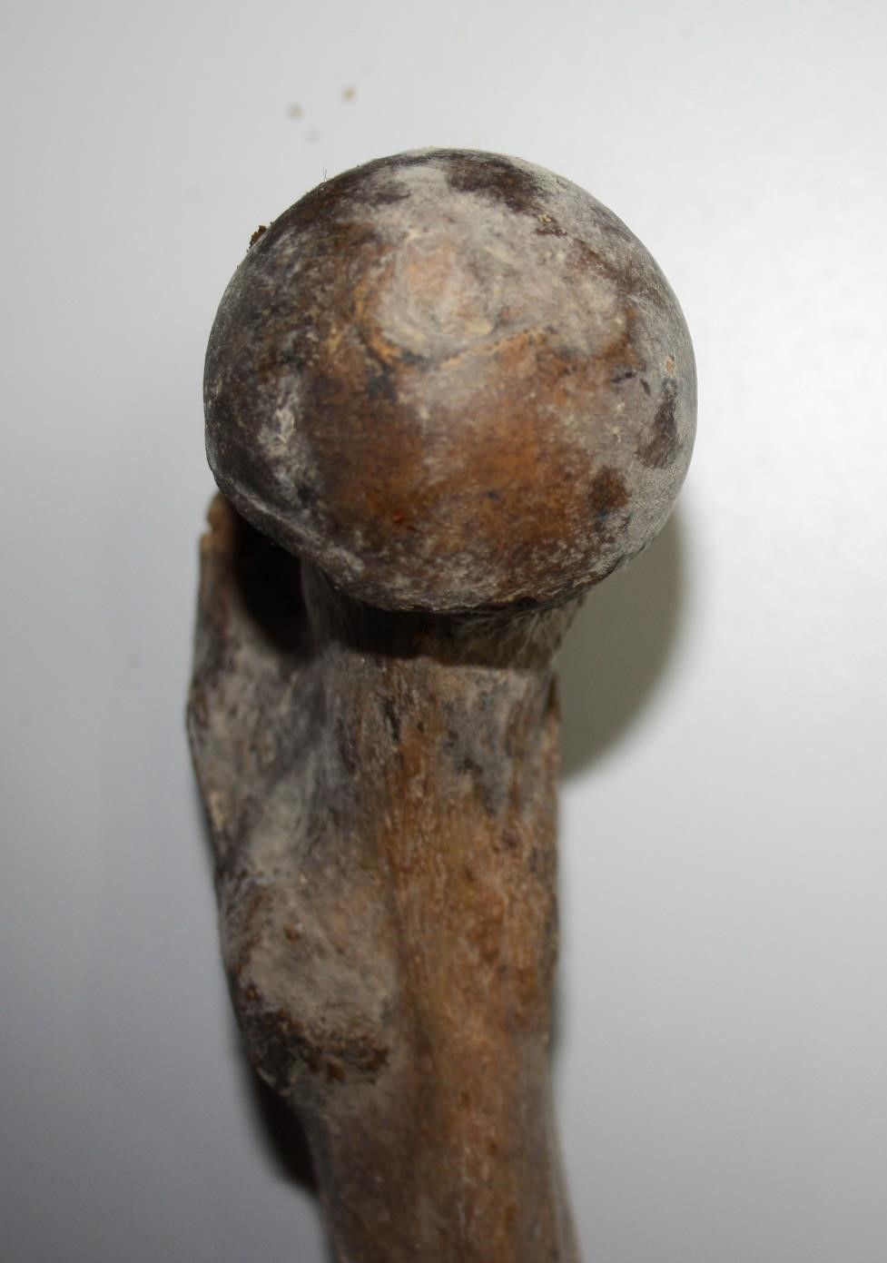

Fig. 33. Right femur. The femoral head fossa is round, with a diameter of 1.3 cm; the distance of the bristle from the upper circumference is 3.8 cm; of the lower circumference of 2.8 cm; of the anterior circumference of 3.2 cm; with a posterior circumference of 2.9 cm.
Anatomical neck
The length of the anterior aspect of the anatomical neck was measured between the middle of the anterior part of the circumference of the femoral head and the medial aspect of the greater trochanter. I found it between 2.12-4.50 cm, at the level of the right femur it was between 2.20-4.32 cm, and at the level of the left femur between 2.12-4.50 cm.
.

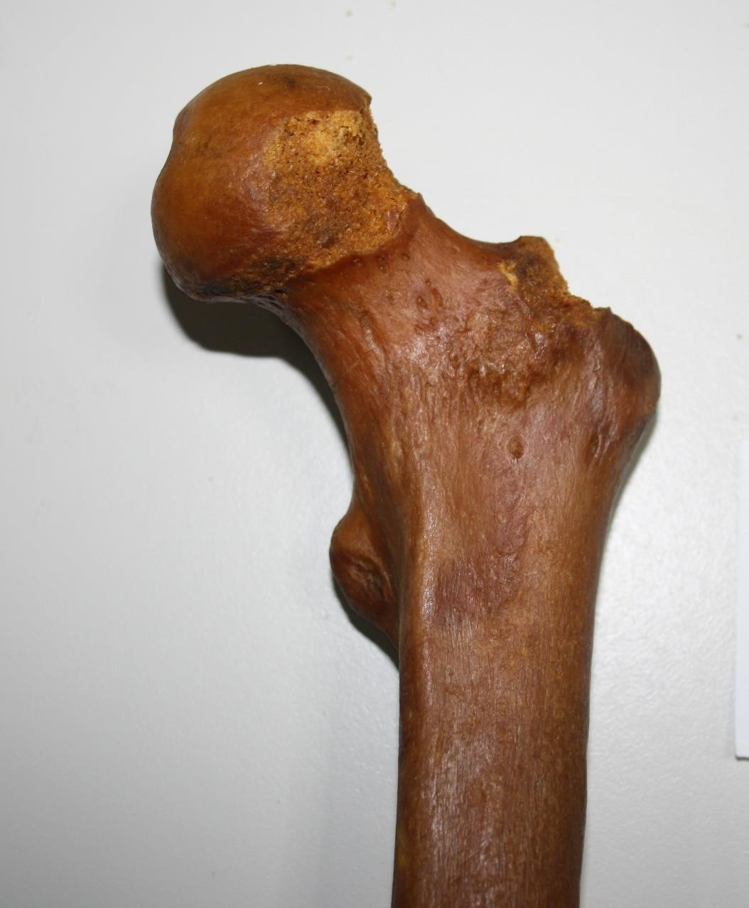

Fig. 36. Left femur, anterior face; length of the front of the anatomical neck: 2.9 cm; medial height of the anatomical neck: 2.90 cm; middle height of the anatomical neck: 3.12 cm; lateral height of the anatomical neck: 3.52 cm; length of the upper edge of the anatomical neck: 2.60 cm; length of the lower edge of the anatomical neck: 3.20 cm.
The length of the posterior aspect of the anatomical neck was between 2.30-4.80 cm, at the level of the right femur it was between 2.42-4.38 cm, and at the level of the left femur between 2.30-4.64 cm.

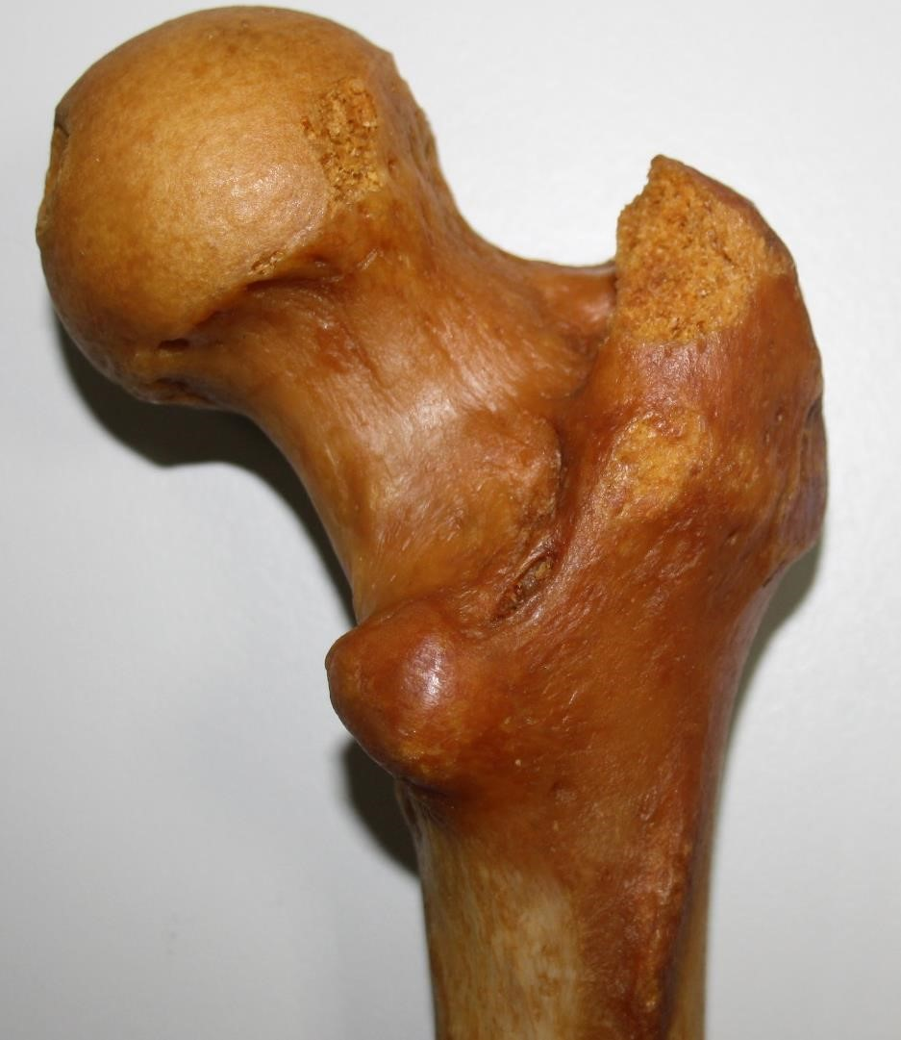

Fig. 37. Proximal epiphysis, right femur, posterior face; Length of the posterior face of the anatomical neck: 3.4 cm.
The medial height of the anatomical neck was between 2.50-3.98 cm, at the level of the right femur it was between 2.50-3.98 cm, and at the level of the left femur between 2.50-3.98 cm
The middle height of the anatomical neck was between 2.72-4.05 cm, at the level of the right femur, it was between 3.0-3.80 cm, and at the level of the left femur between 2.72-4.05 cm.
The lateral height of the anatomical neck was between 2.80-5.51 cm, at the level of the right femur it was between 2.50-3.98 cm, and at the level of the left femur between 2.50-3.98 cm.
The medial thickness of the anatomical neck was found to be between 2.10-4.85 cm, at the level of the right femur, the medial thickness was between 2.55-3.30 cm, and at the level of the left femur between 2.10-4.85 cm.
The average thickness of the anatomical neck was between 2.72-4.05 cm, at the level of the right femur it was between 2.22-2.82 cm, and at the level of the left femur between 2.08-3.67 cm.
The lateral thickness of the anatomical neck was between 2.02-4.26 cm, at the level of the right femur it was between 2.40-4.11 cm, and at the level of the left femur between 2.02-4.26 cm.
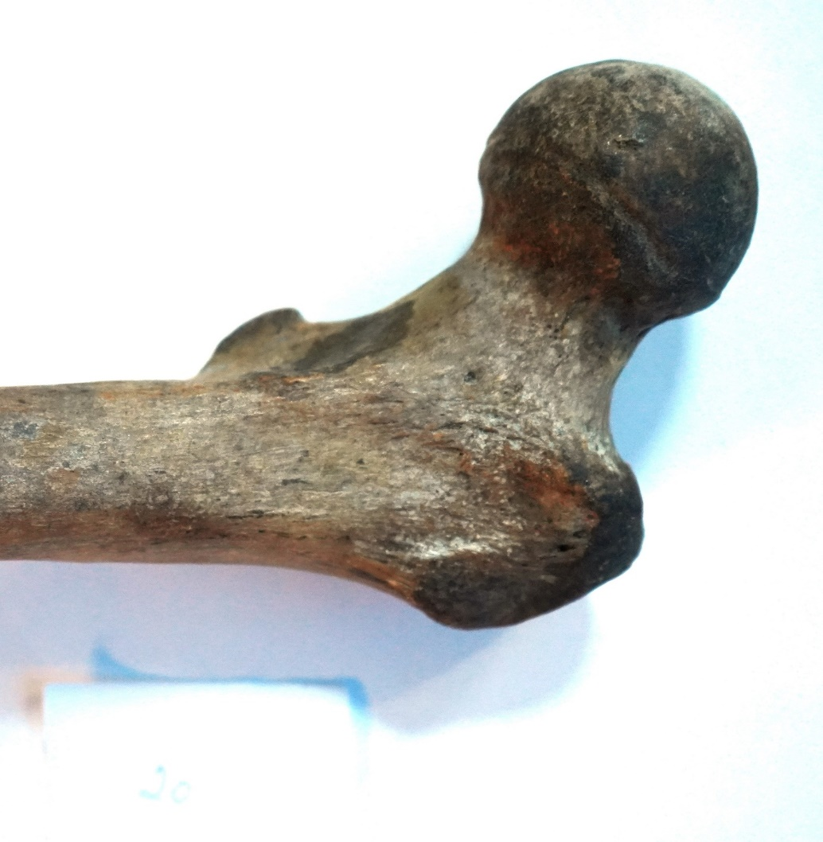
39. Left femur-anterior face. Medial thickness of the anatomical neck: 2.42 cm; average thickness: 2.20 cm; Lateral thickness: 3.35 cm; Inclination angle: 124.5º; Margin angle of the large trochanter neck-axis: 85.8º; Angle of the col-interchanteric line: 109.3º; angle of the middle col-axis of the height of the neck: 90º ; declination angle: 30.0º; the trochanter axis with the axis of the neck forms an angle of 81.0o.
The Great Trochanter
The length of the lateral face was between 3.31-5.40 cm, at the level of the right trochanter it was between 3.92-5.10 cm, and at the level of the left trochanter between 3.31-5.40 cm.
The width of the lateral face of the large trochanter was found to be between 2.22-5.0 cm, at the level of the right trochanter the width was between 2.65-5.0 cm, and at the level of the left trochanter between 2.22-4.50 cm
The upper edge of the large trochanter was found to be between 2.30-4.23 cm, the lower edge was 2.21-4.50 cm long, the front edge was 2.60-4.45 cm long, and the rear edge was 2.50-5.20 cm long.

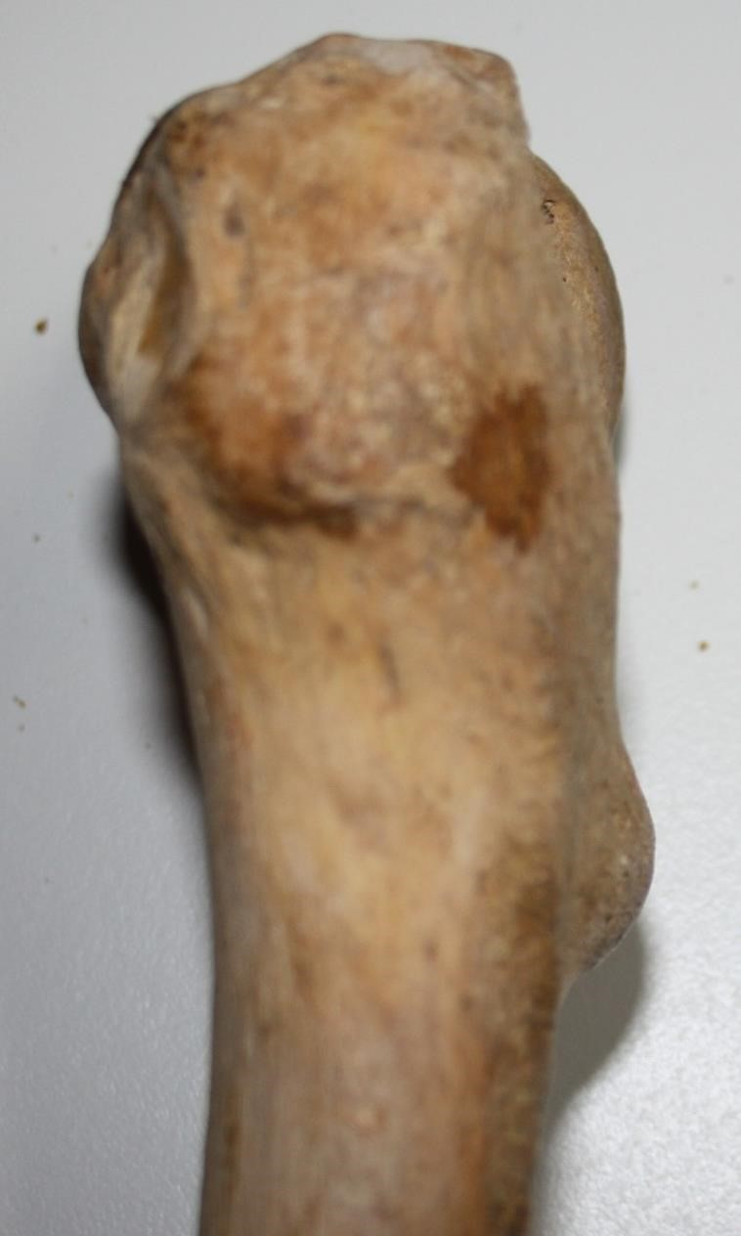

Fig. 40. Left femur, lateral aspect of the large trochanter; the vertical diameter is 4.74 cm, and the horizontal diameter is 3.35 cm; the upper edge is 3.0 cm; lower edge 3.32 cm; posterior edge 5.2 cm; the crest of the middle gluteum is oblique supero-inferior and postero-anterior; It has a length of 3.9 cm.
The trochanteric fossa had a vertical diameter between 0.65-2.0 cm, at the level of the right femur it had a vertical diameter between 0.65-1.92 cm, and at the level of the left femur it had a vertical diameter between 0.90-2.0 cm. The horizontal diameter of the trochanteric fissure had a diameter between 0.64-1.80 cm, at the level of the right femur the diameter was between 0.70-1.80 cm, and at the level of the left femur between 0.64-1.30 cm.

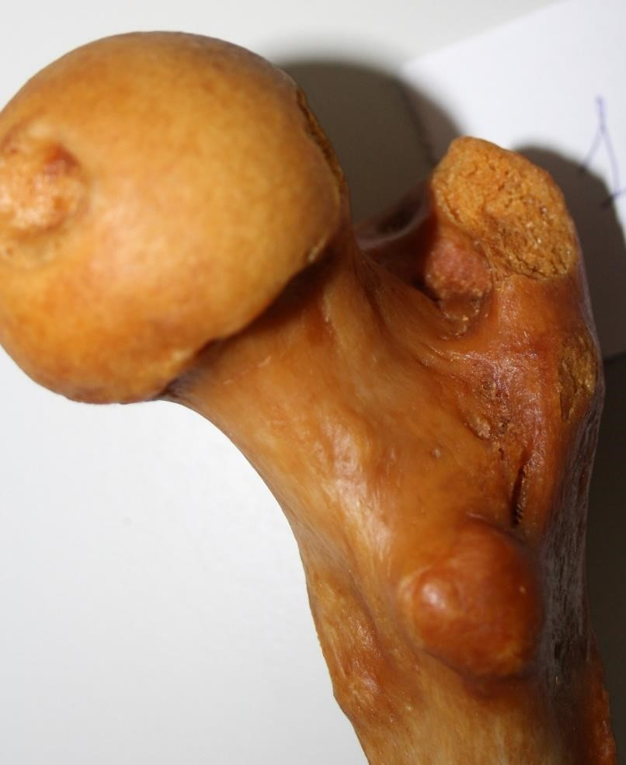

Fig. 45. Right femur; the large trochanter pit is oval with a large vertical shaft of 2.2 cm; the horizontal diameter is 1.2 cm; the small trochanter is oval with a large vertical shaft of 2.3 cm; The horizontal diameter is 1.7 cm.
The crest of the gluteus medius on the lateral aspect of the greater trochanter is oriented supero-inferior and postero-anterior, most frequently, without touching the posterior and anterior edges. It was oblique in 84% of cases, being almost horizontal in the rest of the cases, in 29% of cases it is located closer to its lower edge of the trochanter.
The intertrochanteric line had a length between 1.80-5.40 cm, at the level of the right femur the length of the intertrochanteric line was between 1.80-5.0 cm, and at the level of the left femur the length was between 2.20-5.40 cm.
The intertrochanteric crest had a length between 1.20-11.0 cm, at the level of the right femur it was between 1.49-11.0 cm, and at the level of the left femur between 1.20-11.0 cm.

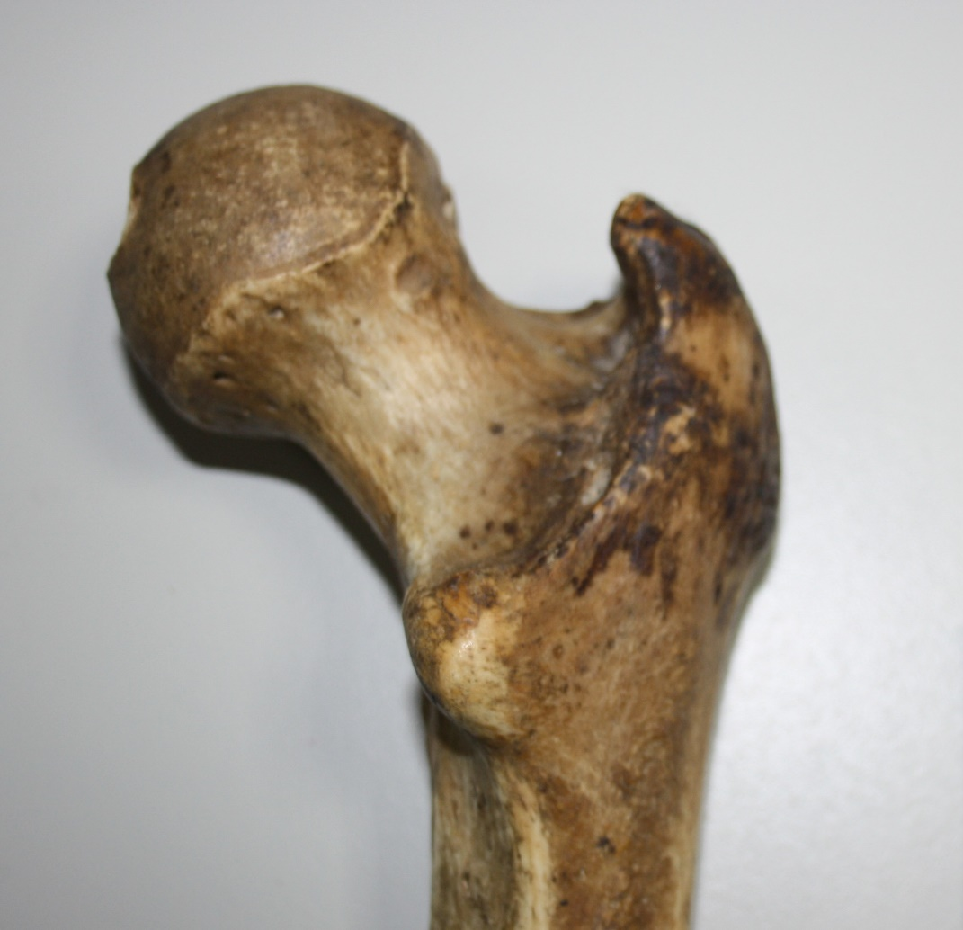
Fig. 48. Right femur, posterior face; length of interchanteric crest: 3.15 cm; width: 0.2-0.5 cm; circumference of surgical neck: 7.8 cm; height of large trochanter: 5.1 cm; lower edge of large trochanter: 3.8 cm.
The small trochanter had a vertical diameter between 1.0-2.80 cm, at the level of the right femur it was between 1.0-2.12 cm, and at the level of the left femur between 1.0-2.80 cm. The horizontal diameter of the small trochanter was between 0.60-1.85 cm, at the level of the right femur it was between 0.92-1.85 cm, and at the level of the left femur between 0.60-1.85 cm. The shape of the small trochanter was found in 77.78% of the cases, being oval with a large vertical axis, round in 15.74% of cases and oval with a large horizontal axis in 6.48% of cases.

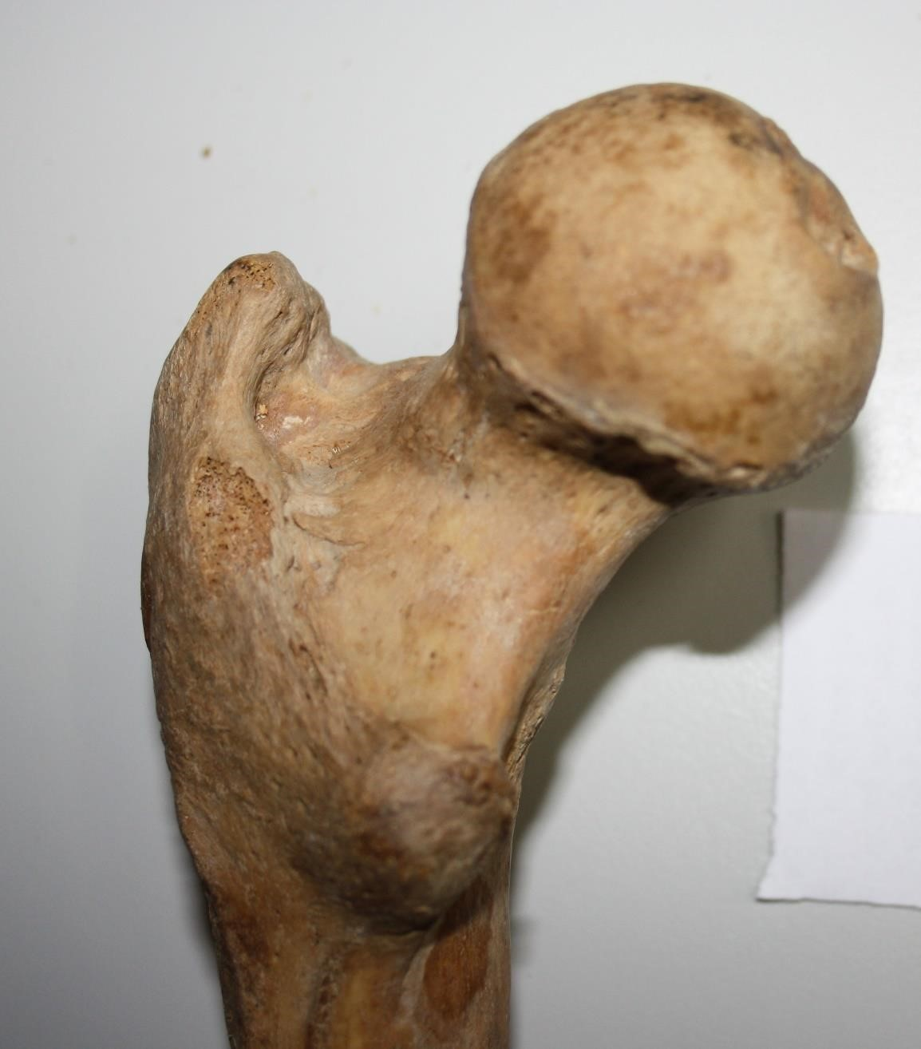

Fig. 51. Left femur. Small oval trochanter, with a large vertical shaft of 1.95 cm; horizontal diameter of 1.80 cm; triangular trochanteric pit with a horizontal diameter of 1.8 cm and a vertical diameter of 2.1 cm.
The surgical neck of the femur had a circumference between 8.60-11.80 cm, the right femur had a circumference between 8.70-11.80 cm, and the left femur between 8.60-11.50 cm.
Angles of the proximal epiphysis of the femur
I found the angle of inclination to be between 113-153.1ª, at the level of the right femur being between 115.1-153.1ª, again at the level of the left femur the angle of inclination was between 113-152.2ª.
- Declination angle is between 18:3 and 33:80ª, at the level of the right femur being between 18.30-33.80º, and^{O} at the level of the left femur, between 18.30-31.0º.

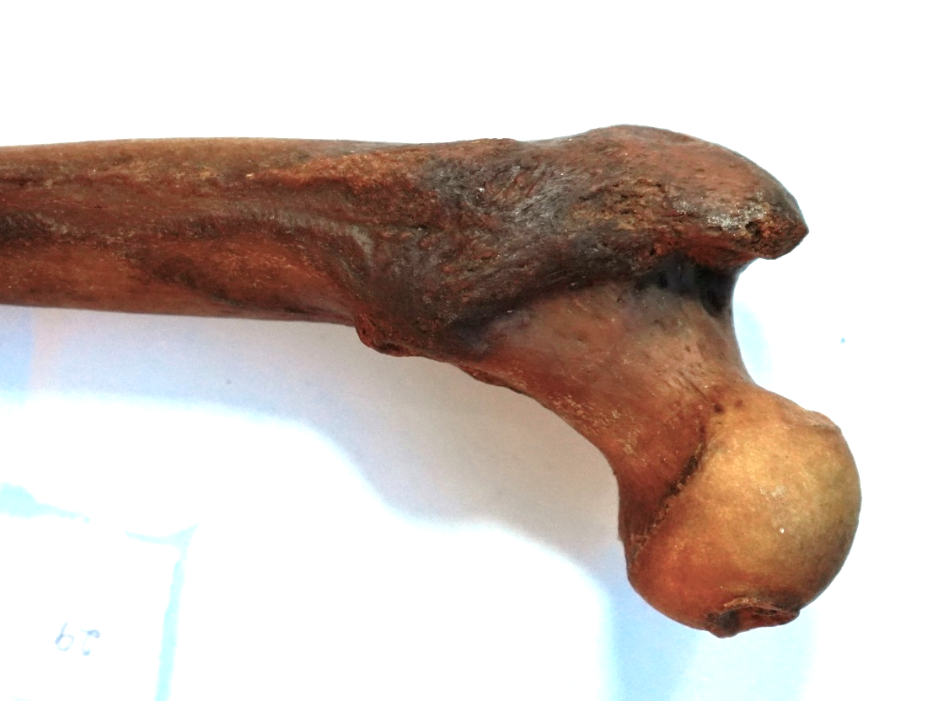
Fig. 52. Right femur-posterior face. Inclination angle: 134.0º; margin angle of the large trochanter neck-axis: 82.4º; angle of the col-interchanteric crest axis: 64.5^{o; angle of the} middle col-axis of the height of the neck: 77.7º; declination angle: 41.5º; the large trochanter axis with the col axis forms an angle of 82.1o.
Frequency of fractures. In my study, conducted between December 2016 and December 2019, I found 140 cases of fractures of the upper extremity of the femur, being cephalic fractures, femoral neck fractures and trochanteric fractures.
Type of fracture | Number | Percentage (%)
femoral neck fractures | 37 cases | 26,43
Trochanteric fractures | 100 cases | 71.43
fractures of the upper femoral shaft | 3 cases | 2.14
Total | 140 cases | 100
Table I: Percentage of different types of fractures of the upper extremity of the femur.
2. Age.
Age | <59 years old | 60-74 years old | 75-89 years old | >90 years old
Femoral fractures | 9 | 14 | 12 | 2
Trochanterian fractures | 26 | 31 | 38 | 5
upper shaft fractures | 3 | 0 | 0 | 0
Table II. Age group for patients with various fractures of the upper extremity of the femur.
3. Gender: in my series for femoral neck fractures I noticed a predominance of females, 20 women compared to 17 men, with a sex ratio of 1.17% for females.
4. Consultation period
- 26.42% of patients consulted the doctor within >5 days; 18.57% in <6 hours; 17.14% in a delay of 24h-5 days; 12.14% in <24h.
Consultation time was not specified in 36 of the patients.
5. The circumstances of the occurrence of fractures. In my series, the circumstances of the fractures were as follows:
- Femoral neck fractures:
• falls: 31 cases (83.78%);
• AVP: 5 cases (13.51%);
• accidents at work: 1 case (2.70%).
PATIENTS
Case 1. A 79-year-old patient with a femoral neck fracture, according to the classification of PAUWELS type II and the classification of GARDEN type IV. The patient had arterial fibrillation and hypertension.
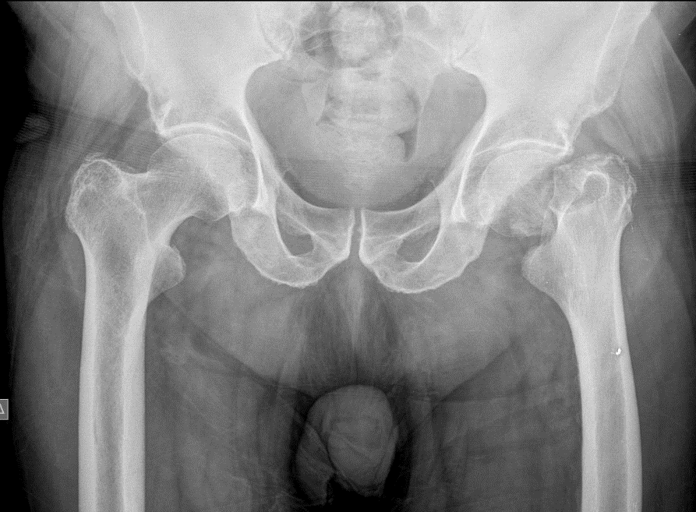
Fig. 57.
Result
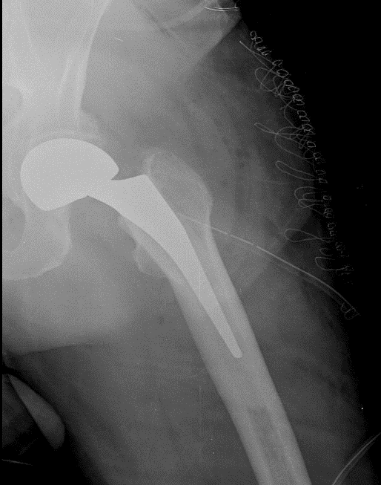
Fig. 58. Femoral neck surgical treatment: femoral hip hemiarthoplasty.
Case 2. An 81-year-old patient with a femoral neck fracture, according to the PAUWELS classification of type I and the GARDEN classification, type III. The patient had arterial fibrillation, hypertension, diabetes.
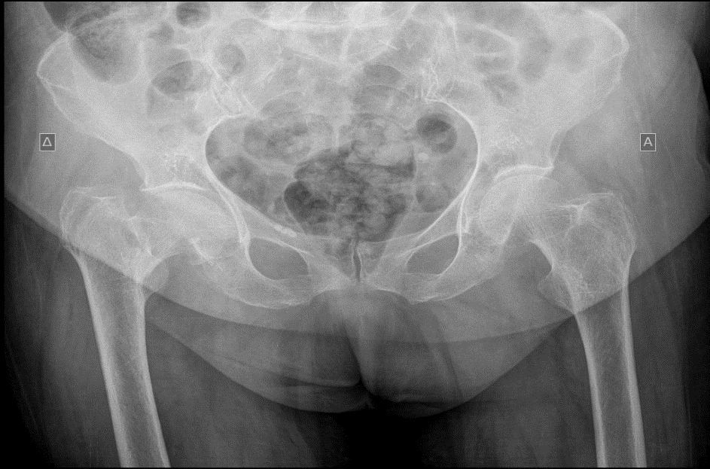
Fig. 59.
Result.
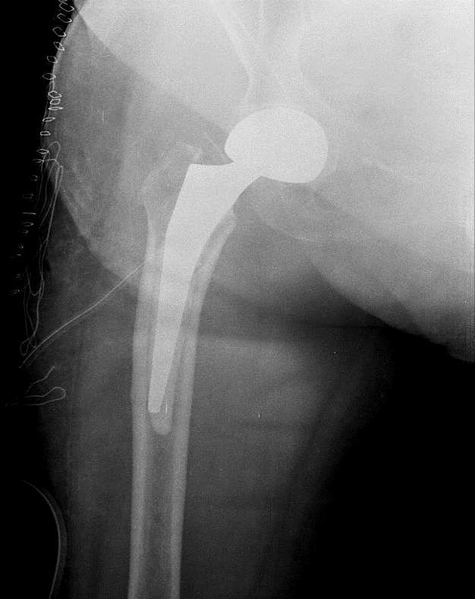
Fig. 60. Treatment: hemiarthoplasty of the bipolar femoral hip with cement.
Case 3. An 83-year-old patient with a femoral neck fracture, according to the classification of PAUWELS type I and the classification of GARDEN type I. The patient had hypertension.
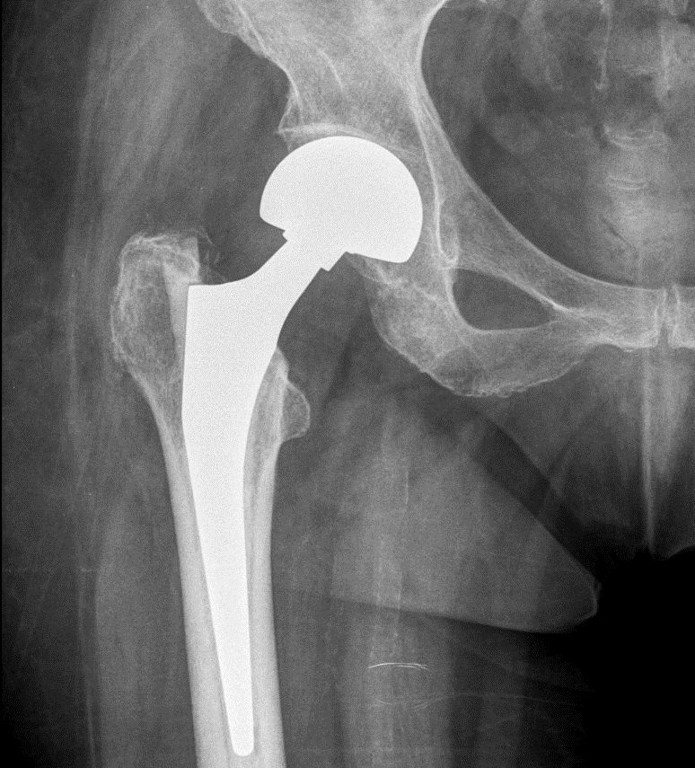
Fig. 61.
Result.
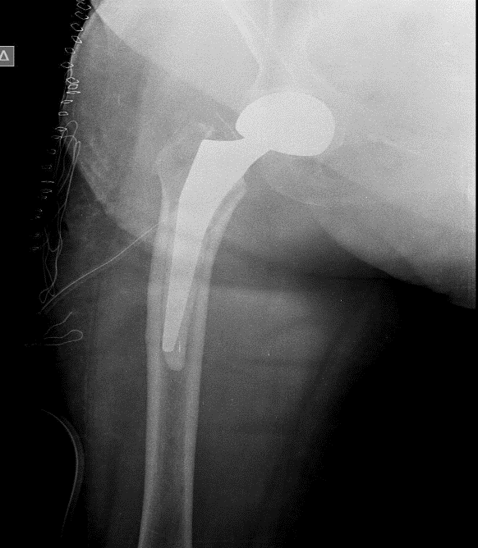
Fig. 62. Treatment: hemiarthoplasty of the bipolar femoral hip with cement.
Case 4. Patient 60 years old with femoral neck fracture, according to the classification of PAUWELS type I and according to the classification of GARDEN type I.
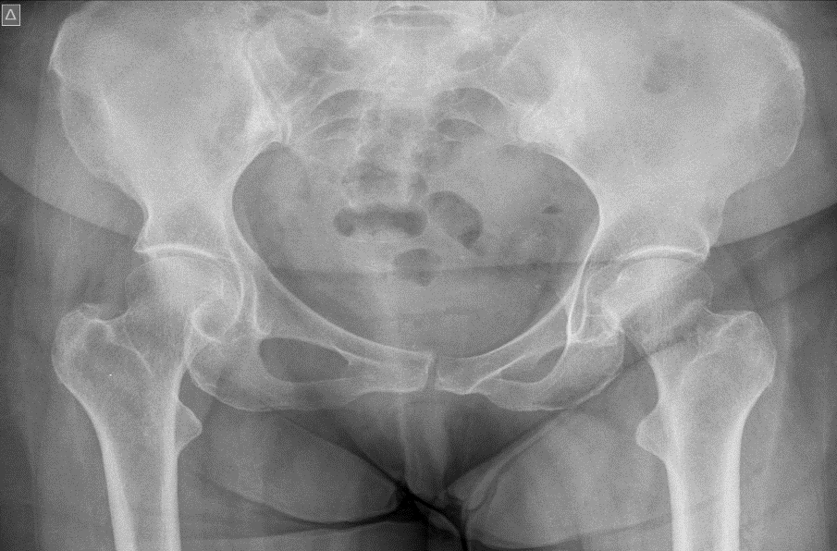
Fig. 63.
Result.
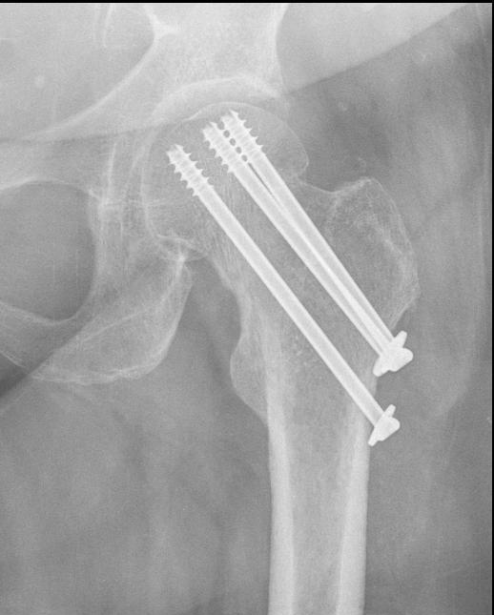
Fig. 64. Surgical treatment: internal fixation with 3 cannulated screws.
Causes of trochanteric fractures:
• falls: 71 cases (71%);
• AVP: 25 cases (25%);
• attacks: 2 cases (2%);
• sports accidents: 1 case (1%);
• accidents at work: 1 case (1%).
Cause of femoral shaft fractures:
• AVP: 2 cases (66.67%);
• road accident: 1 case (33.33%).
In the case of femoral neck fracture, the right side was affected in 22 cases and the left side in 15 cases, which corresponds to 59.5% and 40.5%, respectively.
In the trochanteric fracture, the involvement of the right side was observed in 49 cases and that of the left side in 51 cases, which corresponds to 49% and 51%, respectively.
As for the fracture of the femoral head, we found it on the left side in 2 cases, and on the right side in only one case, which corresponds to 66.67% and 33.34%, respectively.
Patients in the study:
- 78-year-old patient with trochanteric fracture; by EVANS classification is
stable fracture and after AO Trochanteric fractures, pertrochanterian, simple; Conditions: hypertension.
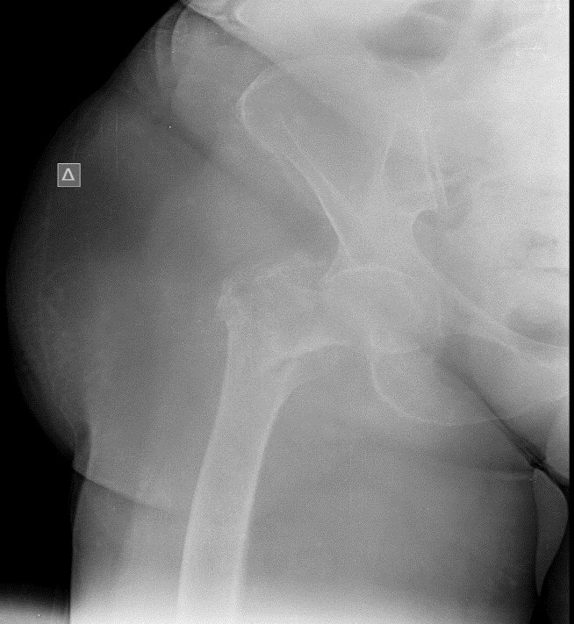
Fig. 65.
Result
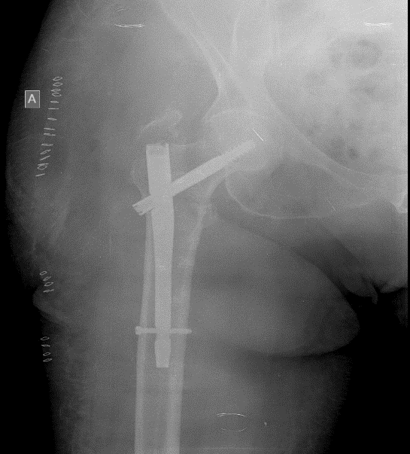
Fig. 66. Treatment: surgery with gamma nail system.
- 86-year-old patient with peritrochanteric fracture; by EVANS classification
the fracture is stable and after AO trochanteric fracture (simple pertrochanteric); Conditions: hypertension, arterial fibrillation.
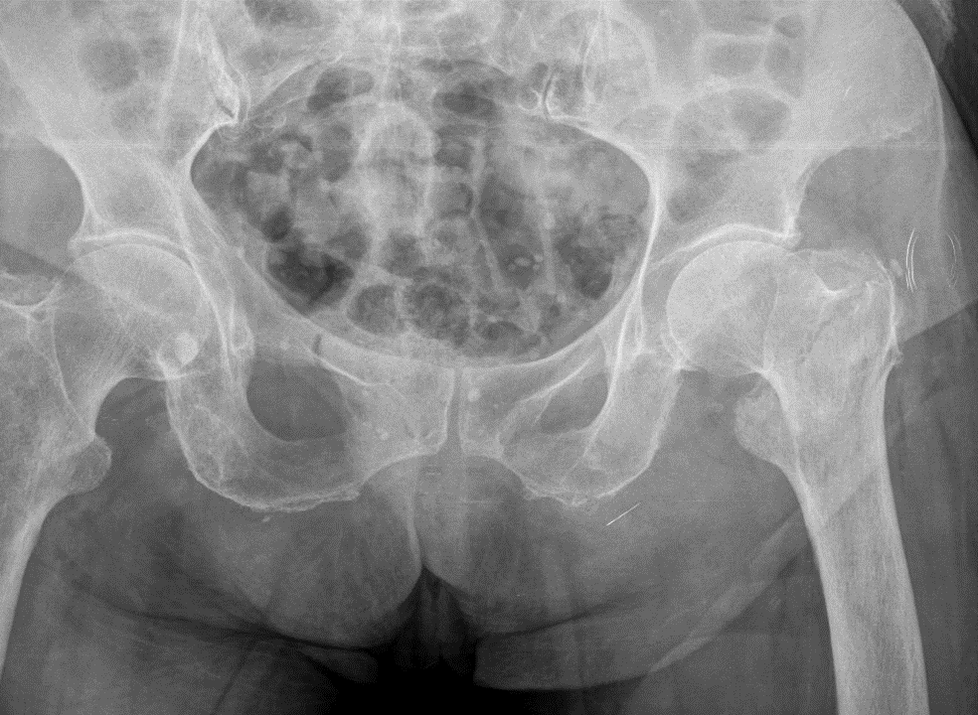
Fig. 67.
Result
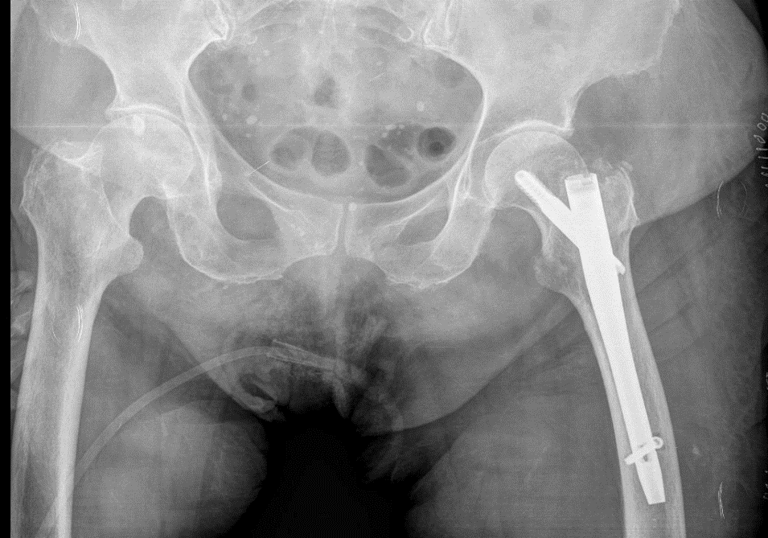
Fig. 68. Treatment: surgery.

The risk factors were:
- cardiovascular diseases: hypertension (17 cases) and heart disease (7 cases);
- metabolic diseases: diabetes (23 cases);
- neurological diseases: Alzheimer's (1 case) and dementia (1 case);
- bronchopulmonary diseases: asthma (4 cases) and tuberculosis (2 cases).
We found that 39.28% of the patients had other conditions.
- Fracture features:
Femoral neck fractures: we adopted the GARDEN classification to stage anatomical lesions and used x-rays of the femoral neck. There is a clear predominance of Garden 4 femoral neck fracture, with a percentage of 67.5%.
TYPE | Type No. of Cases | Percentage
GARDEN 1 | 2 | 5,4%
GARDEN 2 | 3 | 8,1%
GARDEN 3 | 7 | 19%
GARDEN 4 | 25 | 67,5%
Table V. Distribution of fractures according to the GARDEN classification.
Depending on the age of the patients, we found that after the age of 60 there is a higher frequency in the occurrence of the fracture type GARDEN 4
Time between trauma and intervention: in my study it ranges from 2-124 days, with an average of 63 days.
Type of anesthesia. In my series, 130 cases were operated under spinal anesthesia (90%), and 10 cases were operated under general anesthesia (10%).
4. Surgery.
Therapeutic means infemoral neck fractures
The type of treatment depends on the patient's age, Garden classification, and the condition of the femoral head.
 | G1 | G2 | G3 | G4
THR | 0 | 0 | 1 | 1
BIPOLAR | 0 | 3 | 5 | 21
SCREWS | 2 | 1 | 0 | 0
DHS | 0 | 0 | 0 | 0
Table VIII: Type of treatment used in femoral neck fractures
Trochanteric fractures: type of intervention used in trochanteric fractures: in my series was the predominant use of the standard gamma screw (in 75% of cases) and the long gamma screw (in 25% of cases).
Fractures of the femoral diaphysis: 2 of my patients benefited from orthopedic treatment with antegrade intramedullary screw, and 1 patient was treated with intramedullary screw.
Length of hospitalization: The average length of hospital stay was about 22 days, with extremes ranging from one day to 44 days.
Early complications:
- Local complications:
- mechanical complications: in my series I did not write down any cases;
- Infectious complications: We noticed 3 cases of skin infections treated by washing, surgery, bacteriological samples and antibiotic therapy adapted to the germ found.
- general complications: following the study, we noted:
- 1 case of deep vein thrombosis;
- 1 case of temporal-spatial confusion;
- 1 case of functional intestinal obstruction;
- 1 case of peripheral neurogenic syndrome.
Mortality: in my patient series there were 2 deaths.
Functional results.
The functional results were evaluated in 110 patients, 27 patients were not monitored.
Results | Number of cases | Percentage (%)
Excellent/good  Medium  Bad | 85  18  7 | 77.2  16.4  6.4
Total | 110 | 100
Table IX. Functional results according to the Merle d'Aubigne method.
DISCUSSIONS
Comparing Right/Left length of the proximal epiphysis of the femur, we found that the minimum value of this was higher in the left femur by 0.40 cm. The maximum value was also higher in the left femur by 0.90 cm, and the mean value was higher in the right femur by 0.18 cm.
Vertical diameter of the femoral head had a minimum value higher by 0.80 cm at the level of the right femur. At the level of the left femur, the maximum value of the vertical diameter was higher by 0.10 cm, and the mean value was higher by 0.21 cm. Horizontal diameter of the femoral head had a minimum value higher by 0.31 cm at the level of the right femur. The maximum value of the horizontal diameter was equal in both femurs. At the level of the left femur, the mean value of the horizontal diameter was 0.22 cm higher.
The morphometric differences between the vertical and horizontal diameters of the femoral head are due to the fact that the circumference of the femoral head presents continuous rectilinear convexities between the portions (more frequently), extending on the surfaces of the neck and concavities, which distance it from the faces of the neck.
In the literature consulted I did not find the value of the vertical and horizontal diameters specified separately, giving only one value (probably, the average one), I comparing the average values of the horizontal diameter with the data in the literature. I also did not find a distinction between the right and the left diameter.
Author | Diameter value/cm
Mokrovic | 3,88
Rawal | 4,54
Unnanuntana | 5,21
Mite | 4,71
Ruby | 4,34
Cho | 4,55
Gently | 4,54
Vegrzyn | 4,50
Minakshi | 4,23; dr:4.21; ST: 4.25
Baharuddin | 4,08
Shoulder | 5,01
Mahaisavarya | 4,40
Personal results | 5,32; DR: 5.21; STG: 5,43
Table X. The diameter of the femoral head found by me compared to the data in the literature.
The femoral head ridge had the same minimum vertical diameter length in both femurs; the maximum length was 0.19 cm shorter in the left femur; the average length of this diameter was 0.21 cm shorter in the right femur. The minimum length of the horizontal diameter was less than 0.31 cm at the level of the left femur, the maximum length being equal at both femurs; The average length of this diameter was 0.22 cm shorter at the level of the left femur. As particular forms of the fissures of the femoral head, at the level of the right femur we have encountered the oval shapes with the large vertical axis and the reniform appearance. At the level of the left femur we met the oval shape with the large anteroposterior axis and the heart shape.
Anatomical neck: at the level of the anterior face, the anatomical neck has the minimum value of length lower at the level of the left femur by 0.8 mm; the maximum value is lower at the level of the right femur by 0.18 cm, the mean value being lower at the level of the right femur by 0.6 cm. The height of the anterior aspect of the anatomical neck has a minimum value lower at the level of the left femur by 0.1 mm; the maximum value is also lower at the level of the left femur by 0.2 cm, the mean value being lower at the level of the right femur by 0.03 cm. The height of the posterior aspect of the anatomical neck had a minimum value lower at the level of the left femur by 0.12 mm; the maximum value was also lower at the level of the left femur by 0.26 cm, the mean value being lower at the level of the right femur by 0.10 cm.
In the literature we consulted, there are no differences between the anterior and posterior lengths of the femoral neck, I found differences, the average lengths being lower at the level of the anterior aspect of the right femur by 0.05 cm.
Author | Length/cm
Mokrovic | 4,43
Rawal | 4,84
Mite | 3,46
Ruby | 4,70
Gently | 4,54
Vegrzyn | 4,43
Minakshi | 4,48; dr:4.47; ST: 4.29
Personal results | 3,25; DR: 3.21; STG: 3.29
Table XI. The length of the femoral anatomical neck found by me compared to the data in the literature.
Considering the thickness of the anatomical neck, we found that a perfectly cylindrical anatomical neck (when the three thickness values are the same) is extremely rare, most frequently the medial thickness of the neck being more voluminous, a situation in which the anatomical neck has the appearance of a cone trunk with a more voluminous extremity located medially. Less often, the lateral extremity of the neck is more voluminous and much less often the middle thickness is more voluminous. In the latter situation and in cases where the middle thickness is the smallest, the anatomical neck has the appearance of two cone trunks joined by the most voluminous extremity (in the first case) or by the less voluminous extremity (in the second case).
Greater trochanter. Compared to the right/left, the supero-inferior length of the lateral aspect of the greater trochanter (height) had a minimum value lower at the level of the left femur by 0.61 cm; the maximum value was lower at the level of the right femur by 0.30 cm, and the mean value was lower by 0.05 cm at the level of the right femur. Compared to the right/left, the width (anteroposterior length) of the lateral aspect of the greater trochanter had a minimum value lower at the level of the left femur by 0.43 cm; the maximum value was also lower at the level of the left femur by 0.50 cm, and the mean value was lower by 0.29 cm at the level of the right femur.
Considering the length and orientation of the lateral face and the edges of the large trochanter, its shape is trapezoidal, varying only the orientation of its large base. In only one case (on the left side) we found the square shape of the large trochanter, in which it presented equal lengths and parallel orientation of the upper/lower and anterior/posterior edges. The greater trochanter fossa had the same bilateral forms (right femur and left femur), varying only the percentages of their presence. Thus, at the level of the right fissure, we most frequently found the oval shape, with a large horizontal axis, and at the level of the left fissure, the most common being the rounded shape.
Lesser trochanter. Compared to the right/left, the vertical diameter (height) of the lesser trochanter had a minimum value lower at the level of the left femur by 0.30 cm; the maximum value was lower at the level of the right femur by 0.68 cm, and the mean value was lower by 0.12 cm at the level of the left femur. Also in the right/left comparison, the horizontal diameter (width) of the lesser trochanter had a minimum value lower at the level of the left femur by 0.32 cm; the maximum value was the same at both femurs, and the mean value was lower by 0.14 cm at the level of the left femur.
[Robacki] finds a height of 1.0 cm.
As for the shape of the lesser trochanter, in the right femur we did not encounter the oval shape with the horizontal major axis, as we detected the other two shapes in both femurs, but in different percentages. Thus, the oval shape with the large vertical axis in the right femur was found in a higher percentage in 14.28% of cases, and the round shape in the left femur in a higher percentage in 3.49% of cases. [Moore] describes it as a conical or rounded shape.
Angles of the upper epiphysis of the femur
Author | Angle value
Rouviѐre | 130°
Gray | 125°
Kamina | 125°
Putz | 126°
Moore | 115-140°
Kenessi | 125-135°
Papilian | 125-130°
B | 125-135°
Mokrovic | 125.34o
Kawal | 124.42o
Unnanuntana | 132.69o
Mite | 129.71o
Ruby | 122,90o
Husmann | 129.20o
Reikeras | 127,70o
Cho | 130.27o
Gently | 129.88o
Minakshi | 128,90o
Baharuddin | 130.46o
Shoulder | 130th
Mahaisavarya | 128,40o
Gillighan | 127.0o
Vegrzyn | 126.0o
Bordei | 125-130o
Robacki | 125-130o
Personal results | 116.20-143.20o; average: 129.86°
Table XII. The value of the angle of inclination found by me compared to the data in the literature.

Author | Angle value
Gray | 10-15°
Kamina | 15°
Kenessi | 20°
Papilian | 12°
B | 15-25°
Mokrovic | 16.53o
Rawal | 10.9o
Gently | 21.58o
Reikeras | 10.40o
Personal results | 18,30-33,80°; Average: 22.56o
Table XIII. The value of the declension angle found by me compared to the data in the literature.
During the study period, there was a predominance of trochanteric fractures in relation to femoral neck fractures (more frequent by 45.0%) and in relation to femoral shaft fractures (more frequent by 69.29%).
In the specialized literature, there is a predominance of the female sex, which I also found in the series I watched. Fractures of the upper extremity of the femur are more frequent in females, occurring in 74 cases (52.86% of cases), compared to males in 66 cases (47.14% of cases), with a difference of 5.72% in favour of the female sex. Femoral neck fractures are 4.10% more common in women than men, and trochanteric fractures are 8.0% more common in women.
According to [Salthzer], in the Netherlands, women were operated on for a hip fracture 1.5-2 times more often than men in the same age group. The female predominance is explained by postmenopausal osteoporosis.
The most affected age group in subjects with fractures of the upper extremity of the femur is between 75-89 years old (50 cases, 35.71% of cases); This is followed by the age groups 60-74 years old (45 cases, 32.14% of cases), younger than 59 years old (38 cases, 27.14% of cases) and over 90 years old (7 cases, 5.0% of cases).
The most affected age group in subjects with femoral neck fractures is 60-74 years old. For trochanteric fractures, the age varies between 75-89 years. In the case of femoral shaft fractures, all patients belonged to the young age group: <59 years [Adams, Hesse, Papasimos, Boldin].
In the literature, the average age at which a femoral neck fracture occurs is 78 years, with extremes of 70 years to 84 years [Barei, Sekeito, Jiang, Somashekar]. This age is significantly higher than that found in my sample, where the most affected age group is between 60 and 74 years old.
In a study of international variations in hip fracture probabilities, Greece was identified as a high-risk country in Europe, along with Germany, Switzerland, Finland, the Netherlands, Hungary, Italy and Portugal. In 2002, 13,611 people over the age of 50 fractured their hips in Greece.
According to [Salthzer], in the Netherlands the absolute average recovery between 1991 and 2004 was linear, with 230 fractures per year. Given the increasing age of the population, the total number of hip fractures operated on can be expected to be 20,200 in 2010 and 23,900 in 2020.
After [Richmond] in the United States, about 250,000 hip fractures occur annually.
[Tjiag] studies mortality within 3 years after surgery. According to him, compared to the general Dutch population of the same age and sex, there was a significant excess of mortality in the 3 years after surgery and especially in the first 12 months.
After [Salthzer], postoperative hospital mortality fell from 8.1% in 1991 to 5.6% in 2004 and was 1.5 times higher for men aged 70 years or older than for women in the same age group.
[Richmond] evaluates the mortality associated with the hip fracture up to 2 years after the injury. According to him, it has been shown that the greatest risk of mortality from a hip fracture is in the first 6 months after the fracture, and some studies report that the risk is close to the expected mortality after 6 months. However, more recent studies have shown that an increased risk of mortality can persist for several years after the fracture. Patients aged 65-84 had a higher risk of mortality compared to patients aged > or =85.
[Smith] consults clinical trials on preoperative predictors of mortality after surgery in hip fracture. Following the meta-analysis, the four key characteristics associated with the risk of mortality up to 12 months were abnormal ECG, cognitive impairment, age >85 years, and pre-fracture mobility.
The etiology of femoral fractures in my series, as well as in that of [Dhanwai, Berry, Mautalen] is predominantly made up of trivial falls (84%), especially in elderly subjects. This can be explained by senile and postmenopausal osteoporosis (in women), decreased physical activity, visual acuity disorder, decreased reflexes [Alswat, Han, Sözen, Patel, Alegre, Pouresmaeili].
A variable incidence is observed in relation to the geographical area, thus explaining the percentage difference in the frequency of fractures between continents, or different countries of the same continent, especially in Europe. Percentage differences can be observed even between the different areas of the same country [Ishii, Rau].

Country | Years of study Incidence
Malaysia | 1996-1997 50
Crete | 1986 100
Spain | 2002 694
Morocco | 2002 48
South Korea | 2002-2006 126,9
Norway | 2004-2005 346-758
Ecuador | 2005 49,5
Lebanon | 2007 147
Iran | 2007 206-214
Greece | 2016 672,2
Athens | 2017 343,9
Personal Results (Naousa) | 2018-2024 20,96
Table XIV. Geographical variation in the incidence of hip fractures per 100,000 inhabitants, according to the Elderly Health Journal 2019.
In my study, carried out in the Naousa region, the frequency of fractures of the upper extremity of the femur, I found it in a percentage of 20.96% of cases, compared to 100,000 inhabitants. This percentage is much lower than in the rest of Greece and in the cases cited in the literature. The low percentage we found would be due to the fact that some patients prefer to be treated in other regions of Greece, especially in Athens, or even at other hospitals in the Naousa region.
Length of hospital stay: In my study, the average length of hospital stay was about 22 days, with extremes ranging from one day to 44 days.
After [Tjiang], the average length of hospital stay was 21 days (range: 2-98 days). The independent pre-operative predictors for a longer period of hospitalization were ADL dependence, home residence, and poor ambulation. The predictors for permanent institutionalization were: previous stay in an institution and the presence of dementia.
After [Salthzer], the average period of pre- and postoperative hospitalization was halved during the period under investigation (1991-2004).

CONCLUSIONS
The study has two structural peculiarities:
- the anatomical part was performed on the femurs in Constanta, Dobrogea, the area where I graduated university as a medical student;
- the clinical part was performed in the northern area of Greece (Noussa), the region where I work as an orthopedist.
Studies on dry femurs are less common in the literature and specific to the relatively large number of cases we have worked on (128 cases), compared to [Reikeras, 48 cases], [Minakshi, 91 cases], [Rawal, 98 cases] and [Lin, 100 cases]. More numerous cases were found in [Wegrzyn, 151 cases], [Unannuntana, 200 cases], [Cho, 202 cases], [Husmann and Mokrovic, 300 cases] and [Acar, 380 cases], but these studies were carried out on radiographs.
Regarding the anatomical part, we found that the right/left asymmetries between the anatomical landmarks of the two femurs are frequent, regarding dimensions (height, width, thickness), shape and trajectory (orientation).
Frequently, the minimum and maximum results were found in a single specimen, most of the results being included in this range.
The morphometric differences between the anatomical landmarks of the anterior and posterior faces of the anatomical neck of the femur are due to the fact that the circumference of the femoral head is not rectilinear, presenting convexities (more frequently), extending on the surfaces of the neck and concavities, which distance it from the faces of the neck. They are also due to the medial and lateral inclinations of the greater trochanter, which is not always in an upright position, as well as the fact that the upper face (edge) of the neck, which can be inclined anteroposteriorly, decreases the height of the posterior face. Another cause of these morphometric differences between the two faces of the anatomical neck would be due to the fact that the two faces are not flat along their entire length, presenting some slightly concave and convex portions. So, the two faces are not parallel to each other.
The frequently large width of the intertrochanteric line leads some authors to call it the anterior intertrochanteric crest.
After consulting the specialized literature, we found population and ethnic differences between the values of the anatomical landmarks. We note the high diversity in the morphology of the proximal femur, not only between racial and ethnic groups, but also according to the geographical regions of the same population. All these concludes that the hip replacement system is specific to each population. For example, hip prostheses based on European data are unsuitable for Asians or Americans. They are compatible when the morphological parameters are similar.
Fractures of the upper extremity of the femur continue to be problematic even these days, not because of their diagnosis, but because of their management. These are fractures whose main causes are falls, especially in the elderly, without forgetting the importance of traffic accidents, especially in young people.
The treatment is surgical, with the objective of early mobilization and the best possible restoration of the functional state prior to the trauma. But this treatment faces problems related in particular to the nature of the fracture and the technique of the intervention. At the end of this study, I would like to make some important clarifications:
- the frequency of fractures is increasing more and more, hence the importance of their prevention;
- the need for osteoporosis treatment;
- the obligation of early intervention;
- the importance of post-operative follow-up.
Arthroplasty seems to have advantages, if a rigorous technique is followed, and deserves a place of honour in the vast therapeutic methodology of fractures of the upper extremity of the femur, especially in the elderly.
Osteosynthesis is a fairly simple technique and currently constitutes an enormous therapeutic progress.
This study highlighted the delay in consultations for femoral fracture, facts that highlight the need for effective emergency management. For trochanteric fractures, external surgical approaches were preferred, the standard gamma nail, in femoral neck fractures GARDEN IV deprived bipolar treatment. The "excellent/good" functional results reflect the success of the surgeries, and the high frequency of anatomical reductions emphasizes the attention paid to the quality of the procedures.
The incidence in the same age range is higher in women, but men have a higher hospital mortality. It is estimated that the decrease in hospital mortality and the decrease in the length of hospitalization will increase the need for nursing home care for this category of patients. According to Salthzer, in 2004, compared to 1991, there were 2.5 times more patients admitted to a nursing home.
This review identified the characteristics of patients at high risk of mortality after hip fracture surgery beyond the perioperative period who may benefit from appropriate assessment and management. I consider that my study is an important guide for the morphologist, but also for the orthopedic surgeon.
ORIGINALITY OF THE THESIS
It is the only complete study of fractures of the upper extremity of the femur performed at the level of this hospital in the Naousa region.
Description of the morphology of the anatomical landmarks of the upper extremity of the femur on dry femurs existing in the anatomy laboratory of the Faculty of Medicine in Constanta and of the clinical cases existing at the hospital in Naousa.
First of all, it is worth mentioning the large number of personal cases on which the study on femoral morphology was performed (128 dry femurs), compared to other studies in the literature. This allowed to make a comparison of the anatomical landmarks followed with those already described in specialized literature. More than this, the cases I studied can now be used by other authors as a comparison to the cases they analyse.
The results obtained in my study are presented according to the sex of the subjects and comparatively right/left, aspects rarely encountered in the literature or even not reported by most of the cases’ authors.
These results are supported by tables, charts and especially by a large number of conclusive images, which confirm the veracity of the results obtained.
Presentation of morphological variants of the anatomical landmarks followed, especially morphometric, but also of shape, mentioned as a percentage and exemplified with images that do not put any sign of suspicion on those mentioned.
A series of angles at the level of the upper extremity of the femur not mentioned in the consulted literature were measured, angles that I believe are important in the recovery of the femur after the fracture or in the execution of the hip prosthesis:
- the angle that is formed between the axis of the anatomical neck and the vertical axis (height) of the great trochanter;
- the angle between the upper edge of the neck and the height of the large trochanter;
- the angle between the height of the great trochanter and the axis of the anatomical neck;
- the angle between the axis of the neck anatomically horizontal carried through the surgical neck.
Comparison of the morphological characteristics right and left, this aspect being less rare or even not mentioned in the consulted literature.
Consulting a rich and varied bibliography, starting from the second half of the 19th century and up to the present day, with articles published in 2023.
The capitalization of the results presented in this study through communications at scientific events, as well as the publication in extenso of three articles in Romanian journals, journals rated B⁺ or BDI.
Description of the treatment methods used in this hospital, through which good and very good results were obtained, with a very low mortality of the patients under observation.
SELECTED BIBLIOGRAPHY
- Rouviѐre H, Delmas A Femur In: Anatomie Humaine. Descriptive, topographique et fonctionnelle. Tome 3. Membres, systѐme nerveux central. Ed. Masson, Paris, 1997, 308-315
- Kamina P Femur. In: Précis d’Anatomie Clinique. Tome I. Anatomie générale. Organogénѐse des membres. Membre supérieur. Membre inférieur. Ed. Maloine, Paris, 2002, 356-363
- Kénési Cl L`épiphyse proximale du fémur. In: Anatomie clinique. Les membres. Ed. Springer-Verlag, Paris, 1991, 342-344
- Standring S Gray’s Anatomy Femur In: The Anatomical Basis of Clinical Practice, Ed. Elsevier Churchill Livingstone, Edinburgh-London-New York, 2005, 1431-1438
- Papilian V Femurul. In: Anatomia omului. Vol 1 Aparatul locomotor. Ed. Bic All, Bucureşti, 1998, 73-75
- Putz R, Pabst R Sobotta. Fémur. In: Atlas d’Anatomie Humaine. Tome 2. Tronc, viscѐres, membre inférieur. Ed. Médicales Internationales, Paris, 1994, 274-281
- Baciu CC Şoldul. In: Aparatul locomotor (anatomie funcţională, biomecanică, semiologie clinică, diagnostic diferenţial). Ed. Medicală, Bucureşti, 1981, 352-389
- Bordei P, Iliescu DM, Şapte E Femurul. In: Scheletul corpului uman, Ed. Ovidius University Press, Constanţa, 2004, 80-86
- Moore LK, Dalley FA Femur In: Anatomie médicale. Aspects fondamentaux et applications cliniques. Ed. De Boeck Université, Bruxelles, 2001, 509-511
- Chung SMK The arterial suply of the developing proximal end of the human femur. J Bone Jt Surg, 1976, 58-A, 7: 961-970
- Crock HV A revision of the anatomy of the arteries suppyng the upper end of the human femur J Anat (Lond), 1965, 99: 77-88
- Terminologia Anatomica. International Anatomical Terminology. Ed. Thieme Stuttgart. New York, 1998, 22-23; 90
- Wegrzyn J, Roux JP, Loriau Ch, Bonin N, Pibarot C The tridimensional geometry of the proximal femur should determine the design of cementless femoral stem in total hip artroplesty. Intern Orthop, 2018, 42: 329-334
- Bourne RB, Rorabeck CH Soft tissue balancing: the hip. J Arthroplast 17(Suppl 1), 2002, aaa: 17-22
- Rudiger HA, Parvex V, Terrier A Impact of the femoral head position on moment arms in total hip arthroplasty: a parametric finite element study. J Arthroplast, 2016, 31: 715–720
- Gilligan I, Chandraphak S, Mahakkanukrauh P.(2013) Femoral neck-shaft angle in humans: variation relating to climate, clothing, lifestyle, sex, age and side. Journal of anatomy 223 (2): 133-151
- Denisiuk M, Afsari A. Femoral shaft fractures. StatPearls. Treasure Island (FL): StatPearls Publishing. Copyright © 2023, StatPearls Publishing LLC, 2023
18. Ishii S, Cauley JA, Greendale GA, Danielson ME, Safaei Nili N, Karlamangla A. Ethnic differences in composite indices of femoral neck strength. Osteoporosis Int, 2012, 23(4): 1381-1390
19. Dhanwal DK, Dennison EM, Harvey NC, Cooper C. Epidemiology of hip fracture: worldwide geographic variation. Indian J Orthop, 2011, 45(1): 15-22
20. Ly TV, Swiontkowski MF. Treatment of femoral neck fractures in young adults. Instr. Course Lect, 2009, 58: 69-81
21. Rau Y, Amtsfeld J, Reimers N, Matrisch L, Frese J, Schulz AP. Development, incidence and treatment trends of trochanteric fractures in Germany: a cohort study. J Orthop Surg Res, 2023, 10, 18(1): 491-496
22. Barei DP, Schildhauer TA, Nork SE. Non-contiguous fractures of the femoral neck, femoral shaft and distal femur. Journal of Trauma and Acute Care Surgery, 2003, 55(1): 80-86
23. Sekeitto AR, Sikhauli N, van der Jagt DR, Mokete L, Pietrzak JRT. Management of displaced femoral neck fractures: a narrative review. EFORT Open Rev, 2021, 6(2): 139-144
24. Lyritis GP, Rizou S, Galanos A, Makras P. Incidence of hip fractures in Greece over a 30-year period: 1977-2007. Osteoporosis Int, 2013, 24(5): 1579-1585
- Boyd HB, Griffin LL. Classification and treatment of trochanteric fractures. Arch Surg. 1949; Conflict of Interest: NIL Source of Support: NIL 58: 853-587
- Pournaras I Manual orthopedicbook, second edition, 2009, Aristotle University of Thessaloniki Medical School
- Decoulx P, Lavarde G Fractures of the trochanteric region. A statistical study of 2.612 cases. J Chir (Paris), 1969, 98(1): 75-100
- Ibrahim YB, Mohamed AY, Ibrahim HS, Mohamed AH, Cici H, Mohamed YG, et al. Risk factors, classification and operative options of femur fractures in a tertiary care hospital: first report from Somalia. Science Rep. 2023 Aug 8;13(1): 128-147
- Merchan-Galvis AM, Muñoz-García DA, Solano F, Velásquez JC, Sotelo NF, Molina DA, et al. Delayed surgery and health-related quality of life in patients with proximal femoral fracture. Science Rep, 2023, 10;13(1): 111-131
- Sözen T, Özışık L, Başaran N An overview and management of osteoporosis. Eur J Rheumatol, 2017, 4(1): 46-56
- Jalovaara P, Virkkunen H Quality of life after primary hemiarthroplasty for femoral neckfracture. 6 years follow-up of 185 patients. Acta Orthop Scand, 1991, 62: 208-217
- Sendtner E, Renkawitz T, Kramny P, Wenzl M, Grifka J. Fractured neck of femur--internal fixation versus arthroplasty. Dtsch Arztebl Int, 2010, 107(23): 401-417
- Barenius B, Inngul C, Alagic Z, Enocson A A randomized controlled trial of cemented versus cementless arthroplasty in patients with a displaced femoral neck fracture. The Bone & Joint Journal, 100-B(8), 1087-1093
- Tanzer M, Noiseux N Osseous abnormalities and early osteoarthritis: the role of hip impingement. Clinical Orthopaedics and Related Research (1976-2007), 2004, 429: 170-177
- Weldman HD, Heyligers IC, Grimm B, Boymans TA Cemented versus cementless hemiarthroplasty for a displaced fracture of the femoral neck: A systematic review and meta-analysis of current generation hip stems. Bone Joint J, 2017, 99-B(4): 421-431
36. Evans EM The treatment of trochanteric fractures of the femur. J Bone Jt Surg, 1949, 31 B: 190-203
37. Jensen JS Classification of trochanteric fractures. Actaorthop Scand, 1980, 51: 803-810
38. Kyle R. F., Gustilo RB, Premer RF Analysis of six hundred and twenty-two intertrochantenc hip fractures. J Bone joint(Am), 1979, 61: 216-221
39. Bombart M, Ramadier JO Trochanteric fractures Rev Chir Orthop, (1966), 52, 353-374
40. Han L, Liu JJ, Hu YG, Quan RF, Fang WL, Jin B, et al. Controlled study of the Gamma nail and proximal femoral locking plate for unstable fractures of the intertrochanteric femur with torn lateral wall. Science Rep, 2018, 24;8(1): 111-114
41. Mautalen CA, Vega EM, Einhorn TA Are the etiologies of cervical and trochanteric hip fractures different? Bone, 1996, 18 (suppl 3): 133S-137S
42. Moholkar K, Mohan R, Grigoris P The Long Gamma Nail for stabilization of existing and impending pathologic fractures of the femur: a review of 48 cases. Acta Orthop Belg, 2004, 70(5): 429-434
43. Unnanuntana A, Toogood P, Hart D, Cooperman D, Grant RE Evaluation of proximal femoral geometry using digital photographs. Journal of Orthopaedic Research, 2010, 28: 1399-404
- Mokrovic H, Komen S, Gulan G Radiographic analysis of the proximal femoral anatomy in the Croatian population. Intern Orthop, 2021, 45: 923-929
- Umer M, Sepah A, Khan A. Morphology of the proximal femur in the Pakistan population. J Orthop Surg, 2010,18: 279-81
- Baharuddin MY, Salleh SH, Zulkifly AH, Lee MH, Noor AM, A Harris AR, Majid NA, Abd Kader AS Design process of cementless femoral stem using a nonlinear three dimensional finite element analysis. BMC Musculoskelet Disord, 2014, 15: 30-34
- Minakshi Verma et al Morphometry of proximal femur in Indian population. Journal of Clinical and Diagnostic Research, 2017, 11(2): AC01-AC04
- Rubin PJ, Leyvraz PF, Aubaniac JM, Argenson JN, Estève P, de Roguin B (1992) The morphology of the proximal femur. A three-dimensional radiographic analysis. J Bone Joint Surg Br, 74-B: 28-32
- Mahaisavariya B, Sitthiseripratip K, Tongdee T, Bohez EL, Vander SJ, Oris P. Morphological study of the proximal femur: A new method of geometrical assessment using 3-dimensional reverse engineering. Med Engg Phys, 2002, 24(9): 617-22
- Lin KJ, Wei HW, Lin KP, Tsai CL, Lee PY. (2014) Proximal femoral morphology and the relevance to design of Anatomically precontoured plates: a study of the Chinese population. The Scientific World Journal. 2014:106941
- Acar N, Unal M Radiological evaluation of the proximal femoral geometric features in the Turkish population. Medical Journal of Suleyman Demirel University, 2017, 24(4): 127-134
- Reikerås O, Høiseth A, Reigstad A, Fönstelien E (1982) Femoral neck angles: a specimen study with special regard to bilateral differences. Acta Orthop Scand, 53(5): 775-779
- Husmann O, Rubin PJ, Leyvraz PF, de Roguin B, Argenson JN (1997) Three-dimensional morphology of the proximal femur. J Arthroplast, 12: 444-450
- Saltzherr TP, Borghans HJ, Bakker RHC Proximal femur fractures in the elderly in The Netherlands during the period 1991-2004: incidence, mortality, length of hospital stay and an estimate of the care capacity needed in the future. Ned Tijdschr Geneeskd, 2007, 151(2): 160-165
- Adams SB Jr, Mayer SW, Hamming MG, Zura RD. Femoral neck fracture in association with low-energy pelvic ring fractures in an elderly patient. Am J Emerg Med, 2010, 28(6): 746e 1-3
- Hesse B, Gächter A. Complications following the treatment of trochanteric fractures with the gamma nail. Arch Orthop Trauma Surg, 2004, 124(10): 692-698
- Papasimos S, Koutsojannis CM, Panagopoulos A, Megas P, Lambiris E: A randomised comparison of AMBI, TGN and PFN for treatment of unstable trochanteric fractures. Arch Orthop Trauma Surg, 2005, 125 (7): 462-468
- Boldin C, Seibert FJ, Fankhauser F, Peicha G, Grechenig W, Szyszkowitz R: The proximal femoral nail (PFN) – a minimal invasive treatment of unstable proximal femoral fractures: a prospective study of 55 patients with a follow-up of 15 months. Acta Orthop Scand, 2003, 74 (1): 53-58
- Jiang YX, Feng DX, Wang XL, Huang W, Jiang WQ, Wu C, et al. Proportion of stable types of femoral neck fractures in different age groups: a population-based study. J Int Med Res, 2022, 50(12): 300-306
- Somashekar, Krishna SV, Sridhara Murthy J. Treatment of femoral neck fractures: unipolar versus bipolar hemiarthroplasty. Malays Orthop J, 2013, 7(2): 6-11
- Richmond J, Aharonoff BG, D Zuckerman DJ, Koval JK Mortality risk after hip fracture. J Orthop Trauma, 2003, 17(1): 53-56
- Schipper IB, Marti RK, Van der Werken C: Unstable trochanteric femoral fractures: extramedullary or intramedullary fixation. Review of Literature. Injury. 2004, 35 (2): 142-151
- Mattisson L, Bojan A, Enocson A. Epidemiology, treatment and mortality of trochanteric and subtrochanteric hip fractures: data from the Swedish fracture registry. BMC Musculoskeletal Disorder, 2018, 12;19(1): 369-374
- Marottoli RA, Berkman LF, Leo-Summers L, Cooney LM () Predictors of mortality and institutionalization after hip fracture: The New Haven EPESE cohort. Am J Public Health, 1994, 84: 1807-1812
- White BL, Fisher WD, Laurin CA (1987) Rate of mortality for elderly patients after the fracture of the hip in the 1980. J Bone Joint Surg Am 69: 135-340
- Willig R, Keina¨nen-Kiukaaniemi S, Jalovaara P Mortality and quality of life after trochanteric hip fracture. Public Health, 2001, 115: 323-327
- Tjiang G C, Koppert C L, Hermans E Th, Poelhekke L M, Dawson I Replacement of the femoral head due to fracture of the hip: prognostic factors for the duration of hospitalisation, institutionalisation and mortality. Ned Tijdschr Geneeskd, 2006, 25,150(47): 2599-2604
- Smith T, Pelpola K, Ball M, Ong A, Phyo Kyaw Myint PK Pre-operative indicators for mortality following hip fracture surgery: a systematic review and meta-analysis. Age Ageing, 2014, 43(4): 464-471
- Dhanwal DK, Dennison EM, Harvey NC, Cooper C. Epidemiology of hip fracture: worldwide geographic variation. Indian J Orthop. 2011 Jan;45(1):15-22.
- Berry SD, Miller RR. Falls: epidemiology, pathophysiology and relationship to fracture. Curr Osteoporosis Rep, 2008, 6(4): 149-154
- Alswat KA. Gender disparities in osteoporosis. J Clin Med Res, 2017, 9(5): 382-387
- Sözen T, Özışık L, Başaran N. An overview and management of osteoporosis. Eur J Rheumatol, 2017, 4(1): 46-56
- Patel S, Tweed K, Chinappen U. Risk factors for falls and osteoporosis in older women attending an open access bone densitometry service. Age Aging, 2005, 34(1): 67-71
- Alegre-Lopez J, Cordero-Guevara J, Alonso-Valdivielso JL, Fernandez-Melon J Factors associated with mortality and functional disability after hip fracture: an inception cohort study. Osteoporos Int, 2005, 16: 729-736
- Pouresmaeili F, Kamalidehghan B, Kamarehei M, Goh YM. A comprehensive overview of osteoporosis and its risk factors. Ther Clin Risk Manag, 2018, 14: 2029-2049
- Lee KM, Chung CY, Sung KH, Lee SY, Won SH, Kim TG, et al. Risk factors for osteoarthritis and contributing factors to current arthritic pain in south Korean older adults. Yonsei Medical Journal. 2015; 56(1): 124-131
- Lian W, Liu H, Song Q, Liu YQ, Sun LY, Deng Q, et al. Prevalence of hand osteoarthritis and knee osteoarthritis in Kashin-Beck disease endemic areas and non Kashin-Beck disease endemic areas: A status survey. PLoS One. 2018, 13(1): 1-15
- Cho HJ, Morey V, Kang JY, Kim KW, Kim TK. Prevalence and Risk Factors of Spine, Shoulder, Hand, Hip, and Knee Osteoarthritis in Community dwelling Koreans Older Than Age 65 Years. Clinical Orthopaedics and Related Research. 2015; 473(10): 3307–14. Elderly Health Journal 2019, 5(1): 19-31

XXXXXXXXXXXXXXXXXXXXXXXXXXXXXXXXXXXXXXXXXXXXXXXXXXXXXXXXXXXXXXXXXXXXXXXXXXXXXXXXXXXXXXXXXXXXXXXXXXXXXXXXXXXXXXXX

