"OVIDIUS" UNIVERSITY FROM CONSTANTA

DOCTORAL SCHOOL OF APPLIED SCIENCES
DOCTORAL FIELD CIVIL ENGINEERING AND INSTALLATIONS

THESIS
Contributions to increase the quality of constructions by reducing risk factors
SUMMARY

PhD supervisor
University Prof. Dr. Eng . GRĂMESCU ANA MARIA
PhD student
DANA NICOLETA DOMOLESCU

CONSTANTA, 2023

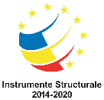
Project co-financed from the European Social Fund through the Human Capital Operational Program 2014-2020
Priority axis 6 - Education and skills
non-university tertiary education graduates who find a job as a result of access to learning activities at a potential job/research/innovation, with an emphasis on economic sectors with competitive potential, identified according to the SNC , and areas of smart specialization, according to SNCDI
Project title: Program to increase performance and innovation in excellent doctoral and postdoctoral research _ PROINVENT
Contract no. 62487/03.06.2022POCU/993/6/13 - SMIS code: 153299

OVIDIUS UNIVERSITY CONSTANTA
FIELD OF CIVIL ENGINEERING AND INSTALLATIONS

Contributions to increase the quality of constructions by reducing risk factors
SUMMARY

Author: Drd. Eng. DOMOLESCU Dana Nicoleta
PhD Supervisor: Prof. Univ. Dr. Eng. GRĂMESCU Ana Maria

content

Title page
CHAPTER 1. General elements. Importance of theme. The objectives of the doctoral research project 9
CHAPTER 2 The evolution of the concept of quality in construction 12
CHAPTER 3 Requirements and requirements of the construction quality system 13
CHAPTER 4 The factors that contribute to the realization of the quality system in construction. The way in which their non-realization influences the quality of constructions 15
CHAPTER 5 - Case study - The collapse of a floor at a shopping center due to a combination of factors and procedures aimed at the application of the quality system in construction. Breaking scenario - element of originality 18
CHAPTER 6 Case studies that through the control carried out at the investment objectives. Nonconformities that were remedied during execution 23
CHAPTER 7 Activities carried out during the PROINVENT project internship carried out at ICECON SA Bucharest 29
CHAPTER 8 Final conclusions 33

The topic addressed is particularly current due to the requirements that are imposed worldwide for the realization of constructions with a high degree of skills, with resistance and stability corresponding to the reduction of the destructive effects generated by risk factors during the entire exploitation period.
The implementation and permanent improvement of the transposition of the quality system from the European Union (Standards, technical norms and technical regulations), is a component of the activity in the construction field that is particularly complex and of great importance for Romania, which involves the simultaneous responsibility of all economic actors, public and private , based on a planned, coherent and organized management at all levels of responsibility.
Starting from the responsibility that Romania has as a member of the common market , not only as a producer of goods, but also as a guarantor of the quality of these goods, we realize that in Romania appropriate technical structures and legislative procedures must be created in order to effectively apply the new European legislation .
From a legal point of view, the harmonization of the system of technical regulations in construction with the exigencies of the European Union refers to:
- Works Directive , 89/440/EEC;
- Construction Products Directive (DPC), 89/106/EEC.
The European directives establish the operating principles of the market in the field of constructions and the criteria for the elaboration of technical norms, but also the way of correlation/interpretation of the laws, norms and decrees of the member countries of the union.
The importance of European legislation also lies in the fact that it is based on a new, modern approach to the entire activity in the construction sector , which consists in the provision for a product or a group of products (materials, elements, structures, constructions as a whole, installations and equipment, projects, etc.) of a number of main or demanding essential requirements .
These requirements are aimed at the system of quality assurance in constructions according to European legislation, implying the achievement and maintenance of the following fundamental requirements during the entire existence of the constructions:
- mechanical strength and stability;
- fire safety;
- hygiene, health and environment;
- safety and accessibility in operation;
- noise protection;
- energy saving and thermal insulation;
- sustainable use of natural resources.
Corresponding to the seven fundamental requirements, seven acts named and interpretative documents detailing them were issued the requirements for design, for products and constructions as a whole. According to these documents, the legislation refers to:
- technical regulations regarding construction design
- norms regarding the quality of materials and products used in construction
- specifications on how to draw up technical approvals for new products, equipment, materials, processes, etc.
the paper is structured in 7 chapters in which the state of knowledge on a national and international level is presented, the objectives of the doctoral research project, the factors that contribute to the risk of constructions with the identification of case studies, the case studies researched by the doctoral student - studies that are divided into accidents caused by non-compliance with the quality system and case studies that, by intensifying the control on the part of those involved responsibly in the quality system , can intervene with remedial measures. The doctoral thesis includes an original research with reference to these recorded aspects. An interesting and original chapter is dedicated to the internship carried out by the PhD student within the PROINVENT project.

CHAPTER 1. General elements. Importance of theme. The objectives of the doctoral research project

1.1 The objectives of the doctoral research project
The objectives of the research project were:
- Identifying the vulnerability of constructions.
- Methods of quantifying the risk factors during the operation of constructions;
- Criterion analysis of the construction quality system: criteria, procedures, measures to ensure quality requirements in construction according to the provisions of Romania and the standards of the European Union. Benchmarking.
- Comparative studies and research with the countries of the European Union and control optimization solutions.
- At the same time, the dissemination of research results by participating in conferences, workshops, article publications, etc.
- Development of knowledge in the field of construction quality;
- Promotion of European directives and analysis of specific situations in the field in order to identify non-compliant factors. Personal contributions to the activity of harmonizing European legislation with Romanian legislation;
- Elaboration of specific procedures for construction quality assurance;
- Proposals for completing the normative framework aimed at ensuring the quality of constructions.
- Identification of the directions of action for the harmonization of the European legislative framework with the Romanian one in the directions: design, execution, exploitation, post-use .
- Proposing public-private partnerships in ensuring the quality of constructions;
- Proposals for the development of the educational system of human resources used in construction.
As part of the research , two research reports were proposed with the following themes:
Report 1 - Vulnerability of constructions. Methods of quantifying the risk factors during the operation of constructions;
Report 2 - The quality system in construction: criteria, procedures, measures to ensure quality requirements in construction according to the provisions of Romania and the standards of the European Union. Benchmarking.
scientific research program was carried out under the guidance of the doctoral supervisor and the guidance committee.
The guidance committee, the doctoral supervisor organized exchanges of experience in this field with universities in Europe, ongoing at the moment being the collaboration of OVIDIUS University with the University of Technology, Koszalin, Poland initiated by prof. univ. Dr. Eng. Anca Constantin, member of the guidance committee, activities in which the doctoral student actively participated
At the same time, the doctoral supervisor, having the capacity of technical expert and expert in European projects initiated by the Ministry of Justice in partnership with the Ministry of Regional Development and Public Administration, favored the participation of the doctoral student in the events of the Ministry of Justice of the Republic of Moldova, the National Judicial Expertise Center , Babeș Bolyai University from Clij Napoca, University of Wroclaw Poland, Kyiv Institute of Scientific Research of Judicial Expertise - Ministry of Justice Ukraine, Kharkiv Scientific Center Ukraine, Kirovograd Center for Scientific Research and Forensic Expertise of the Ministry of Justice Ukraine, city Kropivnitsk , State University of Moldova, Tiraspol University, United Nations Development Program, Swedish Embassy in Moldova - international conferences held on September 30, 2022 and April 14, 2023.
The proposed actions sought to strengthen collaborative relationships with representatives from the private sector, partners concerned with disseminating knowledge, research results, but also potential users of research results.
1.2. The level of knowledge in Romania
The construction quality system represents a set of activities regulated by laws, regulations, procedures applied by organizational structures, which compete to ensure the requirements and demands with an impact on quality constructions in all its stages, namely design, execution, exploitation and after use .
The implementation and permanent improvement of the transposition of the quality system from the European Union (Standards, technical norms and technical regulations), is a component of the activity in the construction field that is particularly complex and of great importance for Romania, which involves the simultaneous responsibility of all economic actors, public and private , based on a planned, coherent and organized management at all levels of responsibility .
1.3. The stage of the level of knowledge on an international level
Research carried out at the level of the European Union highlights the fact that the outsourcing of control and its orientation towards the private can bring new positive results. This aspect would require new certification and recognition systems within the construction industry, increasing the professional level of private control, but also the adoption of control procedures over the private system to guarantee the quality of the control carried out.
In the last period, the European regulations aimed at the quality system in constructions have been influenced by the effect of climate change, the reduction of energy consumption and the reduction of emissions. In this context, we can talk about a new concept of "sustainable quality".
In a summary perspective of these regulations and their evolution in recent years, it is highlighted that they have become more permissive (authorization, registration in the land register, building documents and others).
Requirements and demands have decreased, but one can also observe a transfer of control actions related to the quality of constructions to the private environment and a decrease in the involvement of the state in these actions.
It can be observed that also in Romania there were measures to reduce some procedures for reducing some regulations in order to be rationalized and reduced - with reference to the newly introduced articles in Law 50/1991 updated and completed up to date. Also , it can be observed that many constructions are placed outside of quality control, the current structure in state control being much diminished compared to the volume of investments.
In Romania, as in fact and in the other states of the European Union, the quality system is based on the requirements and exigencies included in the regulations that cover aspects such as: durability , resistance and stability, protection against the action of fire, etc. Of course , all the parameters contained in these regulations refer to the minimum requirements. However, it is observed that there are often violations of substantial regulations. The deficiency of control due to the fact that the current apparatus invested with such attributions is undersized appears more and more clearly. First of all, small interventions are bypassed by inspections and other categories of construction works that have a degree of complexity are not inspected in a serious way.
Across Europe, on-the-spot inspections tend to be random. However, control usually occurs when performing difficult constructions.
The current framework of a country's quality system can be seen as the result of decades of tradition, depending on the evolution of the concept, regulations and laws. A particularly important aspect is compliance with existing regulations and equally their clarity. The construction quality control system focuses mainly on new constructions and ends with commissioning.

CHAPTER 2 The evolution of the concept of quality in construction

In the field of constructions, the concept of quality has had a dynamic evolution in terms of the research level of materials, technologies and labor force, but at the same time, equally dependent on planning and organization, in a word on management construction quality.
Control in the field of quality is about 200 years old, the field of construction being a field that promotes the evolution of the concept of quality, and in this sense, Romania was on the first places in Europe. Thus, starting from the need to continue the tradition, but also from the need to regain the place that Romanian builders had over time, this doctoral thesis makes an in-depth analysis of all the factors that contribute to ensuring quality in construction.
A historical study of the Construction Quality System highlights the "Organic Regulation" from 1832, in which the first principles of creating a "Road Service" were defined, and later in 1841 through the "Department of L'ăuntru" in Moldova , they published the first material technologies for making roads. Thus, a regulation entitled "Setting up for the face of road work in Moldova" is issued.
The earthquake of March 4, 1977 brought back to the fore the need to create resistant, durable constructions, a fact that motivates the emergence of Law 8/1977 as the first law on quality in constructions in Romania. The period that followed, combined with Romania's entry into the European Union, led to the promotion of new, more complete laws, such as the updated and supplemented Law 10/1995, as well as Law 177/2015, which take an important step in the field of increasing responsibility decision-making factors in the field of quality.
Law 177/2015 introduces certain obligations that require that, in the field of construction, when awarding works, conditions regarding the level of competences held must be taken into account. It is interesting to mention that professional certifications of construction companies have been introduced in France since 1949, as well as that in 1999, during the Conference celebrating the 50th anniversary of the introduction of the Construction Quality System in France, it was discussed about the fact that in Romania there was a quality system older than that of many European countries.
Romania's entry into the European Union favored the harmonization of Romanian and European legislation and at the same time raising Romania on a platform of rapid changes. In this context, IT technologies have promoted the 4th industrial revolution, which is characterized by a new era, with the approach of a new quality system.
Day by day more and more emphasis is placed on quality management. The procedure that is not limited only to materials and technologies, but approaches a new concept of organization and planning of execution works.

CHAPTER 3 Requirements and demands of the construction quality system

In chapter 3, the requirements and demands of the construction quality system are presented , elements that represent the set of organizational structures, responsibilities , regulations, procedures and means, which compete to achieve quality constructions in all stages of conception, realization, exploitation and their post-use .
The construction quality system consists of:
a) technical regulations in construction :
b) the quality of the products used in the construction ;
c) technical approvals for new products and processes;
d) verification of the projects, the execution of the works and the expertise of the projects and a
constructions ;
e) management and quality assurance in constructions ;
f) authorization and accreditation of analysis and testing laboratories in the construction activity ;
g) metrological activity in constructions ;
h) reception constructions ;
i) behavior in operation and time interventions ;
j) post-use constructions ;
k) state control of construction quality .
Technical regulations are established through regulations and procedures and have as their object the conception , calculation and composition, execution and exploitation of constructions . The technical regulations establish, mainly, the minimum quality conditions required for constructions , products and processes used in constructions , as well as the way of determining and verifying them.
The certification of the quality of the products used in construction is carried out by the manufacturer, in accordance with the methodology and procedures established on the basis of the law. The use of products without certification of their quality is prohibited for construction works .
The technical approvals for new products, processes and equipment in construction certify their suitability for use, their manufacturing , transport, storage, commissioning and maintenance conditions .
Verification of projects for execution constructions , in terms of compliance with the technical regulations regarding the requirements essential , it will be done by certified project verifiers , but not by project developers . At the same time, the application of unverified projects and execution details is prohibited . The quality of the execution is verified by the investors through specialist managers or through economic agents certified in consultancy .
The technical expertise of the projects and constructions according to the legal provisions are carried out only by certified technical experts .
The assurance of the metrological activity in constructions is carried out according to the legal provisions regarding calibration, verification and maintaining the measuring and control means used in this field in working order .
Reception constructions constitutes the certification of their realization based on their examination, in accordance with the execution documentation and with the documents contained in the technical book of the construction .
The technical book of the construction includes the execution documentation and documents regarding its realization and exploitation.
Reception construction is done by the investor - owner, in the presence of the designer and the executor and /or specialized representatives .
The monitoring of the operation behavior of the constructions is carried out throughout the operation period and includes all activities related to direct examination or investigation with specific means of observation and measurement, in order to maintain rEQUIREMENTS essential .
The interventions in the existing constructions aim at reconstruction, consolidation, transformation, expansion, abolition works partial , as well as repair works , which are done only on the basis of a project approved by the original designer of the building or a technical expertise drawn up by a certified technical expert, and must be recorded in the technical book of the construction .
Post-use construction includes decommissioning, dismantling and demolition of constructions , renovation activities and reuse of elements and recoverable products, as well as waste recycling with the provision of environmental protection according to the law.

CHAPTER 4 The factors that contribute to the realization of the quality system in construction. How their non-realization influences the quality of constructions

More and more constructions are subject to serious incidents, among which we mention fire, explosions, floods, seismic action, uncontrolled actions of people.
In this regard, we highlight a series of serious inadvertences generated by the issuance of notices and agreements, of authorizations without complying with the legal provisions and which led to serious accidents such as the situations presented in the following.

4.1. Issuing notices with non-compliance with the legal provisions .
This situation is specific:
  - of abuses, negligence, with violations of provisions with reference to the damage to neighboring built-up areas, to historical monument constructions.
  - The location of constructions in areas adjacent to urban areas, intended as metropolitan areas and which have not been fully researched from the point of view of the terrain parameters that would ensure an adequate behavior of the constructions (e.g. location on areas with landslides or on vulnerable, degraded areas , etc.)
4.2. Unauthorized interventions in collective buildings/condominiums on the ground floor area with the aim of setting up some commercial spaces.
The repercussions of these interventions can lead to local or even large-scale damage to the occurrence of destructive, accidental events.

An example in this sense is the construction of blocks at the urban limit, sometimes with the expansion of utility networks that do not have the guaranteed flows for additional users, can generate discharges from the pipes, the lack of capacity to take over rainwater.

4.3. Failure to comply with the materials used in the work compared to those provided in the projects.
Sometimes they can lead to significant damage. An example is the damage caused by a fire whose propagation was amplified by the solution adopted in execution compared to the one proposed by the project.

The extent of damage in the example presented in detail in the doctoral thesis was divided into four main categories: resistance structure , facade , internal casing and finishes, mechanical and electrical services . For each category, a general research of the main building elements and systems was done. The description broadly covered the extent of the damage caused by the fire, the contamination with soot and the water used to extinguish the fire produced at these main elements and systems of the building.
4.4. Issuing authorizations without a prior analysis of the real situations in the field
This state of fact demonstrates that authorizations and approvals are still easily given in conditions where the requirements set forth in the regulations are not always met. An exemplary case is the attic of the blocks with the interests of the developers' profit. This measure can create the following deficiencies:
  - The impossibility of tabulation because the tesasa is a common space and belongs indivisible to the owners;
  - The terrace had possibilities of evacuation and protection in case of fire for the tenants of the last level;
  - The internal networks of the block were dimensioned for a certain number of consumers, not having the attic in mind 30-60 years ago;
  - not always respected, therefore the apartments on the column are compartmentalized and in such cases the extended connections to the columns become vulnerable sources of infiltration for the apartment located at a lower level.

4.5 . Situations that affect the hygiene and the environmental environment of the homes due to non-compliance with the authorized location and the inadequate quality of the works.

Failure to observe the location of a new construction by neglecting the distance of 45 cm from the neighboring building led to the appearance and development of mold, to the increase of humidity on the construction elements. Between the two constructions, the executor inserted polystyrene vulnerable to moisture, with direct contact with the external environment. The wetting of this interposed layer between the two properties, its transfer, the lack of ventilation but also some deficiencies in thermal transfer led to the precarious condition that appeared inside one of the buildings.
4.6. Execution Deficiencies
Like _ execution deficiencies _ in the thesis are presented areas that do not ensure continuity corresponding - segregation concrete , execution without a project technically , the unwrapping too early , armament inadequate etc. _
4.7. Wrong reinforcement of reinforced concrete elements
- Resistance reinforcement _ It is positioned in the middle WIDTH BOARDS
  - There are no documents for the quality certification of infrastructure and superstructure works ;
  - There is no quality control system works during execution proven according to legal provisions;
4.8. Design Deficiencies
More and more constructions with height regime P+1/2E are executed according to the DTAC phase documentation without drawing up a technical project or without being verified according to legal provisions. In arguing these statements, the PhD student analyzed a D+P+E home. The completed construction has been sold . The new owner wants to install underfloor heating and realized that the floor vibrates simply by moving on it.

CHAPTER 5 - Case Study – The Collapse A floor at a shopping center owed A the sum of factors and procedures aimed at practice Sistema quality in the constructions . Breaking scenario - element of originality

In the THE this chapter presents a case study that led to the collapse _ STRUCTURE BOARDS of a Building in the time IMPLEMENTATION and which produced TORT important _ causes of this accident are related to the effects NON provisions legal with reference to the system quality in the constructions .
construction A center commercial to which farms metal collapsed _ _ in the time concreting floors located at a height superior as a result of a complex of factors . In the this case the PhD student studied nonconformities ENFORCEMENT the quality system through analyze and interpretation engineering of the farm failure scenario _ metallic , of yielding the floor FOUND in one phase execution intermediary , through _ DISPOSALS the metal and appearance the rupture plane in the adjacent area the clamping gussets through welding of the diagonals .
Nonconformities identified were : _
  - the execution without a technical project with details of the execution, without a technological project or specifications – the execution was carried out based on the documentation drawn up for obtaining the construction permit;
  - the materials used inappropriate for the technical solution for the realization of metal trusses;
  - negligence in the execution by not considering a work technology corroborated with the load assumptions of the resistance elements in the different phases of the execution, when the mathematical work model is different from the mathematical model of the finished structure;
  - the lack of professional training of the work teams, the negligence of the responsible factors in ensuring the quality of the construction works.
Document analysis highlight the fact that the material used for confection FARM metal that gave way was not correspondingly . Analysis parameters _ fall MATERIAL used for fragile material. The yield occurred at the level gusset because resistance mechanics A it decreased _ with the execution welds . In the the present situation was possible notice the fact that in the some knots NUMBER join through welding EXCEEDING the provided by the designer and figured in PLANS the documentation DTAC phase .
In the BULLETIN provided by the testing laboratory -laboratory authorised and RENAR certificates are specified the fact that SAMPLES analyzed have the starting aspect of Wiedmanstatten . Specialized literature _ AWARDS formation this cooling phase QUICK A austenite from temperatures raised , being made of ferrite and pearl with separations rude . Acicular/ lamellar appearance coarse of the phase Widmanstatten is due training ferrites from austenite supercooling over SOME plans CRYSTAL specific FORMATS THE May possible in the time completion welds .
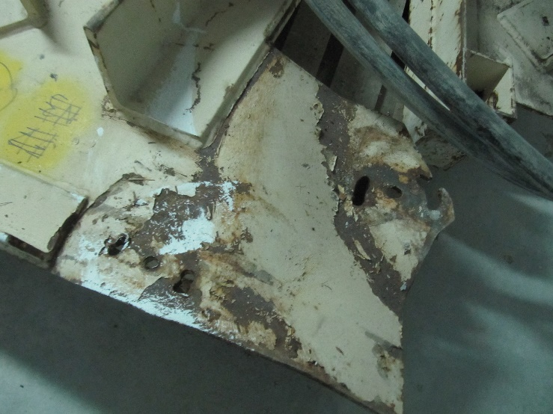
Fig 5.2.1.
As it is known , the basic constituent of steel It is the iron that is called safe _ In insertion solutions , carbon _ appears in steel in the form of iron carbide or cemented . Part of cementite _ together with 6 ferita parts form pearlite , the latter _ being a normal constituent of carbon steel .
Steels for constructions are made of perlite and ferrite depending on the type EACH steel . In the inserts where the network It is deformed ( network the ferrite that presents gaps ) penetrate some diameter elements _ greater than that of the void , are of those May many OR solutions unstable that can decompose producing changes in characteristics mechanics of steels (e.g. carbon and nitrogen causes aging of steel , percentages low carbon produce embrittlement of steel , sa). In low- alloy steels , at temperatures raised at which the processing takes place of steel ( rolling , forging ), the iron in the alloy is found in the allotropic state ( austenite ). Cementite decomposes into ferrite _ and carbon , carbon dissolves in ferrite . The crystallization process of alloys carbon iron under heating conditions or cooling the slow It is REPRESENTATIVE through a balance diagram _ iron -carbon. For construction steels _ PRESENTS interest landing suitable carbon percentage 0.20-0.30. For construction steels with a carbon percentage of less than 0.20% appear May first a mixture of ferrite and austenite which in the end, through transformation austenite in pearlite leads to a mixture of pearlite - ferrite . Transformations are reversible and MATCH SOME slow heating -cooling processes .
transformation structural appear during elaboration of steel during rolling , during treatment thermal and welding _ steel parts - depending on them _ behaving steel in constructions . _ Depending on the different temperatures at which cooling occurs may occur differently constituents : at a high cooling rate appear the bainite that she is composed of from ferrite and cementite which the latter cannot form immediately - resulting in a ferrite _ strong saturated with carbon that limits / occludes the behavior plasticity of steel ; at temperatures May low austenite it passes safely Harnessing the carbon and form a constituent NuMu martensite that confers fragility .
When cooling the steel may still appear and other structure detrimental behavior construction steel _ due to the fact that I induce to him a behavior fragility and substantially reduce the resistances MECHANICAL example structure Wiedmannstatten – is characterize Steels CAST and STRUCTURE join welded . Structure Wiedmannstatten appears if the austenite _ It is bulky and / or an overheating has occurred _ ELEMENT or of the joint , or a heating has taken place extended . This one structure GIVES PRODUCT fragility . Fragility is due the fact that ferrite is formed in the form of needles, plates , entering the pearlite lamellae ( Constructii metal – C Dalban sa - Publishing House didactic and teaching Bucharest 1997 – pages 35 – 44).
Analyzing influence alloying elements _ on features mechanics of steel used in construction together with the analysis report issued by ArcelorMittal Galati , the following can be done appreciations :
  - - The carbon content of construction steels varies between 0.15-0.25%. Small percentages of carbon (between 0.1 and 0.4%) cause embrittlement of steel. Consequently , the influence of carbon can become unfavorable during thermal processing of a construction element and especially in the case of its welding - it corresponds to the situation in the case of the file ;
  - - The content of manganese Mn for the steels used in construction is limited to 1.7-1.8% and has the role of increasing the quality , improves the resistance properties of steel - but in the present situation its content is quite reduced according to the analysis report, it is 0.65%;
This phenomenon appeared in a quality steel the one from which it was made the farm in conjunction with supplementation of the weld seams on the gusset led to embrittlement the fastening element ( the gusset ) and the decrease resistance its mechanics . _
Parameters recorded in the analysis bulletins point out _ the fact that that steel used does not meet the quality A steel weldable . Weldability4a covers 2 aspects : safety welds that refer to appropriation THE JOINT Welded realized in a structure whose material suffered _ influence of a welding technologies _ and which does not present tendency to break fragile at operating temperature ( here _ observations are relevant previously detailed and which highlights the fact that a steel with parameters that highlight a behavior was used fragile ), adoption of a welding technologies _ SUITABLE quality parameters ( which in the present situation are not known nothing ); good welding behavior by which is understood as by aDOPTION of a TECHNOLOGY to obtain a good quality joint , without _ defects . Through result weldability the steel It is definition through the composition the chemistry of the material to be welded , the treatment thermal , degree of deoxidation , to All specialized literature _ EXPLAINS the fact that it influences structures have the disadvantage of fragility overheated that present structure Wiedmannstatten .
Structure Widmanstatten It is very fragility and has a resistance mechanics particularly low , in fact for which it appeared They must combated .
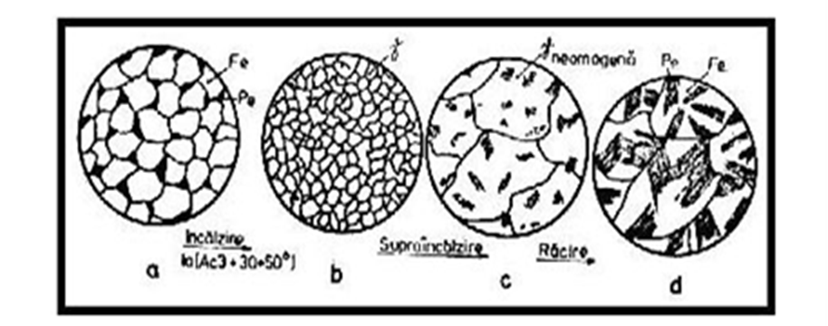
Fig 5.2.2 - Transformations structure in the time A cycle thermal welding _
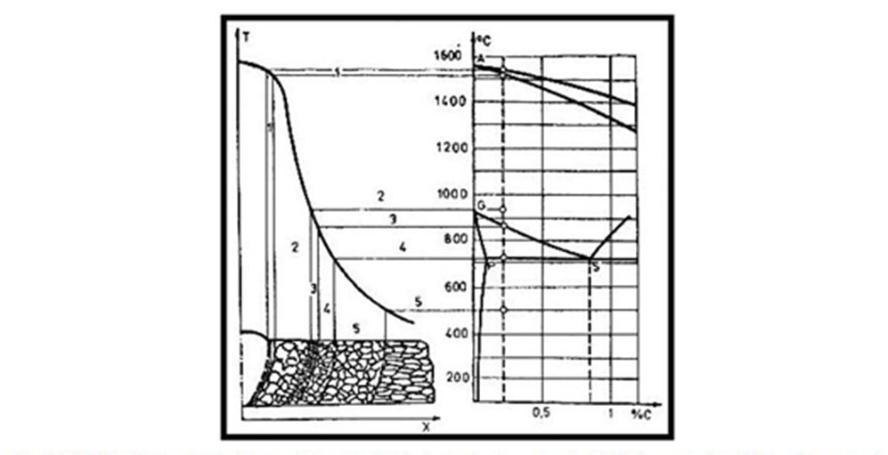
Fig 5.2.3. modifications structures in the affected area thermal depending on the position alloy in the equilibrium diagram _ and the field thermal from welding

Execution FARM metal is done without this one to have an execution project _ for the confection Metalica fully in accordance with the provisions legal ;
According to the legislation Romanian (STAS 767/0/88) documentation execution technique _ must to be developed by _ the factors responsible for insurance quality in construction and namely : designer , society commercial that manufactures steel construction elements _ _ and the society commercial that mounts these elements .
ISSUES presented above _ combined with the fact that the minutes of reception of the project technically it was done after production the event , combined with the fact that the project technically it doesn't wear verification visa _ and owning the consultant , he points out the fact that the project technically it was n't elaborated in complexity to as provided _ the law , but partially on overall components used to obtain authorization or at consultation level _ and information _ contractor the work of beginning MINISTRY without having _ the project technically complete.
The project , drawn up until the production date the event did not contain details execution , the plans were not complete, did not contain memories and specifications , specifications _ _ technological , preliminary measurements , sa
Induction in the structure the roof of a states of effort ADDITIONAL generated by casting excess concrete in portions _ overloaded . He did n't there was a project technology that would have been compulsory for This one phase . It doesn't exist no concrete worker . This one LATEST statement It is supported by the fact that in the day PRODUCTION EVENT in a while 100 meters were poured in about 5 hours concrete cubes _ possible to be distributed preferential ( if we think that there were 5 employees of which a boss work point , a locksmith and 3 workers unqualified according to the specifications in the research made by _ Oradea Labor Inspectorate ), with a degree of non-uniformity of the load aspect possible to induce a state of efforts CRITICAL in the structure metallic . In this sense there is images photographs on file the cause .
An important aspect IS quality parameters of farms _ metallic . They were executed by a subcontractor and when they arrived at the site they were not accompanied by quality bulletins , certificates of conformity of the structure in the assembly , handling provisions _ and ASSEMBLY or other parameters MECHANICAL important . In the the present situation is possible notice the fact that in the some knots NUMBER join through welding EXCEEDING the provided by the designer in the THE DRAWING drawn up .
At these aspects are added and the technology inadequate concreting of the floor from the reference level . In the this sense the expert studied the criminal case in integrity his inclusive materials illustrative SUBMITTED in the form electronics (CDs). Through therefore there were STEPS in which the charge was concentrated a certain period of time.

CHAPTER 6 Case studies that through the control carried out at the investment objectives. Nonconformities that were fixed during execution

The case studies were inspected and analyzed by the author of this doctoral thesis. Each case study presents the results of the verification carried out, the inadvertences noted by the doctoral student, the corrective measures and also the graphic representation of the weight of causality.

    - Finding
- Control regarding completion mode _ and keeping the book construction techniques _ Answer possible : YES, NO, O - comments in the case of non-compliance or ADDITIONS
- Existence book technical - incomplete | a
- Head. A – Documentation looking the design | a
- Head. B – Documentation looking IMPLEMENTATION | a
- Head. C – Documentation looking RECEIPT | a
- Receipt minutes upon completion _ papers / final | a
- Head. D – Documentation looking operation , repair , maintenance and UCE | a
- Stipulations Written regarding UCE, maintenance and list the basic prescriptions that must OBSERVED in the time EXPLOITATION Building | Yes
- Projects based _ to which they were carried out , after RECEIPT final works , construction changes _ _ against the project initial | not
- Findings of some _ _ deficiencies PUBLISHED in the time EXPLOITATION and intervention measures _ taken | not
- Journal events | not
- The outcome verification periodicals within _ PROSECUTION stream | not
- Intervention measures _ in the EVENT finding SOME deficiencies - repairs , consolidations | not
- event exceptional - earthquakes , floods , fires , rain , hail , snow , landslides _ _ | not
- Minutes drawn up by the verification bodies | not
- tracking stream
- Tracking program | not
- Realization periodic control _ objective / objects in the the base instructions Written | not
- In the THE inspection were found deficiencies that may affect the requirements essentials of the objective / object | not
- Intervention works _ in the time on objective / object :
- Maintenance work _ | not
- Restoration work determined by production SOME DEGRADATION important , with the purpose of maintenance or improvement of condition TECHNICAL | not
- Modernization works _ | not
- Repair work _ stream | not
- Repair work _ Capitale | not
- Other works | not
- tracking special
- Project to establish tracking _ specious | not
the reason ESTABLISHING PROSECUTION special :
- Measuring , recording , processing and interpretation systematic of values parameters what the DEFINE measure in which the objective / object ISI maintain the requirements vital ESTABLISHED through project | not
- Request for inspection broad or MAKING of a survey TECHNICAL
- survey technique : | not
- Technical expert certificate | not
  - No. certificate / domain
- Other findings
On the date of execution control , the construction works for the objective " Rehabilitation school SECONDARY Ciucurova body II" were completed . They were executed in the the base building permit . _

6.1.2. Nonconformities

1.1. The construction technical book is not structured in chapters and does not present the centralizer with its component parts .
1.2. The design documentation does not contain the specifications
1.3. - The execution documentation does not contain execution details
- The documentation does not contain all the permanent quality records made during the execution of the works, as well as the other documentation prepared according to the technical regulations , prepared according to the technical regulations, which attest the quality of the works ( technical approvals , conformity and performance certificates of the products installed in the work, the register of minutes of hidden works, the control acts concluded by the control bodies, the single register of communications and construction site provisions , minutes of specific and special tests, etc.);
Qualitative reception minutes prepared by site managers were presented and technically responsible for the execution of the following works: "removal of formwork , demolition of plaster, installation of formwork and coverings, thermosystem installation , decorative plaster, plaster repairs , plaster plaster on walls and ceilings, paintings on the walls and ceilings, installation of floor tiles , installation of tiles , installation of PVC carpentry, installation of installations and sanitary objects", these verbal processes were not appropriated by the site manager , they do not mention the identification elements (sector, position , axis, elevation, etc.) so that the respective works can be identify as a position , in each room or area, both inside and outside , the presented documents do not contain the minutes of verification of the installation of the structural elements of the frame , of their anchoring elements and of the bracing elements, they do not contain the minutes of reception of the works that have become hidden for installation works , do not contain the documents certifying the performance of the fireproofing of the wooden elements from the formwork , the qualitative acceptance report for: " formulation assembly and envelope" is not appropriated by the resistance designer .
1.4. The investor, by concluding the acceptance report upon completion of the works, did not comply with the provisions of art . 7. of the Regulation on the reception of construction works and related installations , approved by GD 273/1994 with subsequent amendments, regarding the composition of the reception committee . Also, the provisions of art. 8. of the Regulation, the representative of the Inspectorate not being invited to participate as a member and the designer's representative not being invited to participate as an invitee at the reception at the end of the works for the " Rehabilitation " objective school SECONDARY Ciucurova body II"
simultaneously they do n't have DONE the documents that certify the value calculated by the competent public administration authority that issued the building authorization in order to regularize the authorization fee, from which the final value of the works performed, as well as the quotas legally owed to the State Construction Inspectorate - ISC;
At the end of the acceptance report at the end of the works, the energy performance certificate was missing , according to the provisions of Law no. 372/2005 regarding the energy performance of buildings, republished, as appropriate;
1.5. 1.6. He didn't show up event log _ typified .
2. It is not carried out the behavior tracking activity _ in the construction time - violating _ provisions legal art. 27, lit. c), of Law no. 10/1995 regarding the quality in the Building republished with completions and The changes subsequent ones . ( there is no decision/contract appointing the person responsible for the current follow-up , no maintenance work is carried out and current repairs , etc. ).

6.1.3. Deviations from:
- Decision no. 273/1994 regarding the approval of the Reception Regulation constructions with subsequent additions and modifications, annex no. 6
- Art. 23, lit. i), of Law no. 10/1995 regarding the quality in the Building republished with completions and The changes subsequent
- Art. 7, art. 8, art. 14 of the Regulation on the reception of construction works and installations related to them , approved by HG 273/1994 with the amendments subsequent
- Art. 27, lit. c) of Law no. 10/1995 regarding the quality in the Building republished with completions and The changes subsequent
- Regulation P130/1999, chapter 3.1.2.

6.1.4. Measures taken

- Carrying out the activity behavior tracking _ _ in the construction time - according _ provisions legal art. 27, lit. c), of Law no. 10/1995 regarding the quality in the Building republished with completions and The changes subsequent ones .
- Drawing up periodic reports on the current monitoring of the construction , which will be drawn up at least once a year and mandatory after the occurrence of special events (earthquakes, explosions, fires, etc.) Mentioning the periodic reports in the Event Journal.
- Appointment by decision of the person in charge of the current follow-up who performs the activity of following up the construction in time .
- Submission event log _ typified .
- maintenance work and current repairs . According to the provisions of art. 27, lit. a) of Law no. 10/1995 regarding the quality in constructions , the owners of the constructions have the obligation to ensure the monitoring of the behavior of the construction over time , according to the provisions of the technical book and the technical regulations and to carry out on time maintenance works _ and repairs _ results from this activity .
- Payment quotas according to the provisions legal .

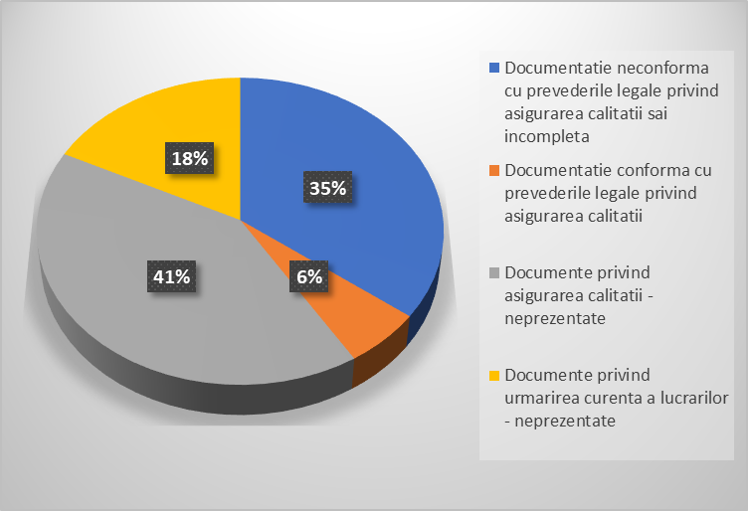
Diagram - The percentage looking checking quality Building through analyzing risk factors _ case study 1 - Rehabilitation school SECONDARY Ciucurova body II
- Author Dr. Eng . Dana Domolescu

Quality control constructions by analyzing the risk factors case study 2 - concrete plant
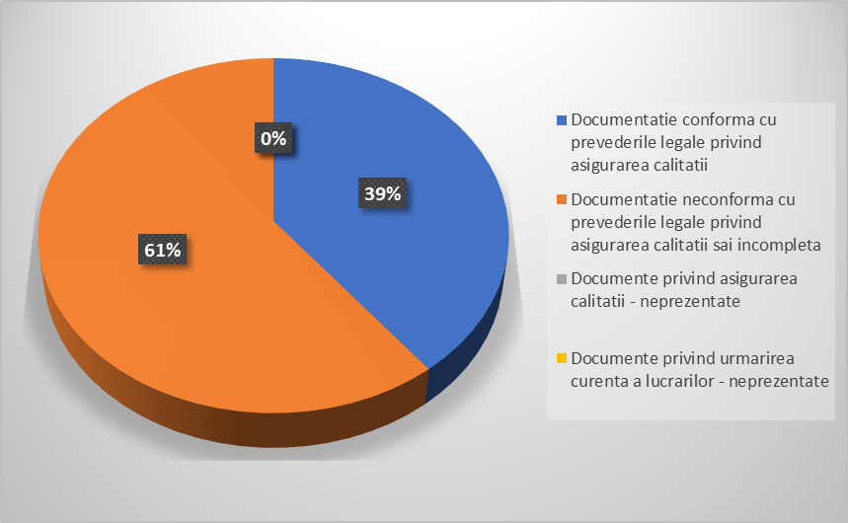
Quality check percentage constructions by analyzing the risk factors case study 2 - concrete plant
- Author dr.eng . Dana Domolescu

CHAPTER 7 Activities carried out within the PROINVENT project internship carried out at ICECON SA Bucharest

Chapter 7 presents the results of the internship that took place at SC ICECON SA Bucharest based on contract no. 62487/3.06.2022 concluded between the Ovidius University of Constanța and ICECON SA Bucharest, having as a mentor Ms. prof. univ. dr. ing . Grămescu Ana Maria, as PhD supervisor, and as tutor appointed Mrs. Eng . Pintoi Ramona.
The 3 objectives pursued within this internship are:
- Researching the level of knowledge on a European level of the fundamental requirements regarding the quality of constructions, with reference to the quality of construction materials.
- Materials research techniques and procedures for identifying characteristic strengths.
- Criteria for commercialization on the internal market of construction materials.
In the framework this internship were _ _ _ CARRIED concrete analysis works _ _ for DIFFERENT situations analyzed , that's all for INVESTMENT in the civil constructions as and for concretes road . They were PURSUED element what the Involves workability , density , both of concrete fresh How and of that reinforced , compressive strength _ and tensile strength . _ An attention special was granted and how in which a concrete , in the differently situations real , which does not respect in the totality parameters from the project , maybe affect resistance and stability BUILDING or may be REDUCE the duration of its exploitation .
Motivated by the fact that through preparation awarded to me by the PhD supervisor EXPOSED many I had casuistics exposed a rich casuistry , among which the more serious are:
- concrete cracking, in the slab area,
- lack of cement adhesion in the concrete structure,
- the effect of the segregated areas as a result of a high density of reinforcing bars in the area of the frame nodes corroborated with the cases identified by me within the professional activity carried out within the ISC Constanța.
The research also included issues related to the contribution of deficiencies to the modification of the calculation parameters, respectively to the modifications of the working conditions.
In this sense, the tests were carried out according to STAS SR EN 12350/2. I will describe the procedure and working method applied in the next subchapter.
The research carried out revealed losses of working resistances and implicitly the increase of the risk factor of the buildings in operation. The working equipment is shown in the images below. The devices have been calibrated and checked according to legal provisions.
ICECON SA Bucharest owns RENAR authorized laboratories, being a notified institution in the European Union.
The results of the research contributed substantially to the interpretation of the theoretical research carried out on the real phenomena faced by a construction, contributing to the development of knowledge.
During the activity, monthly practice reports, a narrative report and observation sheets from the tutor were presented. As can be seen from the aforementioned reports and files, I consider that during the internship I have acquired additional skills in research activity, synthesis skills, developing my ability to interpret both the case studies analyzed and presented in this work, as well as and other situations that I have encountered in my professional activity.
The results of the internship were presented in a workshop organized by the Ovidius University of Constanța, within the PROINVENT project, on May 6, 2023. This workshop was held in a hybrid system. So we could also enjoy the online participation of all the partner Universities, in addition to the numerous and distinguished audience present in the hall.
The topic presented was the increase in the quality of construction materials, an important factor in ensuring the structural safety of buildings.
The research also included aspects related to the contribution that deficiencies have to the modification of the calculation parameters, respectively to the modifications of the working conditions.
In this sense, the tests were carried out according to STAS SR EN 12350/2. I will describe the procedure and working method applied in the next subchapter.
The research carried out revealed losses of working resistances and implicitly the increase of the risk factor of the buildings in operation. The working equipment is shown in the images below. The devices have been calibrated and checked according to legal provisions.
ICECON SA Bucharest owns RENAR authorized laboratories, being a notified institution in the European Union.
The results of the research contributed substantially to the interpretation of the theoretical research carried out on the real phenomena faced by a construction, contributing to the development of knowledge.
During the activity, monthly practice reports, a narrative report and observation sheets from the tutor were presented. As can be seen from the aforementioned reports and files, I believe that during the internship I have acquired additional skills in research, synthesis skills, developing my ability to interpret both the case studies analyzed and presented in this work, as well as of other situations that I have encountered in my professional activity.
The results of the internship were presented in a workshop organized by the Ovidius University of Constanța, within the PROINVENT project, on May 6, 2023. This workshop was held in a hybrid system. So we could also enjoy the online participation of all the partner Universities, in addition to the numerous and distinguished audience present in the hall.
The topic presented was the increase in the quality of construction materials, an important factor in ensuring the structural safety of buildings.
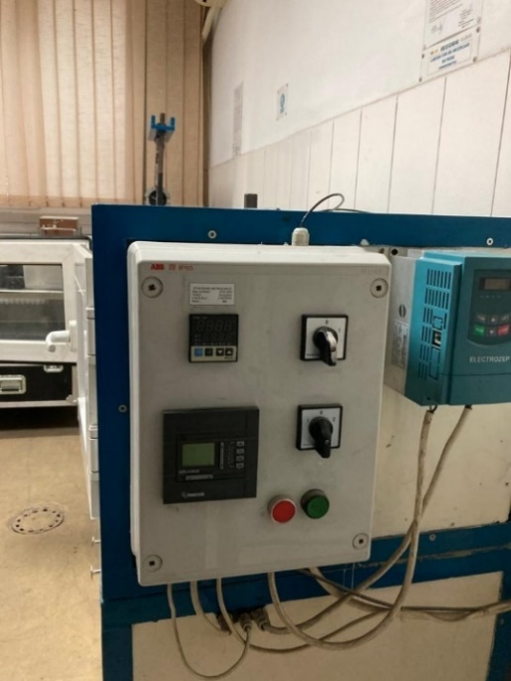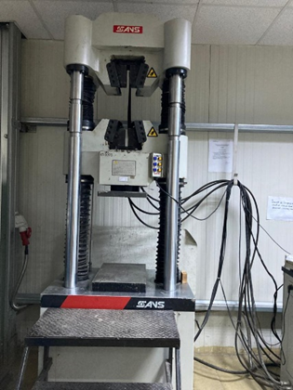
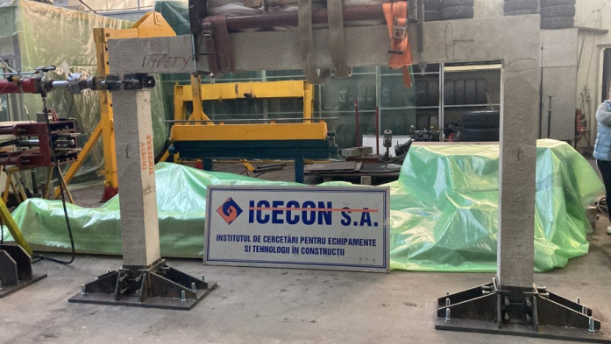

The internship I did between July 2022 and February 2023 at ICECON SA Bucharest allowed me to participate in a series of particularly interesting laboratory tests. These tests were carried out according to the procedures established by the Institute, procedures which are approved at the European level. They mainly referred to construction materials that were to be recognized or not, the quality according to the requirements of the technical project or for new materials in order to issue the Technical Approval or not, and, if they were appropriate, to be promoted on the Romanian market, and others aimed at the parameters that define the material that had to be used. During the internship I participated with the group of researchers in the identification of the characteristics that define the class of concrete, therefore tests aimed at the workability of concrete, the density of fresh concrete and the density of hardened concrete, compressive and tensile strength, as well as losses of strength caused by the freeze-thaw phenomenon.
The procedure used complied with: STAS SR EN 12350/2, STAS SR EN 12350-2 - 2009 - Test on fresh concrete - Workability , STAS SR EN 12350/6 for density of fresh concrete , STAS SR EN 12350-6:2009 Test on concrete fresh. Part 6: Density STAS SR EN 12390/7 FOR and STAS SR EN 12390-7:2019 - Density of hardened concrete and fresh concrete. With reference to the calculation characteristics of these materials, the following were taken into account: STAS SREN 12390/6 for tensile strength by splitting, STAS SR EN 12390-6:2010 Test on reinforced concrete. Part 6: Tensile strength by splitting the specimen and compressive strength.
At the end of the research, the results were recorded to be later interpreted and corroborated with the reference parameters.
The results obtained contributed to my improvement in the field of quality certification of construction materials, the results were compared with the procedures of other laboratories, noting that the procedures applied during the internship are in accordance with the European requirements and demands for such works. And that these certifications regulate criteria for commercialization on the internal market of construction materials.

CHAPTER 8 Final conclusions

In this chapter it was analyzed the degree of fulfillment of the objectives of the doctoral research project in which the doctoral student had a number of objectives that I appreciate that during the course of the studies and research, they were completely completed, deepening each element that I describe in the lines below.
The objectives of the research project were:
Identifying the vulnerability of constructions.
The research carried out on concrete case studies allowed me to select the inadvertences found in the different case studies that concerned:
  - Negligence, omissions in issuing notices and agreements;
  - Incomplete or error-prone projects;
  - Execution of works that do not respect the projects or that are not based on a technical project;
  - Negligence or errors in execution caused by the lack of experience of the staff, their lack of training;
  - Superficiality of site managers;
  - Changes of solutions or materials without the consent of the designers ;
  - Lack of rigorous control during the design and execution of constructions;
  - Lack of rigorous control during the period of monitoring the behavior in exploitation.
Based on these aspects, this objective was met and I carried out a statistical study of the objectives inspected from a sample of case studies, seeking to establish the percentage weights of affectability of these vulnerabilities of the fundamental requirements but at the same time presenting comparatively in two distinct chapters the modality of effects, namely:
  - Accidents with major effects where the control can only determine the destructive effects in which case we did a research of the failure scenario by quantifying the factors responsible for the accident, the deficiencies found in the application of the quality system - presented in chapter 5;
  - With the prevention of destructive effects through control methods and procedures that led to remedies and optimizations, these were presented in chapter 6 - objective met .
➢ Methods of quantifying the risk factors during the construction operation period;
➢ Criterion analysis of the construction quality system: criteria, procedures, measures to ensure quality requirements in construction according to the provisions of Romania and the standards of the European Union. The comparative analysis concerned the research procedures in establishing the quality parameters of the concrete put into operation, respectively the verification of the quality of these materials. This applied research was carried out through the PROINVENT project based on the partnership concluded between the OVIDIUS University of Constanța and SC ICECON SA Bucharest , the only certified laboratory, certified by RENAR and nominated by the European Union.
Within this research program, the theme was: Contributions to reduce the degree of structural vulnerability of the built fund by ensuring the quality of construction works , which represented a synthesis of the objectives.
The main objective of this research topic carried out within the scientific research program PROINVENT 2022-2023 consisted in deepening the studies, carrying out an internship necessary for the elaboration of the doctoral thesis and in the training/development of the personal skills included in the RNCIS doctoral qualification sheet .
The theme proved to be particularly current (according to the presentation in chapter 1) due to the current requirements that are imposed worldwide for the realization of constructions with a high degree of skills, with resistance and stability corresponding to the reduction of the destructive effects generated by risk factors throughout the duration of the building's operation.
At the completion of the scientific research program I prepared the research report.
The evaluation of my progress in the research activity was carried out quarterly by explicit reporting on the activities and results relevant to the research topic undertaken through the doctoral research project.
The results of the research contributed to the development of knowledge in the field, to the synthesis of some proposals for improving the legislative framework, the technical prescriptions in the reference field.
It is possible, with the participation of the group for guidance and coordination of the scientific research activity , to conclude contracts for the valorization of scientific production in the future.
The activity carried out by me in conjunction with the professional activity within the State Construction Inspection constitutes a support framework for the development of the researcher 's career in the studied field.
The proposed actions aim to strengthen collaborative relationships with representatives from the private sector, partners concerned with disseminating knowledge, research results, but also potential users of the proposed research results (contract between OVIDIUS Constanța University and SC ICECON SA Bucharest within the PRO INVENT project).
In this sense, through the care of the doctoral supervisor and with the support of the members of the guidance committee, exchanges of experience were organized, actions to promote the research results both for the field studied by the doctoral student for the research period, but also for those who completed the doctorate in the field of Civil Engineering and Installations.
scientific research program involved participation in several scientific projects established by the PhD supervisor, projects developed within the Scientific Research Center within the Faculty of Construction of the OVIDIUS University Constanța but also within other research programs initiated in partnership with structures of the Romanian Academy, other European universities, professional associations, private civil society structures, as well as the PRO INVENT project;
At the same time, the doctoral supervisor, having the capacity of technical expert and expert in European projects initiated by the Ministry of Justice in partnership with the Ministry of Regional Development and Public Administration, favored the participation of the doctoral student in scientific events promoting the results of the research, events organized by the Ministry of Justice of the Republic Moldova, National Judicial Expertise Center , Babeș Bolyai University in Clij Napoca, Wroclaw University Poland, Kiev Institute of Scientific Research of Judicial Expertise - Ministry of Justice Ukraine, Kharkiv Scientific Center Ukraine , Kirovograd Center for Scientific Research and Forensic Expertise of MAI Ukraine, city Kropivnitsk , State University of Moldova, Tiraspol University, United Nations Development Program, Swedish Embassy in Moldova - international conferences held on September 30, 2022 and April 14, 2023.
The study carried out as part of the doctoral research project entitled "Contributions regarding the increase in the quality of constructions by reducing risk factors" refers both to the international situation and to the conditions in our country. The historical period highlighted control concerns in the field of buildings since ancient times, but it can be noted that in Romania the effects of the 1977 earthquake caused the quality system to be brought to the fore, in the category of the most important legislative provisions in construction. The research carried out has fully demonstrated that there is an intrinsic link between the principles of composition, execution and exploitation and the degree of vulnerability of constructions. At the same time, the research highlighted the fact that in the first stage the existence of technical regulations plays a role and immediately in the second stage the manner in which they are respected. The existence of correct and complete regulations, of an adequate and up-to-date legislative framework starts from the construction authorization phase. It can be seen that recently urban areas are expanding and construction permits are being issued on sites that are sometimes not sufficiently well studied and framed as land for construction. So as I have shown , it is very important for the body issuing notices and agreements to carry out geotechnical, hydrogeological, environmental protection research and studies, on the lands intended for construction for which they issue construction permits.
The research carried out showed that there are also situations where the lands that were historically intended for the construction of the building activity, have degraded due to mining exploitations, exaggerated deforestation, the diversion of the courses of some rivers. And these lands must be researched and reassigned, as appropriate, to other functions, giving them another destination, another utility.
During this research, we found that many structures, design firms do not pay due attention or simply do not have the necessary professional competence to be able to carry out complete and correct documentation in accordance with the legal provisions. More and more such situations highlight inadvertences related to: operational safety, mechanical resistance and structural safety, hygiene and health problems, inadvertences regarding energy performance, affecting the degree of sunshine.
The research carried out also highlighted acute problems in the execution system. In this sense, there are non-compliances with the project, non-compliances with the location, non-compliances with the execution technologies. Not infrequently, constructions are encountered on construction sites that are not carried out on the basis of a technical project with execution details, but by unauthorized work teams that "execute" according to the "minimalist" project drawn up to obtain the Building Authorization. Normally in such situations the reinforcement of the resistance elements will not be carried out on the basis of a project drawn up by an engineer, but in the "reality of the construction site" the reinforcement of the resistance elements is carried out by a more or less qualified worker, who it goes on the principle of doubtful experience. In this category of inadvertences, the cause is the very deficient way of applying the quality system, in which the beneficiary, through the site managers, by specialty, have the obligation to verify the existence of the authorization, the technical project, the execution details.
The research highlighted that a particularly important element in the certification of quality in construction is the "Acceptance Report", which in many situations is drawn up and signed only formally, thus covering possible mistakes and hidden defects, which later highlight significant depreciations .
The research carried out on the application of construction quality control procedures in the countries of the European Union highlights the fact that, in the vast majority of these countries, constructions must meet the requirements provided by their own regulations. internal regulations.
The own regulations provide a set of minimum requirements. It can be seen that not all constructions are subject to rigorous control. Those with a small height regime being exempted many times. The results of the research highlighted the fact that the approach of this control system by categories of constructions is based on the risk analysis and is reduced to the severity or the extent of the subsequent consequences.
In chapter 2 it was shown that in most countries, constructions are divided into classes of consequence for structural safety, but also with regard to the application of Euro-codes. Many of the countries divide constructions into 3 classes, respectively: constructions that need authorization with a high degree of difficulty, those in class 3 and going up to simple structures, those in class 1, where the consequences are minor.
The results of the research showed that the control procedures must aim at both compliance with regulations and compliance with the location, compliance with arrangements, compliance with aesthetics.
As I showed at the beginning works in most European states, quality control is carried out in a mixed system, both by state institutions and by private structures.
Constructions, in the European Union, can only be used after obtaining the "Certificate of Final Reception".
Comparative studies and research with European Union countries and control optimization solutions were studied by consulting a rich bibliography and presented in chapter 1.
research results through participation in conferences, workshops, article publications, etc. I mention that the research results materialized in two research reports, 9 articles published and presented at international and national conferences, a chapter in the book Climate changes on constructions published in ed MATRIX and presentations of the research results at 3 workshops , but also in within the actions organized by:
  - Institute of Doctoral Studies through the PROINVENT project;
  - Research Center of the Faculty of Construction;
  - The Romanian Committee for the History and Philosophy of Science and Technology within the Romanian Academy Fil Constanța;
  - Other international and national institutions.
The results obtained within the carried out activity contributed substantially to the development of knowledge in the field of construction quality;
As part of the research , two research reports were proposed and carried out with the following themes:
Report 1 - Vulnerability of constructions. Methods of quantifying the risk factors during the operation of constructions;
Report 2 - The quality system in construction: criteria, procedures, measures to ensure quality requirements in construction according to the provisions of Romania and the standards of the European Union. Benchmarking.
At the same time, I presented a synthesis of the research carried out during the internship - presentation carried out within a PROINVENT Workshop entitled : " Increasing the quality of construction materials, an important factor in ensuring their structural safety".
We carried out joint activities to disseminate the results of the doctoral research with fellow doctoral students from IOSUD and master's students from the Faculty of Construction between November and December 2022.
the Workshop was held with the theme: "Aspects regarding the quality system in construction " in which I presented - The quality system in construction", followed by my doctoral supervisor with the theme: – Accidents and damages in constructions generated by non-compliance with the quality system in constructions.
It should also be mentioned the activities carried out together with the research team of the Research Center of the Faculty of Construction of OVIDIUS University Constanța
Thus, actions were organized to disseminate the results of the research in the period 2021-2023 in the framework of the theme led by the doctoral supervisor prof . DR Eng Grămescu Ana Maria with the theme: "Modern solutions and techniques applied to civil constructions in order to increase safety performance in operation", with the following objectives:
- Studies and research regarding the behavior of condominiums over time;
- Identification of the structural analysis procedures of various civil constructions according to the evolution of the seismic design norms compared to those according to which they were made;
- Increasing the operational resistance to seismic actions of multi- story buildings through effective structural intervention measures, without affecting the users;
- The development of procedures for the use of condominiums in risky situations with the development of procedures for the safe use of constructions subject to risk. Risk management of a condominium or complex of condominiums.
- Implementation of inspection strategies of multi-storey buildings in order to reduce risk factors.
- Elaboration of instructions to complement the existing norms regarding quality in construction .

Personal contributions

Considering the fact that my professional activity for over 20 years has been carried out in the construction quality system, the doctoral research project, the internship, the case study nature motivated me to develop new analysis methodologies that materialize in new concepts, procedures and systems that leads to an increase in the quality of constructions.
Thus, chapters 4,5,6,7 are personal contributions with elements of originality researched by me within the doctoral program, results that led to obtaining optimization elements, increasing the role of inspections in all stages of a construction.
In the head 4 of this doctoral thesis I presented the factors that influence degradation. By identifying the factors and the reference case study, a vast material was created from which the vulnerable factors are highlighted, as well as the degree of risk/vulnerability. The presented situations have a high degree of originality.
The analysis presented in ch. 4 starts from a first factor that can lead to the depreciation of the building, namely: issuing notices and authorization without complying with the legal provisions. The developed examples showed the fact that in many situations the state institutions do not correctly assess the situation, the potentiality/probability of negative evolution of the situation that can become a vulnerability. I noticed that notices and agreements are issued in violation of urban protected areas, declared based on Law 422/2001 updated and completed up to date, thus not infrequently causing damage to existing buildings.
A situation that I have studied in the framework of this doctoral research is the location of some constructions on deformable land, subject to excess moisture (for example the area adjacent to Lake Zaghen located 4 km from the city of Tulcea) on the bordering areas of urban centers . which have tilted or even cracked - new constructions, locations in the Jiului Valley area, where the land is known to be degraded due to mining operations. This aspect highlights the fact that insufficient geotechnical and geological research is being done. I notified and an important problem in landslide areas, for which there is not enough information provided on the basis of in-depth geo and hydrogeological studies to eliminate the deficient land from the urban arsenal. These inadvertences were brought to our attention institutions with responsibilities through the doctoral director .
In the analysis of the risk factors carried out within the research project as an element of maximum originality, we identified the major impact of unauthorized intervention works, whose destructive effects appear with the occurrence of exceptional actions such as earthquakes. From this category, an eloquent example is the interventions carried out on the ground floors of blocks of flats for the arrangement of commercial spaces, wall demolitions, creation of voids, etc. With a degree of originality, we have identified as a degree of risk the interventions carried out at condominiums by tenants by decommissioning some walls, sometimes even at prefabricated structures with a structural role.
Another original element in the research carried out was the case study detailed in chapter 5 due to non-compliance with the material from the project in conjunction with other factors. It was also shown that the palette of materials that appeared on the construction market is very varied and not infrequently at the level of construction sites, the following can be observed:
      - Materials are replaced without always having the designer's approval.
      - Their technical condition can cause various damages, the most aggressive of which are fires.
Head. 4 highlights, once again, how important it is that in the execution the documents issued by the designer are followed accurately and precisely. In the content of ch. 4 are recorded as inadvertences with destructive effects, these situations affecting the hygiene and environmental environment of a building, being exemplified by the case of a holiday home type building presented in chapter 4.
The researches carried out and presented in chapter 6 with reference to the weight of the factors that affect the quality of the constructions have highlighted through the graphs that there are inadvertents in all stages of realization but that the control institutions must act in order to reduce their weight.
The graphics made represent an element of originality and can contribute to the establishment of a corrective action on the part of the designers , executors , beneficiaries. It is important that these deficiencies can be detected at a stage where they can still be remedied, through corrective measures. This is the State Construction Inspectorate, as the mission of the ISC is to be a body with such verification and control attributions, as well as the disposition of corrective measures. From this point of view ch. 7 is a centralizing chapter of the inspection sheets drawn up over a period of 1 year, in which the inadvertences on each point of work are noticed and recorded, making a weighting chart in order to highlight the areas that need to be completed with trained people or to procedures are initiated to prepare the existing ones. So much for the head. 4 as well as chap. 7 I presented original elements on the basis of which I formulated proposals for measures to optimize control in order to minimize the detected irregularities.

Elements of originality
Through the studies and research carried out that followed the fulfillment of the established objectives, stages were completed that are characterized by a high degree of originality and that were studied through procedures that were corroborated with European regulations. Starting from the level of knowledge on a European level, through a comparative study of the quality system in different countries, taking note of their verification system, we identified the range of important risks faced by the constructions in chapter 4 , performing a synthetic analysis of the shortcomings found .
In chapter 5, we researched and modeled the scenario of the breaking of metal trusses on a board at a corroborating commercial center all the risk factors such as: the quality of the material, the execution , the technology, to which were also added the lack of responsibility of the staff with attributions in the verification quality .
Chapter 6 has a high degree of originality because it presents in synthesis with graphic representations on weights of risk factors the results of the inspections carried out at the various objectives under construction within the activity carried out at ISC Constanța. The analysis performed was based on the solution of an analysis on samples using regression functions. This analysis allowed me, based on the follow-up samples, to develop a mathematical model generated by the phenomenon of risk factors. In this context the function: y=f(x1.... xk ) where x are risk factors is called a regression function, and with its help we quantitatively evaluated the dependence of the influence between the resulting factor and the variable factors that generate the risk. We used "Regression Theory" in the quality system motivated by the fact that the analysis is dependent on environmental conditions.
By the specifics of the chosen model, the variable factors that influence the quality system are considered, respectively the inadvertences in the design, in the execution, in the operation, including the lack of follow-up of the construction during the execution. The specificity of the analysis model is dependent on a multitude of factors, which have been identified and which have a major influence on the assessments of the construction quality.
The results of the research carried out in chapter 6 offer the possibility of knowing the weak points resulting from the analysis of the functions so that it gives the possibility for the user to act on the functions that showed high vulnerability so that the reduction of these effects leads to the increase of the quality of the constructions. The analysis carried out has a high degree of originality and can lead to its approval at national level.
Another element of originality presented in chapter 7 is the results of the research carried out during the internship at ICECON SA Bucharest, carried out within the PROINVENT research program, a program that followed the performance of tests on construction materials according to the methods and procedures practiced by the laboratories of European union. These tests were carried out both for the existing works , respectively for the concrete put into operation and for the system of issuing technical approvals .
Valorization of research results
During this research, the results obtained were included in the framework of:
- Research reports:
Report 1: Vulnerability of constructions . The degree of vulnerability as a factor of ensuring performance constructions , of the requirements in operation. Analysis criteria and procedures;
Report 2: The quality system in construction: procedural criteria, measures to ensure quality requirements in construction according to Romanian and European Union legislation .
- Published articles
- Răzvan Dimofte , Ana Maria Grămescu , Dana Nicoleta Domolescu – The behavior of large panel constructions to seismic actions . - The International Scientific Conference CIBv3-4 November 2022; https://webbut.unitbv.ro/index.php/Series_I/information/authors ;
- Alexandra Popa, Alina Elena Ionaşcu , Dana Nicoleta Domolescu – Innovative Marketing Strategies for the Development of Tourism in Romania - Ovidius University Annals Economic Sciences Series Volume XXI, issue 2/2021 published http://stec.univ-ovidius.ro/htlm/anale/RO/ovidius-university-annals-economic-sciences-series-volume-xxi-issue-2
- Grămescu Ana Maria, Maria Georgeta Stoian, Dana Nicoleta Domolescu - "Judicial expertise an interdisciplinary science" The development of ecological forensic expertise - an essential objective in environmental protection" Chisinau September 30, 2022 appeared in the magazine Legea si Viața October 2022 ISSN 2587-4365 pages 120-128 https://www.legeazkon.md/index/ro and http://www.legeasiviata.in.ua Index Copernicus International (Republic of Poland) EBSCO index;
- Ana Maria Grămescu , M.-G. Stoian, AMDaniela Barbu, Dana Nicoleta Domolescu , The importance of sampling in the presentation of scientific truth , CZU: 340.69:504.05, in the magazine Legea si Life , Publication scientific -practical, accredited by the Supreme Council for Science and Technological Development of the Academy of Sciences of Moldova, special edition on the occasion of the Conference International "Qualitative research of the crime scene - an important factor in the performance of subsequent judicial expertises", Editor " Ştefan cel Mare" Academy of the MAI, Chişinău , June 2023, pp. 35-42, ISSN 2587-4365, E-ISSN 2587-4373 , Index Copernicus International (Republic of Poland) EBSCO index;
- Ana Maria Grămescu , Dana Nicoleta Domolescu , M.-G. Stoian, D. Pericleanu, A. Gemănaru , Aspects regarding the importance of research results in technical expertise in construction , CZU: 340.69:504.05, in the magazine Legea si Life , Publication scientific -practical, accredited by the Supreme Council for Science and Technological Development of the Academy of Sciences of Moldova, special edition on the occasion of the Conference International "Qualitative research of the crime scene - an important factor in the performance of subsequent judicial expertises", Editor " Ştefan cel Mare" Academy of the MAI, Chişinău , June 2023, pp. 35-42, ISSN 2587-4365, E-ISSN 2587-4373 , Index Copernicus International (Republic of Poland)EBSCO;
- Grămescu Ana Maria, Domolescu Nicoleta Dana , Pericleanu Dan, Pericleanu Mihaela, Mihai Geanina - Requirements and Exigencies in Construction Quality Assurance - Ovidius University Annals of Constanta - Series Civil Engineering, under publication;
- Timofte Razvan , Grămescu Ana Maria, Domolescu Dana Nicoleta - The behavior of large panel constructions to seismic actions - Ovidius University Annals of Constanta 2022 - Series Civil Engineering;
- BDI article - Grămescu Ana Maria , Domolescu Dana Nicoleta , Pericleanu Dan, Pericleanu Mihaela, Mihai Geanina - Requirements and Exigencies in Construction Quality Assurance - Ovidius University Annals of Constanta - Series Civil Engineering, vol.24, 2022, pp 207-214, DOI:10.2478/ouacsce-2022-0023.
- Ana Maria Grămescu , Dorina Nicolina ISOPESCU, Cosmin FILIP, Harry Michelle BOIAGIAN, Domolescu Dana Nicoleta - Technical regulations in construction and their impact in ensuring quality and performance in construction in the context of climate change. chapter 12 of the book "Constructions in the context of climate change" ed MATRIX 2021 ISBN 978-606-25-0680-3.

- Research summary presented in a PROINVENT Workshop:
PROINVENT Workshop on May 5, 2023, the topic presented by Dr. Eng Domolescu Dana Nicoleta : " Increasing the quality of construction materials is an important factor in ensuring the structural safety of the building ".

- Joint activities for disseminating the results of the doctoral research carried out with the doctoral students from IOSUD and the master's students from the Faculty of Construction
November-December 2022 period
On 28/11/2022, the works of the Workshop were carried out with the theme:
Aspects regarding the quality system in construction
Presentations:
Presentation 1. Dr. Eng Domolescu Dana – Quality system in construction. Progress report Project " Program for increasing performance and innovation in excellence doctoral and postdoctoral research " - PROINVENT
Presentation 2. Doctoral supervisor Prof. Dr. Eng Grămescu Ana Maria – Accidents and damage in construction caused by non-compliance with the construction quality system.

- Activities carried out together with the research team of the Research Center of the Faculty of Construction of OVIDIUS University Constanța
Actions were carried out to disseminate the results of the research in the period 2021-2023 in the framework of the topic led by the doctoral supervisor prof . DR Eng Grămescu Ana Maria with the theme: "Modern solutions and techniques applied to civil constructions in order to increase safety performance in operation", with the following objectives:
- Studies and research regarding the behavior of condominiums over time;
- Identification of the structural analysis procedures of various civil constructions according to the evolution of the seismic design norms compared to those according to which they were made;
- Increasing the operational resistance to seismic actions of multi- story buildings through effective structural intervention measures, without affecting the users;
The development of procedures for the use of condominiums in risky situations with the development of procedures for the safe use of constructions subject to risk. Risk management of a condominium or complex of condominiums.
- Implementation of strategies for the renovation of the existing built fund;
- Elaboration of instructions to supplement the standards regarding quality in construction .

New research directions highlighted by the development of the doctoral program

Other aspects were highlighted in the research project which, in my view, could represent a potential continuation of the research within a postdoctoral program. An important direction that in my view can represent a new research vision is the impact of climate change on materials and technologies, changes in the behavior of materials, how climate change will influence the operating conditions, the duration of operation but also the science of construction materials. In this sense, the organizations responsible for the control of calcium will also have the task of recording the changes observed during reference periods.

M. Strangwood - Phase Transformations in Steels Fundamentals and Diffusion-Controlled Transformations Volume 1 in Woodhead Publishing Series in Metals and Surface Engineering Book • 2012 Edited by : Elena Pereloma and David V. Edmonds
Gabriela Stanciu PhD theses, Transilvania University Braşov 2012

